Department of Veterans Affairs

Veterans Health Administration

Accounts Receivable 4.5

Cross-Servicing User Manual

**VistA Patch PRCA*4.5*315**



**May 2018**

Version 1.3

(*This page left intentionally blank for two-sided printing / copying.*)

Revision History

| Date | Version | Description | Author |
| --- | --- | --- | --- |
| 05/25/2018 | 1.3 | Updated for patch PRCA*4.5*315  This patch adds two new reports: Cross-Servicing Stop Reactivate Report & Treasury Cross-Servicing IAI Report pages 35 – 37. Updated report options to support CSV format.  Updated screenshots for the Cross-Servicing Recall, Reconciliation reports. A historical “y” indicator is added to the full/brief account profile for CS bills that are recalled by the batch process or returned from Treasury. Updated option names for the recall/reactivate debtor & recall/reactivate bills. Added new option - TCSP reconciliation worklist – to manage bills returned from Treasury page 46. Cross-servicing no longer blocks manual increase adjustments for CS bills and allows manual increase adjustments to the 5B record. A new set of cross-servicing transactions have been added to display an audit trail for detailing events (transactions) that have occurred on healthcare debts referred for debt collection. | HAPE Team |
| 9/21/2017 | 1.2 | Updated for patch PRCA*4.5*327  This patch adds the addition of two new notifications, the Failed Debtor Action & the Batch Completion, to the TCSP mail group. See page 66. | HPS Admin Team |
| 7/13/2017 | 1.1 | Updated for patch PRCA*4.5*325  This patch converts all scripts for handling Treasury Cross Service Project (TCSP) exceptions between Vista and Treasury to user option with improved controls. These scripts were provided to sites by the TCSP developers to handle mismatched Vista debtor/bills with the Treasury status for the same debtor/bills. See the following sections: 4.4 (TCSP Flag Control), fig. 21 – 26, glossary sections R & T, | HPS Admin Team |
| 10/04/2016 | 1.0 | Initial publication | HPES Team |
| 9/28/2016 | 0.10 | Information for updates included in test version T81; see the following sections: 2.5 (heading text), 2.5 #6, 2.6 #4, 3, 5.1, 5.2.2, 8.3.3 (paragraphs & note). | HPES Team |
| 3/18/2016 | 0.09 | Added Enhancement Requests/updated content | HPES Team |
| 11/18/2015 | 0.08 | Added Activation Dates for test sites to Section 2.5. Modified Letter 3 language in Section 2.5 | HPES Team |
| 07/17/2015 | 0.07 | Draft to be used during IOC Testing ONLY; general formatting review; verified all links in the References section. | HPES Team |
| 06/02/2015 | 0.06 | Added Section 8.4 for all blocked options on Cross-Serviced debt; added Section 9.2 for removing the stop on the bill placed for the reject on the Recall Debtor option.  Updated screenshots for the 5BU AIO IAI transmissions due to code change. | HPES Team |
| 05/11/2015 | 0.05 | Draft to be used during second round of UFT (May 15 – May 29, 2015) ONLY.  Updated Production File Transfer graphic to include the DPN file transfer on Tuesdays.  Updated screenshots for DPN; added a sample DPN Letter (Section 7).  Added additional information on the DPN Rejects to Section 7.1.  Added additional text to Section 4.2.1 on the various record types that can be transmitted in the Update File.  Updated screenshots for 5B “ABAL” and AIO”. Also, added the following text: The signed principal amount is the amount by which the transaction amount changes the principal, not the amount of the principal. There should be no positive amounts in these fields because Cross-Servicing will not allow increase adjustments.  Added description of fields in the Cross-Servicing file section.  Modifications to Section 5.2.2 due to Enhancement Request # 159105 (VistA To Produce a 5B Record Transaction Back to Treasury [AITC/DMC] after a Treasury 170 Offset Type That Is An OVERPAYMENT Has Been Processed By VistA. | HPES Team |
| 02/09/2015 | 0.04 | Updated screenshots for 5B “ABAL and “AIO” Transmissions RTC# 145340; added verbiage indicating that end users should not use the Suspend an AR Bill option on Cross-Serviced debt (Appendix D). Added the following note to Section 2.6: “*Bills that are placed in a Suspended status continue to age and gather interest and administrative charges in VistA*.” (refers to bills not referred to CS).  Draft to be used during UFT (Phase 1) Testing ONLY | HPES Team |
| 02/06/2015 | 0.03 | Draft to be used during UFT (Phase 1) Testing ONLY | HPES Team |
| 01/14/2015 | 0.02 | Second draft for review | HPES Team |
| 12/18/2014 | 0.01 | Draft for use during Pre-UFT Smoke Test (UFT Phase 0) ONLY | HPES Team |

**Table of Contents**

1. Introduction 1

1.1 Purpose 1

1.2 Audience 1

1.3 References 1

1.4 Questions 2

1.5 Program Coordination 2

2. What is Cross-Servicing? 3

2.1 Cross-Servicing & Treasury Offset Program 3

2.2 Cross-Servicing High-Level Process Flow 3

2.3 Integrated Agency Interface (IAI) 5

2.4 Type of Debts Referred to Cross-Servicing 5

2.5 Rules for Initially Sending a Debt to Cross-Servicing 5

2.6 Debts Not Sent to Cross-Servicing 7

2.7 Cross-Servicing Fees 8

3. Cross-Servicing Fields & Messages 10

3.1 Debt Referred to Cross-Servicing 10

3.2 Debt / Debtor Recalled from Cross-Servicing 15

3.3 Debt Rejected by Cross-Servicing 17

4. Cross-Servicing Options 22

4.1 Report Options 24

4.2 Recall/Reactivate TCSP Referrals 37

4.3 Stop/Reactivate TCSP Referral for a Bill 41

4.4 TCSP Flag Control 43

4.5 Reconciliation List Manager Option 45

5. Cross-Servicing Batch Jobs 71

5.1 Referral Batch Job 72

5.2 Update Batch Job 74

5.3 Recall Batch Job 78

6. Debts / Debtors Returned by Treasury for Reconciliation 81

7. Due Process Notification Letter 83

7.1 Due Process Notification Rejects 84

8. Collections: Payment Processing 87

8.1 What is Lockbox? 87

8.2 No Manual Payments on Cross-Serviced Bills 87

8.3 Lockbox Payment Types 87

8.4 Other Blocked Options on Cross-Serviced Bills 93

9. Cross-Servicing Rejects 95

9.1 Reject Messages 95

9.2 Recall Debtor Rejects 95

9.3 ZZ Error Code 96

10. Additional VistA Information 99

10.1 Cross-Servicing Mail Group 99

10.2 Cross-Servicing File Transfer Schedule 100

10.3 Cross-Servicing Files & Fields 100

Appendix A. Cross-Servicing Record Types & Action Codes 106

Appendix B. Cross-Servicing IAI Error Codes 107

Appendix C. Patient Statement Updates for Cross-Servicing 117

Appendix D. Acronyms 119

Appendix E. Glossary 120

Appendix F. References 126

**List of Figures**

Figure 1: Cross-Servicing Scope of Integration and Process Flow 4

Figure 2: Bulletin: TCSP Qualified/No 3rd Letter Sent 7

Figure 3: Brief Account Profile – Debt Referred to Cross-Servicing 11

Figure 4: Brief Account Profile – Bill Subscreen – CS Referred Date 12

Figure 5: Account Profile (AP) – Debt Referred to Cross-Servicing 13

Figure 6: Bill Profile (BP) – Debt Referred to Cross-Servicing 13

Figure 7: Profile of Accounts Receivable – Debt Referred to Cross-Servicing 14

Figure 8: Profile of Accounts Receivable – CS Referred Date 14

Figure 9: Profile of Accounts Receivable – “CS” Transactions Display 15

Figure 10: Brief Account Profile – CS Recall Reason & CS Recall Date 16

Figure 11: Bill Profile (BP) – Debt Recalled from Cross-Servicing 17

Figure 12: Profile of Accounts Receivable – Debtor Recalled from Cross-Servicing 17

Figure 13: Brief Account Profile – Debt Rejected by Cross-Servicing 18

Figure 14: Bill Profile (BP) – Debt Rejected by Cross-Servicing 19

Figure 15: Profile of Accounts Receivable – Debt Rejected by Cross-Servicing 20

Figure 16: Cross-Servicing Bill Report 25

Figure 17: Cross-Servicing Recall Report (Sorted by Bill Number) 27

Figure 18: Cross-Servicing Stop Reactivate Report 29

Figure 19: Debt Referral Reject Report (Brief – Treasury - Sorted by Bill Number) 31

Figure 20: List of IAI Error Codes (Codes 10 – 17) 32

Figure 18: Print Cross-Servicing Report (Sorted by Bill Number) 33

Figure 21: Print Reconciliation Report 35

Figure 62: Treasury Cross-Servicing IAI Report 37

Figure 56: TCSP Flag Control Menu option 43

Figure 57: Set Cross-Service Flag on Bill 43

Figure 58: Clear Cross-Service Flag on Bill 44

Figure 59: Clear Cross-Service Flag on Debtor (and all bills) 44

Figure 60: Set Cross-Service Flag on Debtor 44

Figure 61: Fully re-establish debtor/bill as cross-serviced 44

Figure 24: TCSP Reconciliation Worklist – Main Screen 46

Figure 25: TCSP Reconciliation Worklist - Expand Patient 47

Figure 26: TCSP Reconciliation Worklist - View Insurance 47

Figure 27: TCSP Reconciliation Worklist – View Insurance - View Policy Info 48

Figure 28: TCSP Reconciliation Worklist – View Insurance – Annual Benefits 49

Figure 29: TCSP Reconciliation Worklist – View Insurance – Benefits Used 49

Figure 30: TCSP Reconciliation Worklist – View Insurance – Change Patient 50

Figure 31: TCSP Reconciliation Worklist – View Insurance – Expand Benefits 50

Figure 31: TCSP Reconciliation Worklist: Patient Inq(uiry) 51

Figure 32: TCSP Reconciliation Worklist: Print Statement 52

Figure 33: TCSP Reconciliation Worklist: Remove From Worklist 53

Figure 34: TCSP Reconciliation Worklist – Account Profile 53

Figure 35: TCSP Reconciliation Worklist – Account Profile – Bill Profile 54

Figure 36: TCSP Reconciliation Worklist – Account Profile – Stop TCSP 55

Figure 37: TCSP Reconciliation Worklist – Account Profile – Delete TCSP Stop 56

Figure 38: TCSP Reconciliation Worklist – Account Profile – Suspend Bill 57

Figure 39: TCSP Reconciliation Worklist – Account Profile – Re-Establish Bill 58

Figure 40: TCSP Reconciliation Worklist – Account Profile – Recall Bill 58

Figure 41: TCSP Reconciliation Worklist – Account Profile – Delete Bill Recall 59

Figure 42: TCSP Reconciliation Worklist – Account Profile – Term Fiscal 60

Figure 43: TCSP Reconciliation Worklist – Account Profile – Select Status 62

Figure 44: TCSP Reconciliation Worklist – Account Profile – Recall Debtor 62

Figure 45: TCSP Reconciliation Worklist – Account Profile – Increase Adj 62

Figure 46: TCSP Reconciliation Worklist – Account Profile – Select New Acct 64

Figure 47: Account Profile: Cancel/Edit/Add 65

Figure 48: Account Profile: Cancel/Edit/Add – Add A Charge 66

Figure 49: Account Profile: Cancel/Edit/Add - Cancel A Charge 66

Figure 51: Account Profile: Cancel/Edit/Add - Cancel A Charge (cont’d.) 66

Figure 51: Account Profile: Cancel/Edit/Add - Change Patient 67

Figure 52: AccountCCOUNT ProfileROFILE: CancelANCEL/AddDD/EditDIT ChargesHARGES - ChangeHANGE Date DATE Range 68

Figure 53: AccountCCOUNT ProfileROFILE: CancelCANCEL/AddDD/EditDIT ChargesHARGES - PassASS A ChargeCHARGE: 69

Figure 54: Account Profile: Cancel/Edit/Add Charges - Update Events 69

Figure 55: AccountCCOUNT ProfileROFILE: DecreaseECREASE AdjustmentDJUSTMENT 70

Figure 63: Referral, Update & Recall Files Transfer Schedule for Cross-Servicing 71

Figure 64: Bulletin: ‘CS Add Referral’ (New Cross-Servicing Referral Debt) 72

Figure 65: Record Type 1 – Action Code A – Add New Debt 73

Figure 66: Record Type 2 – Action Code A – Add New Debtor 73

Figure 67: Record Type 2A – Action Code A – Add New Individual Debtor 73

Figure 68: Record Type 2C – Action Code A – Add New Debtor Contact Information 73

Figure 69: Record Type 3 – Action Code A – Add Case Information 73

Figure 70: Bulletin: 'CS Existing Debtor' (New Debt for Existing Debtor) 74

Figure 71: Transmission Message: Add Debt to Existing Debtor 74

Figure 72: Bulletin: ‘CS Updates’ (Updates to Debtor’s Patient File) 75

Figure 73: Transmission Message: ‘CS Updates’ (Updates to Debtor’s Patient File) 75

Figure 74: Transmission Message: Manual Decrease Adjustment - ABAL 76

Figure 75: Bulletin: Manual Decrease Adjustment - ABAL 77

Figure 76: Transmission Message: Automatic Decrease Adjustment - AIO 77

Figure 77: Bulletin: Automatic Decrease Adjustment – AIO 78

Figure 78: Bulletin: ‘CS Recalls Sent’ (Debt Recall) 78

Figure 79: Transmission Message: Cross-Servicing Recalls (Debt Recall) 79

Figure 80: Bulletin: ‘CS Recalls Sent’ (Debtor Recall) 79

Figure 81: Transmission Message: Cross-Servicing Recalls (Debtor Recall) 80

Figure 82: Bulletin: CS Qualified / Returned Debts 81

Figure 83: Bulletins: Due Process Notification (DPN) 83

Figure 84: Bulletin: Due Process Notification Letter Print Date 84

Figure 85: Bulletin: Due Process Notification Reject Records 84

Figure 86: Sample Due Process Notification Letter 85

Figure 87: Bill Referred to Cross-Servicing - No Manual Payments Allowed 87

Figure 88: Lockbox Payment Transmission Content - DMC Collections File (168) 88

Figure 89: Deposit Processing (168) 88

Figure 90: Receipt Profile (168) 89

Figure 91: Transaction Profile (168) 89

Figure 92: Lockbox Payment Transmission Content - TOP Collections File (169) 90

Figure 93: Deposit Processing Screen (169) 90

Figure 94: Receipt Profile Screen (169) 90

Figure 95: Lockbox Payment Transmission Content - Treasury Collections File (170) 91

Figure 96: Bulletin: Auto Payment Processing Completed (170) 91

Figure 97: Deposit Processing Screen (170) 92

Figure 98: Receipt Profile Screen (170) 92

Figure 99: Transaction Profile Screen (170) 93

Figure 100: Repayment Plan Option Blocked on Cross-Serviced Bills 93

Figure 101: Administrative Cost Adjustment Option Blocked on Cross-Serviced Bills 93

Figure 102: Fiscal Officer Terminated Option Blocked on Cross-Serviced Bills 94

Figure 103: Sample Debt Referral Reject Report (Rejects on a Debtor Recall) 96

Figure 104: Bulletin: Cross-Servicing Rejects (AITC) 96

Figure 105: Bulletin: Cross-Servicing Rejects (Treasury) 97

Figure 106: Failed Debtor Action Notice & Batch Completion Notice 99

Figure 107: Failed Debtor Action Notice 99

Figure 108: Batch Completion Notice 99

Figure 109: Cross-Servicing File Transfer Schedule 100

Figure 110: Notice of Rights and Responsibilities (Page 1) 117

Figure 111: Notice of Rights and Responsibilities (Page 2) 118

**List of Tables**

Table 1: Recall Scenarios for Cross-Serviced Debt 37

Table 2: Reconciliation Scenarios & VistA Actions 81

Table 3: Offset / Payment Types 87

Table 4: Cross-Servicing Fields in AR Debtor File (#340) 100

Table 5: Cross-Servicing Fields in AR Debtor File (#342) 100

Table 6: Cross-Servicing Fields in TCS IAI Error Codes File (#348.5) 101

Table 7: Cross-Servicing Fields in TCS IAI Action Code File (#348.6) 101

Table 8: Cross-Servicing Fields in TCS IAI Record Types File (#348.7) 101

Table 9: Cross-Servicing Fields in Accounts Receivable File (#430) 101

Table 10: Cross-Servicing Fields in Subfile CS Decrease Adj Trans Number (sub file of AR #430) (#430.0171) 104

Table 11: Cross-Servicing Fields in Reject Date (sub-file of AR #430) (#430.0172) 105

Table 12: Cross-Servicing Fields in AR Return Reason Code File (#430.5) 105

Table 13: Cross-Servicing Record Types & Action Codes 106

Table 14: Cross-Servicing IAI Error Codes 107

(*This page left intentionally blank for two-sided printing / copying.*)

# Introduction

The Department of Treasury (Treasury) Cross-Servicing program is the Department of Veterans Affairs’ (VA) next phase in the implementation of the Debt Collection Improvement Act (DCIA) of 1996. In 1996, 31 U.S.C 3716, Administrative Offset, was amended by DCIA, which initiated the requirement for VA to transfer any debt delinquent more than 180 days to Treasury for administrative offset or collection. With this amendment, VA implemented the Treasury Offset Program (TOP), which provided Consolidated Patient Account Centers (CPAC) Accounts Receivable (AR) staff members with an automated method of referring delinquent debt to Treasury. With the passing of the Digital Accountability and Transparency Act of 2014 (DATA Act), VA must now refer delinquent debt to Treasury after 120 days.

The Cross-Servicing functionality, developed as part of the Cross-Servicing program, was delivered and integrated under the Veterans Health Information Systems and Technology Architecture (VistA) AR 4.5 patch, PRCA*4.5*301. This new functionality will allow the Veterans Health Administration (VHA) to refer debt that has been delinquent 120 days or more to Treasury for administrative offset or collection.

## Purpose

The purpose of this manual is to assist end users with the VistA Cross-Servicing AR 4.5 functionality, providing step-by-step examples that describe the options used for generating Cross-Servicing Reports, stopping or recalling Cross-Servicing referred debt and debtors, and how to locate the fields and text displays that reference Cross-Servicing referrals, recalls, and rejects.

## Audience

The intended users of the Cross-Servicing functionality are the AR Supervisors and the Veteran Services Department technicians who handle First Party AR function for the CPACs.

## References

The following references were used in the development of the Cross-Servicing program and in the development of this manual:

1. 31 USC § 3716 - Administrative offset:

<http://www.gpo.gov/fdsys/granule/USCODE-2010-title31/USCODE-2010-title31-subtitleIII-chap37-subchapII-sec3716/content-detail.html>

1. Austin Information Technology Center. *Lockbox to AR Transmission Layout*.
2. Bureau of the Fiscal Services – Debt Management and Cross-Servicing:

<http://fiscal.treasury.gov/fsservices/gov/debtColl/dms/xservg/debt_crosserv.htm>

1. Bureau of the Fiscal Services – Guides, Policies, and Instructions:

<http://fiscal.treasury.gov/fsservices/gov/debtColl/rsrcsTools/debt_manuals.htm>

1. Bureau of the Fiscal Services – Legal Authorities Quick Reference Chart:

<http://fiscal.treasury.gov/fsservices/gov/debtColl/dms/top/legalAuthrtyQkRef/debt_dca_quickref_index.htm>

1. Bureau of the Fiscal Services – Public Laws, Statutes, Regulations & Guidance Managing Federal Receivables:

<http://fiscal.treasury.gov/fsservices/gov/debtColl/rsrcsTools/debt_guidance_mfr.htm>

1. Debt Collection Improvement Act (DCIA) of 1996:

<http://www.fms.treas.gov/debt/dmdcia.txt>

1. Digital Accountability and Transparency Act (DATA Act):

<http://www.gpo.gov/fdsys/pkg/PLAW-113publ101/html/PLAW-113publ101.htm>

1. FedDebt Q & A Site:

<http://fiscal.treasury.gov/fsservices/gov/debtColl/faqs/debt_questions_feddebt.htm>

1. Treasury Financial Manual:

<http://www.fms.treas.gov/tfm/vol1/v1p4c400.pdf>

1. U.S. Department of Treasury. Debt Management Services. Financial Management Service. *Integrated Agency Interface File Format For Cross-Servicing*.

## Questions

Please direct all questions on the Cross-Servicing functionality and business processes to Ernie Washington at [ernest.washington@va.gov](mailto:ernest.washington@va.gov) or (202) 382-2553.

## Program Coordination

Cross-Servicing is a joint effort between VistA AR, the Austin Information Technology Center (AITC), the Debt Management Center (DMC), and Treasury. For more information on each organization, please reference the following links:

* Veterans Health Administration (VHA) Chief Business Office (CBO): <http://vaww1.va.gov/cbo/>
* Austin Information Technology Center (AITC): <https://vaww.sde.portal.va.gov/sites/eo/Pages/Default.aspx>
* Department of Veterans Affairs (VA) Debt Management Center (DMC):   
  <http://www.va.gov/debtman/>
* Consolidated Patient Account Center (CPAC):   
  <http://www.va.gov/CBO/cbo/cpac.asp>
* U.S. Department of the Treasury, Bureau of the Fiscal Service: <http://fiscal.treasury.gov/fsservices/gov/debtColl/dms/xservg/debt_crosserv.htm>

# What is Cross-Servicing?

This section provides a brief overview of how the VistA AR 4.5 Cross-Servicing functionality integrates with AITC, DMC, and Treasury.

## Cross-Servicing & Treasury Offset Program

The Treasury Cross-Servicing program is a mandatory, government-wide, delinquent, debt‑matching, and payment-offset system. It is a cost-effective means by which VA and all Federal program agencies recover delinquent debts through Treasury debt collection efforts, Administrative Wage Garnishment, referral to Private Collection Agencies, and offsetting Federal payments due the delinquent debtor. At the implementation of the Cross-Servicing program, all new, legally enforceable, non-tax, First Party debt owed to VHA that is over 120 days will be referred to Cross-Servicing. First party debt, previously processed by Treasury Offset Program (TOP), will remain in TOP. As with TOP, Cross-Servicing is a collaborative effort among VistA AR, AITC, DMC, and Treasury.

| **NOTE:** |
| --- |
| At the implementation of the Cross-Servicing program, new, First Party debt that has been delinquent 120 days or more will be processed by Cross-Servicing.  **Once a debt has been referred to Cross-Servicing, VHA can no longer service the debt.**  First Party debt, previously processed by TOP, will remain in TOP. Any updates transmitted on a TOP account will continue to be updated in TOP, not Cross-Servicing. |

## Cross-Servicing High-Level Process Flow

The following provides a high-level overview of the Cross-Servicing process and functionality:

1. After the DMC referral process, those debtors without VA benefits to offset are subject to the Cross-Servicing Program.
2. AR sends new bill referrals, updates, and / or recalls of previously referred bills to AITC every Tuesday. Updates include, but are not limited to, such things as change in the debtor’s address or change in name.
3. AITC sends a MailMan confirmation message to each VAMC when their transmission is received at AITC.
4. AITC compiles file information from all VAMCs into Treasury’s Integrated Agency Interface (IAI) File Format (refer to *Section 2.3 Integrated Agency Interface (IAI)*) and forwards to DMC.
5. DMC validates header and footer information and forwards the file on to Treasury Cross‑Servicing. If the validation fails, DMC will reject the entire file and send it back to AITC for repair and re-transmission. However, the DMC check is now at the bill level rather than at the account level.
6. If there are errors within the file that Treasury receives, an Unprocessable File from Treasury is sent electronically to DMC and forwarded on to AITC.
7. AITC transmits the Cross-Servicing Unprocessable Files to each VAMC via MailMan. Reject messages and subsequent Unprocessable Files may originate from AITC or Treasury. Reject bulletins are generated containing the bill number and the error code(s) (refer to *Section 9 Cross-Servicing Rejects*).
8. If the Cross-Servicing Referral file rejects, the AR system will delete all of the Cross‑Servicing referral information for the debt in VistA. The reject information will display on the profile screens (refer to *Section 3.3 Debt Rejected by Cross-Servicing*) and in the **Debt Referral Reject Report** (refer to *Section 4.1.4 Debt Referral Reject Report*).The AR staff must correct the cause of the error. Once corrected, the account will follow the appropriate processing sequence. Depending on the status of the account, this may include referral to Cross-Servicing with the next weekly transmission.
9. Upon implementation of Cross-Servicing, a one-time only process will generate an initial Due Process Notification (DPN) file that identifies bills that comply with all of the Cross-Servicing criteria, but are less than $25.
10. On a weekly basis, the Initial DPN File will be checked by VistA for any bills that had previously been identified as less than $25 and have now increased (due to fees and charges) to $25 or more.
11. VistA will send this file to AITC for the purpose of printing the DPN Letters to the debtors of record.
12. AITC will process through each record and determine if the record is valid and can generate a Printed Letter, or determine if it is in error and is to be returned to VistA, identifying the two digit IAI error code(s). A DPN reject bulletin is generated listing the bills that were rejected with the associated error code (refer to *Section 7.1 Due Process Notification Rejects*).
13. VistA receives the DPN Letter Printed & Error File from AITC and logs the Date Letter Printed or Errors found. (Note: This Date Letter Printed is used to calculate a 60-day waiting period before the Debt Referral for this bill can be made through the Referral process.)
14. Once a week, Treasury will send collections from Cross-Servicing to DMC.
15. DMC converts the VHA payments from the IAI Collection File to the Cross-Servicing Lockbox format.
16. AITC receives the Collections File and parses by VAMC.
17. VistA receives and processes the updates identified in the Collection File.

Figure : Cross-Servicing Scope of Integration and Process Flow

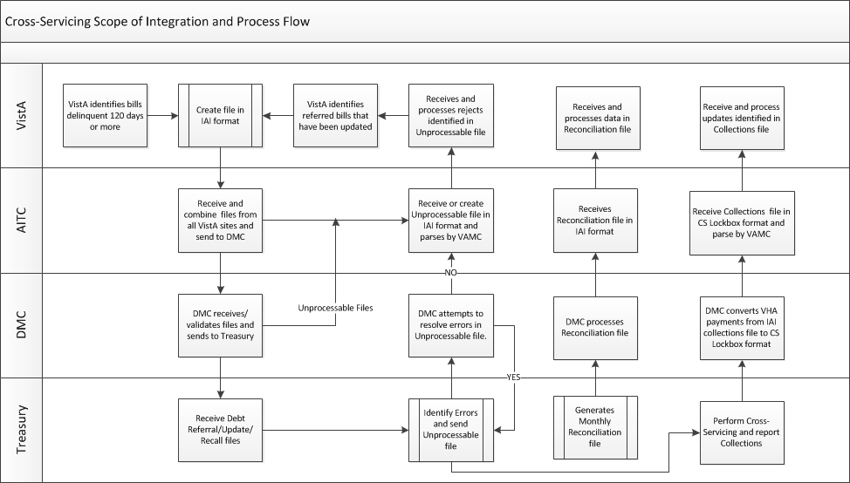

## Integrated Agency Interface (IAI)

Treasury’s Integrated Agency Interface (IAI) file format[1] provides VA with a single file format for submitting multiple record types to Cross-Servicing via the FedDebt system.

For Cross-Servicing, IAI is used to: (1) Refer initial debt / debtor(s), (2) Process financial updates (payments and adjustments), (3) Modify debt / debtor information, (4) Recall a debt / debtor, (5) Receive an Unprocessable Report from Treasury, and (6) Receive the Reconciliation File from Treasury.

Treasury’s Debt Management Services (DMS) processes IAI batch files daily, and provides a comprehensive Unprocessable report to notify VHA that (a) its files have been processed, (b) whether any errors occurred and (c) what those errors are. DMS transmits reports to VA no later than the day after the file processing is complete. VHA receives an IAI Collection File each time DMS transmits an Intra-governmental Payments and Collections (IPAC) transfer for Cross-Servicing collections. This IAI Collection File includes all payment transactions for the specified collection period (refer to *Section 8 Collections: Payment Processing*).

## Type of Debts Referred to Cross-Servicing

The following AR Categories indicate First Party bills to be referred to Cross-Servicing:

1 – Hospital Care (NSC)

2 – Outpatient Care (NSC)

3 – Nursing Home Care (NSC)

24 – C (Means Test)

29 – Rx Co-payment / SC Vet

30 – Rx Co-payment / NSC Vet

31 – Nursing Home Care Per Diem

32 – Hospital Care Per Diem

40 – Adult Day Health Care

41 – Domiciliary

42 – Geriatric Evaluation – Institution

43 – Geriatric Evaluation – Non-institution

44 – Nursing Home Care – LTC

45 – Respite Care – Institution

46 – Respite Care – Non-institution

## Rules for Initially Sending a Debt to Cross-Servicing

All of the following criteria must be true for a debt to be referred to Cross-Servicing:

1. The bill must be delinquent 120 days or more. (Note: This equates to 150 days old or older based on the date value in the “DATE ACCOUNT ACTIVATED” field (#60) in the Accounts Receivable file (#430)).
2. As debts become eligible for Cross-Servicing, they are referred during the next weekly Cross-Servicing batch cycle transmission according to the following station locations and date specifications:

* If the DATE ACCOUNT ACTIVATED (file # 430, 60) is no earlier than February 1, 2015 for stations #598 (Little Rock, AR), #528 (Upstate NY-VISN 2), and #517 (Beckley, WV).
* If the DATE ACCOUNT ACTIVATED (file # 430, 60) is no earlier than August 1, 2015 for all other stations.

1. The Debtor Type must be a First Party bill.
2. The bill status must be *Active*.
3. The Site Deletion Referral Flag for a debtor must be set to ‘blank’ or ‘NO’ in the AR Debtor File (#340).
4. The DMC Referral Flag must be removed from the bill. *DATE SENT TO DMC* field (file #430, 121) must be Null and *DMC Debt Valid* field (file #430,125) must be No or Pending.
5. An individual bill must be equal to or greater than $25.00.
6. If the *Letter3* field under *Collection Follow up Date* on the profile screen does not have a date, the debt will not be referred to Cross-Servicing. VistA generates the ‘TCSP QUALIFIED/NO 3RD LETTER SENT ON MM/DD/YY’ bulletin when there is eligible debt for Cross-Servicing and a third collection letter has not been sent (**Error! Reference source not found.**). Technicians should review the debtor’s account to determine why the third letter has not been sent.

Figure : Bulletin: TCSP Qualified/No 3rd Letter Sent

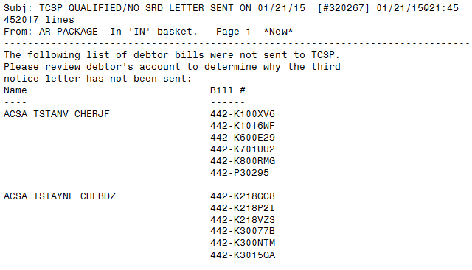

## Debts Not Sent to Cross-Servicing

If any of the following criteria is true, the bill will NOT be referred to Cross-Servicing:

1. Debts where the Debtor has included VA debts in their bankruptcy petition and has provided proof of bankruptcy.
2. Debts where the debtor’s date of death is recorded in VistA.
3. Debt that is in litigation and has been referred to the Department of Justice (DOJ). The software checks to see if the flag is set to “DOJ”. It will not refer a particular bill that is referred to DOJ; however, it can refer other bills by the same debtor that are not flagged as being referred to DOJ.
4. Debt that is in *Offset* status at DMC. DATE SENT TO DMC (#121) would be populated.
5. Debt that has a DMC Debt Valid (#125) field of “No” or “Pending” in the ACCOUNTS RECEIVABLE (#430) file.
6. Debt that is on a repayment plan in VistA.
7. Debt that is in *Suspended* status in the AR system (this includes, but is not limited to, the following: waiver, disputes, bankruptcy).

| **NOTE:** |
| --- |
| Bills that are placed in a *Suspended* status continue to age and gather interest and administrative charges in VistA. If a bill has been suspended and is unsuspended on or after Day 120 of the delinquency (and meets all of the other Cross-Servicing criteria), it will be referred to Cross-Servicing in the next weekly transmission. |

1. The Debtor is an entity or institution (a non-individual).
2. The Debt is less than $25.00.
3. A third collection letter has not been sent.

## Cross-Servicing Fees

The debtor is responsible for paying any and all of the Cross-Servicing offset processing fee(s) from Treasury. Treasury will automatically withhold the offset fee prior to sending the money to VHA. VHA will receive the net amount of the offset. In addition, if a debtor has more than one offset processed on a given day, there will be a fee associated with each offset.

For debt that is continuing to be collected through TOP, the flat fee remains in effect. For all debt referred to Cross-Servicing, Treasury applies an offset fee. Additional fees may be applied if debt is collected through Administrative Wage Garnishment (AWG) or a Private Collection Agency (PCA).

For all questions related to debt that has been referred to Cross-Servicing, please refer the debtor to a Treasury Customer Service Representative at (888) 826-3127.

(*This page left intentionally blank for two-sided printing / copying.*)

# Cross-Servicing Fields & Messages

This section provides an overview of the various messages, symbols, and fields that indicate whether or not a bill has been referred to Cross-Servicing, recalled from Cross-Servicing, or rejected (by AITC, DMC, or Treasury).

The AR profile screens will display the following Cross-Servicing information (click the links below to be taken to the appropriate sub-section):

* **Debt Referred to Cross-Servicing**
* **Debt / Debtor Recalled from Cross-Servicing**
* **Debt Rejected by Cross-Servicing**

The following sub-sections outline the location of the Cross-Servicing information on the AR screens.

## Debt Referred to Cross-Servicing

This section describes the text, fields, and symbols that display on the various AR screens when a debt has been referred to Cross-Servicing.

### Brief Account Profile Screen

From the **Brief Account Profile** screen, a user is able to identify the bills on a debtor’s account that have been referred to Cross-Servicing by the following displays:

If a debtor has at least one bill referred to Cross-Servicing, the following text displays in the header of the screen: “x Debt Referred to Cross-Servicing” and “Total CS Debt” (Figure 3).

In the list of bills that display on a debtor’s account profile, an “x” will display before the Station Number in the *Bill #* column for bills that are at Cross-Servicing.

A historical "y" indicator will be displayed if a Cross-Serviced bill has been recalled or returned from Treasury.

Figure : Brief Account Profile – Debt Referred to Cross-Servicing

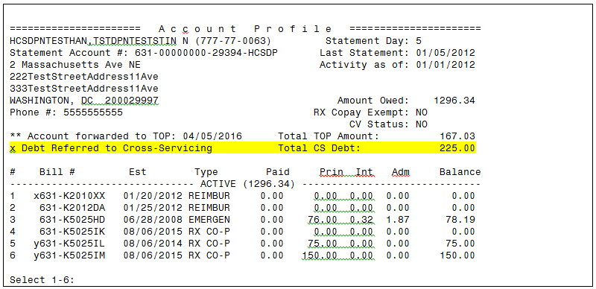

1. Once the bill has been selected from the **Brief Account Profile** screen, the user is directed to the subscreen for that bill. If the bill has been referred to Cross-Servicing, the *CS Referred Date* will display on the sub-screen for that bill below “x Debt Referred to Cross-Servicing” (Figure 4). Note that the *Total CS Debt* in the below figure refers to the total amount of debt referred to Cross-Servicing. All transactions performed on the bill will display including any non-financial cross-servicing audit transactions (marked with “CS”). These transactions provide non-financial information and comments relevant to cross-servicing events that are not otherwise documented in the system.

Figure : Brief Account Profile – Bill Subscreen – CS Referred Date

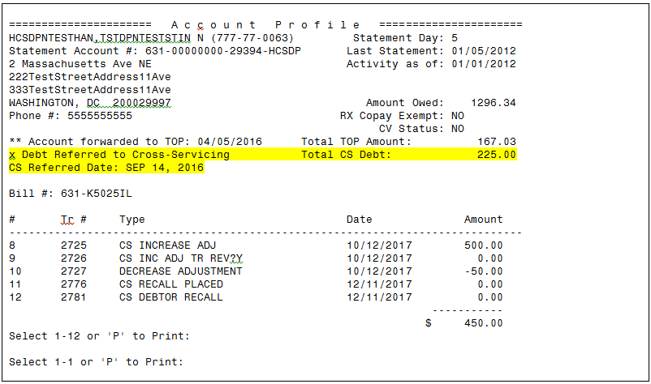

### Full Account Profile Screen

From the **Full Account Profile** screen, a user is able to identify which bills on a debtor’s account have been referred to Cross-Servicing by the same displays as the **Brief Account Profile** screen (refer to *Section 3.1.1 Brief Account Profile Screen*). After a REJECT, the “X” indicator is removed from the bill on the Full Account Profile Screen, Brief Account Profile Screen, and any other screen as appropriate.

### Account Profile – Agent Cashiers Menu

On the **Account Profile** **(AP)** screen, accessed from the **Agent Cashiers Menu**, if a debtor has one or more bills referred to Cross-Servicing, *Debt Referred to Cross-Servicing* and *Total CS Debt* will display immediately after the *TOTAL BALANCE OWED FOR ALL BILLS DISPLAYED* lineof the profile indicating that one or more debts has been forwarded to Cross-Servicing (Figure 5).

| **NOTE:** |
| --- |
| The *Total CS Debt* amount refers to the total amount of debt that has been referred to Cross-Servicing, not the total balance owed for all bills. |

Figure : Account Profile (AP) – Debt Referred to Cross-Servicing

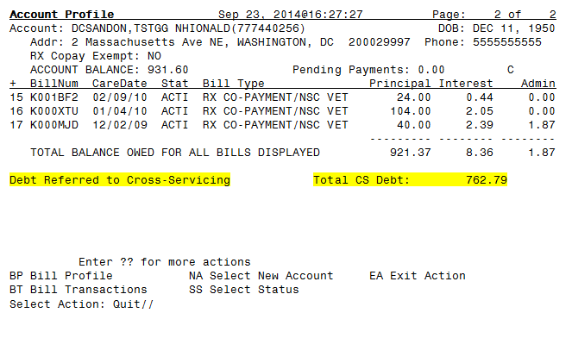

### Bill Profile

On the **Bill Profile (BP)** screen, the *Debt Referred to Cross-Servicing* text displays *before the listing of the charges* on the bill. Below is an example of a Bill Profile screen using the last bill (K000MJD) listed on the Account Profile screen in Figure 5.

Figure : Bill Profile (BP) – Debt Referred to Cross-Servicing

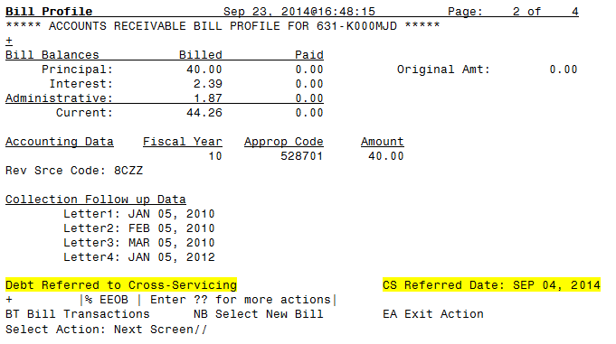

### Profile of Accounts Receivable

On the **Profile of Accounts Receivable** screen, *Debt Referred to Cross-Servicing* will display in the header when one or more bills have been referred to Cross-Servicing.

Figure : Profile of Accounts Receivable – Debt Referred to Cross-Servicing

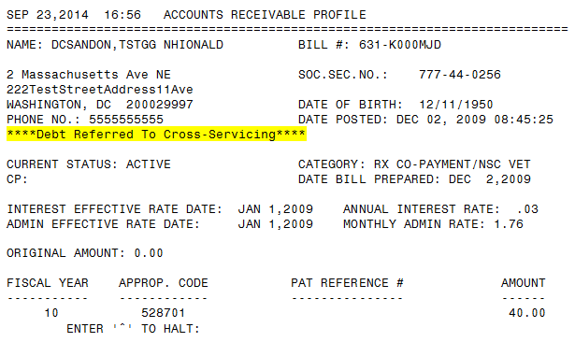

If the selected bill has been referred to Cross-Servicing, the *CS Referred Date* will display below the *CURRENT* balance of the bill and above the *TRANSACTIONS*.

Figure : Profile of Accounts Receivable – CS Referred Date

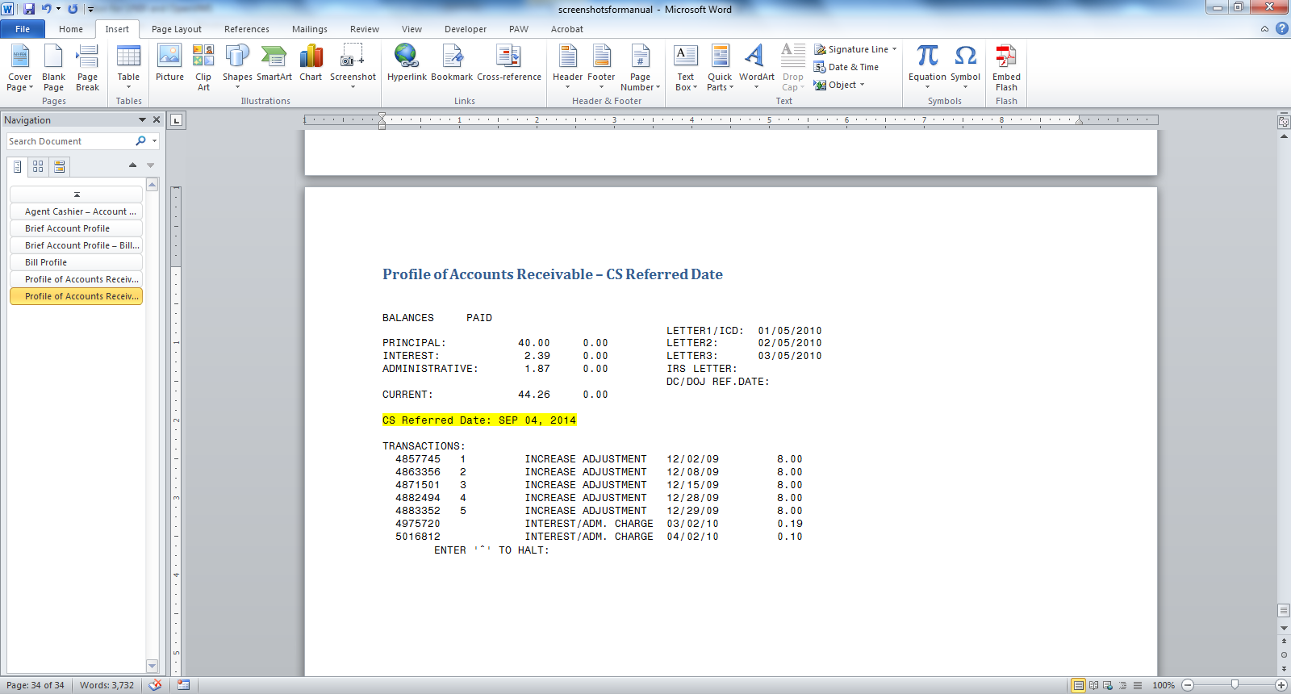

All transactions performed on the bill will display including any non-financial cross-servicing audit transactions (marked with “CS”). These transactions provide non-financial information and comments relevant to cross-servicing events that are not otherwise documented in the system.

Figure : Profile of Accounts Receivable – “CS” Transactions Display

TRANSACTIONS:

5600148 1 INCREASE ADJUSTMENT 08/25/16 8.00

5600149 2 DECREASE ADJUSTMENT 10/17/16 -8.00

*5601851 CS RECALL PLACED 09/25/17 0.00

5601859 CS INCREASE ADJ 09/25/17 10.00

*5601860 CS INC ADJ TR REV?N 09/25/17 0.00

5601861 ADMIN.COST CHARGE 09/25/17 3.30

*5601862 CS ADMIN ADJ TR REV?N 09/25/17 0.00

ENTER '^' TO HALT:

## Debt / Debtor Recalled from Cross-Servicing

This section describes the text and fields that display on the various AR screens when a debt has been recalled from Cross-Servicing.

### Brief Account Profile Screen

From the **Brief Account Profile** screen, a user is able to identify the bills that have been either automatically recalled from Cross-Servicing (due to the debt balance dropping below $25 and where there has been no activity in 365 days or more) or manually recalled from Cross-Servicing. Note that VistA automatically applies the Recall Reason, “Agency is Forgiving Debt”, to all of the automatically recalled bills.

Once a bill or debtor has been recalled, the Cross-Servicing referred information is deleted from the bill, as described below:

* Once the bill has been recalled from Cross-Servicing, and only if the debtor has no other bills referred to Cross-Servicing, the “x Debt Referred to Cross-Servicing” and “Total CS Debt” will no longer display.
* In the list of bills that display on a debtor’s account profile, the “x” will be replaced by “y” before the Station Number in the *Bill #* column.

Also, the *CS Recall Reason* and *CS Recall Date* will display on Page 2 of the **Brief Account Profile** screen above the Bill # (Figure 9).

All transactions performed on the bill will display including any non-financial cross-servicing audit transactions (marked with “CS”). Recalls placed and processed recall transactions will display.

| **NOTE:** |
| --- |
| If a debtor has more than one bill referred to Cross-Servicing, and only one of the bills has been recalled, the *x Debt Referred to Cross-Servicing* and the *Total CS Debt* will continue to display in the header on the Brief and Full Account Profile screens. The *Total CS Debt* refers to the total amount of all debt referred to Cross-Servicing. |

Figure : Brief Account Profile – CS Recall Reason & CS Recall Date

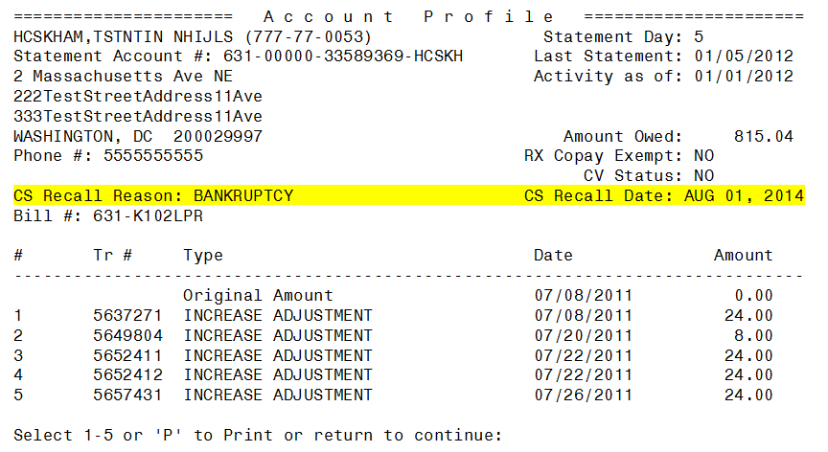

### Full Account Profile Screen

From the **Full Account Profile** screen, a user is able to identify which bills on a debtor’s account have been recalled from Cross-Servicing by the same displays as the **Brief Account Profile** screen (refer to the previous section).

### Bill Profile

On the **Bill Profile** (BP) screen, the *CS Recall Reason and CS Recall Date* displays on Page 2 after the *Collection Follow up Data* on the bill.

Figure : Bill Profile (BP) – Debt Recalled from Cross-Servicing

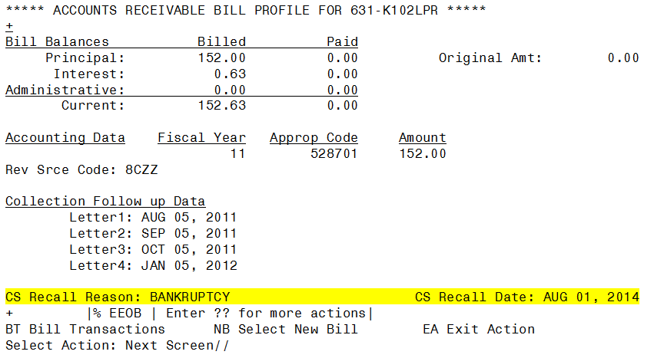

### Profile of Accounts Receivable

On the **Profile of Accounts Receivable** screen, the *CS Recall Reason* and *CS Recall Date* will display in the header when a bill or debtor has been recalled from Cross-Servicing.

All transactions performed on the bill will display including any non-financial cross-servicing audit transactions (marked with “CS”). Recalls placed and processed recall transactions will display.

Figure : Profile of Accounts Receivable – Debtor Recalled from Cross-Servicing

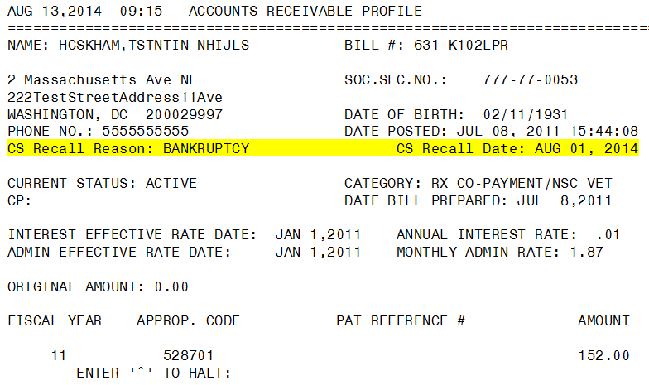

## Debt Rejected by Cross-Servicing

Once a debt is rejected by Cross-Servicing, the referral information is deleted from the debt (refer to *Section 9 Cross-Servicing Rejects*). VistA maintains a historical record of the rejects by adding the reject code, reject reason, reject date, and reject sourceto the various profile screens.

| **NOTE:** |
| --- |
| The reject code, reason, date, and source remain on the screen even after the error is corrected. |

This section describes the fields that display on the various AR screens when a debt has been rejected by Cross-Servicing.

### Brief Account Profile Screen

Once a debt has been rejected, the Cross-Servicing referred information is deleted from the debt. The following information will display below the header on the **Brief Account Profile** screen: “CS Rejects” with the Reject Date, Reject Code, Source, (Source Codes: A=AITC; D=DMC; T=Treasury), and Reject Reason(s).

Figure : Brief Account Profile – Debt Rejected by Cross-Servicing

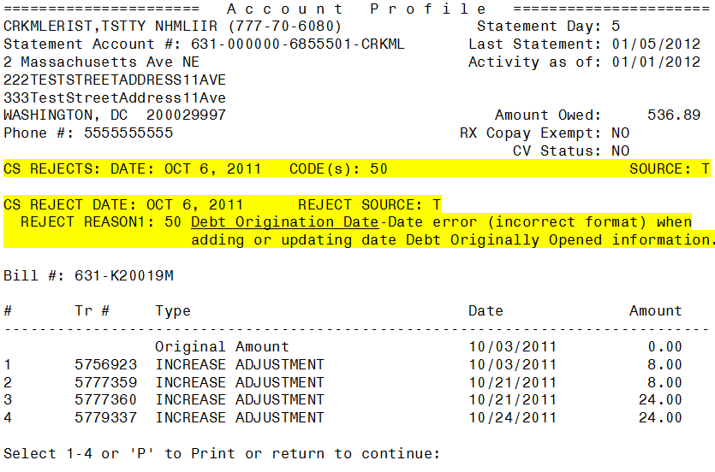

### Full Account Profile Screen

From the **Full Account Profile** screen, a user is able to identify which bills on a debtor’s account have been rejected by Cross-Servicing by the same displays as the **Brief Account Profile** screen (refer to the previous section). The “**x**” indicator is removed from the bill.

### Bill Profile

On the **Bill Profile** (BP) screen, the reject information displays on Page 2 after the *Collection Follow up Data* on the bill (Figure 13).

Figure : Bill Profile (BP) – Debt Rejected by Cross-Servicing

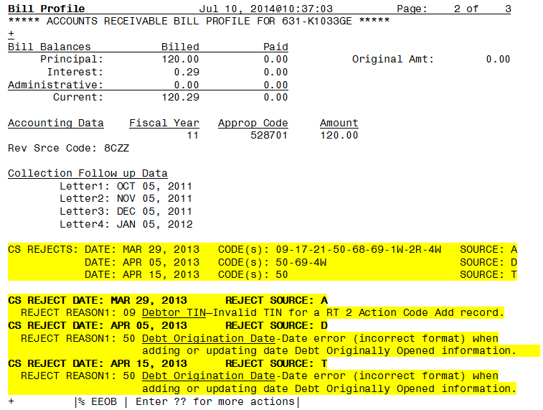

### Profile of Accounts Receivable

On the **Profile of Accounts Receivable** screen, the reject informationdisplays below the header.

Figure : Profile of Accounts Receivable – Debt Rejected by Cross-Servicing

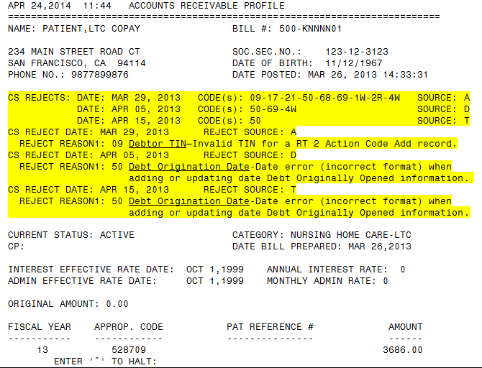

(*This page left intentionally blank for two-sided printing / copying.*)

# Cross-Servicing Options

There are a number of VistA options that users can utilize related to Cross-Servicing activities, including seven reports, the ability to recall a bill or debtor and to place a stop on a bill. Each option is listed below. All of the options are accessed from the **Cross-Servicing Menu [RCTCSP MENU]**. For each option, detailed VistA steps are provided in this section.

* **Bill Recall/Reactivate TCSP Referral [RCTCSP RECALLB]:** Recall a bill from being referred to Cross-Servicing or reactivate a bill (remove the recall flag) that has been recalled (before the Recall Batch Job runs).
* **Cross-Servicing Bill Report [RCTCSP BILL REPORT]:** For a selected debtor, all bills that have been referred to Cross-Servicing, and the date that each bill was referred.
* **Cross-Servicing Recall Report [RCTCSP RECALL REPORT]:** Bills that have been recalled from Cross-Servicing and the date each bill was recalled.
* **Cross-Servicing Stop Reactivate Report [RCTCSP STOP REACTIVATE REPORT]:** The Cross-Servicing Stop Reactivate Report lists the bills that have been stopped from Cross-Servicing, or Reactivated, or Both. The user may select a range of Debtors or all Debtors, and a range of dates or all dates. Excel CSV output is also supported.
* **Debt Referral Reject Report [RCTCSP REJECT REPORT]:** Rejected bills from the Unprocessable files from AITC, DMC, and Treasury, and the date, error code, and reason(s) the bill was rejected.
* **Debtor Recall/Reactivate TCSP Referral [RCTCSP RECALLD]:** Recalls all bills referred to Cross-Servicing at the same time for the selected debtor.
* **List IAI Error Codes [RCTCSP IAI ERROR CODES LIST]:** Reference list of the Cross-Servicing error codes, the field name / action, the record type, and error message.
* **Print Cross-Servicing Report [RCTCSP REPORT]:** Current balance of all bills referred to Cross-Servicing and the date the bills were referred. This report provides the option to sort by bill number, debtor name, or the referral date.
* **Reconciliation Report - Cross-Servicing [RCTCSP RECONCIL REPORT]:** Bills / debtors that have been returned by Treasury for reconciliation.
* **Reconciliation List Manager [RCTCSP RECONCILIATION WORKLIST]:** List Manager for VistA AR Cross-servicing reconciliation. This option is used to work debts that are returned from Treasury.**Stop/Reactivate TCSP Referral for a Bill [RCTCSP STOP]:** Stop a bill in VistA from being referred to Cross-Servicing or updates on the bill from being transmitted; also, use this functionality to remove the ‘Stop’ flag (reactivate).
* **TCSP Flag Control [RCDP TCSP FLAG CONTROL]:** The options included in this menu are used to correct the bill or debtor data attributes (or flags) as needed because of a variance in the bill or debtor data between the VistA system and the Treasury system.  This menu option was introduced with Accounts Receivable patch, PRCA*4.5*325. This menu option is locked with security key RCDP TCSP FLAG.

This option will allow TCSP flag control to the following options:

* 1. Set cross-service flag on BILL
  2. Clear cross-service flag on BILL
  3. Clear cross-service flag on DEBTOR (AND ALL BILLS)
  4. Set cross-service flag on DEBTOR
  5. Fully re-establish debtor/bill as cross-serviced
* **Treasury Cross-Servicing IAI Report [RCTCSP IAI REPORT]:** This report displays a record of current VHA bills at Treasury. It is a tool that can be used to identify bills erroneously listed in a referral status in VistA when reconciled with the Print Cross-Servicing Report.

| **NOTE:** |
| --- |
| Refer to *Section 3* *Cross-Servicing Fields & Messages* for a description of the various screens where Cross-Servicing referrals, recalls, and reject information displays. |

## Report Options

This sub-section describes the seven Cross-Servicing reports accessed from the **Cross-Servicing Menu**.

### Cross-Servicing Bill Report

The **Cross-Servicing Bill Report** lists all of the bills that have been referred to Cross-Servicing for a debtor. The report lists the bill number (*BILL NO.*), status code (*ST*), the original amount of the bill (*ORIG AMT*), the current amount of the bill (*CURR AMT*), the principle (*PRIN*), interest (*INT*), administrative fees (*ADMIN*), court fees (*COURT*), and the date the bill was referred to Cross-Servicing (*CS REF DATE*). Additionally, the header of the report contains the total amount of all debt referred to Cross-Servicing for the debtor (*CURRENT CS DEBT*).

1. At the **Select Cross-Servicing Menu Option:** prompt, enter the option: **Cross-Servicing Bill Report** or **RCTCSP BILL REPORT**.
2. Enter the debtor’s name at the **Select AR Debtor:** prompt.
3. Finally, a prompt displays asking to **CAPTURE report data to an Excel document?? NO//**

The default is (N)o.

If (Y)es is entered, the following message displays:

**To capture as an Excel format, it is recommended that you queue this report to a spool device with margins of 256 and page length of 99999 (e.g., spoolname;256;99999). This should help avoid wrapping problems.**

**Another method would be to set up your terminal to capture the detail report data. On some terminals, this can be done by invoking 'Logging' or clicking on the 'Tools' menu above, then click on 'Capture Incoming Data' to save to Desktop. To avoid undesired wrapping of the data saved to the file, change the DISPLAY screen width size to 132 and you can enter '0;256;99999' at the 'DEVICE:' prompt.**

| **NOTE:** |
| --- |
| To avoid undesired wrapping of the data saved to the file, enter '0;256;999' at the 'DEVICE:' prompt. |

1. To queue the report to a MailMan message, at the DEVICE prompt enter the letter ‘Q’:

DEVICE: QUEUE TO PRINT ON

DEVICE: HFS FILE => MESSAGE

Subject: [Enter message subject]

Select one of the following:

M Me

P Postmaster

From whom: Me//

Send mail to: CSUSER,ONE // CSUSER,ONE (default will display here)

Select basket to send to: IN//

And Send to:

Requested Start Time: NOW// (Enter time to run report. NOW is the default)

Report compilation has started with task# 999999.

1. Otherwise, press [Enter] to view the complete report.
2. The list of bills for the debtor will display in ascending order by bill number (Figure 15).

Figure : Cross-Servicing Bill Report

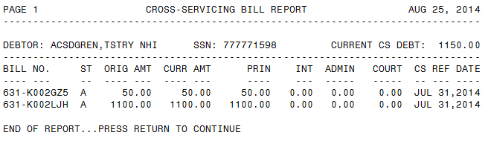

### Cross-Servicing Recall Report

The **Cross-Servicing Recall Report** lists the bills that have been recalled from Cross-Servicing. The user has the option of sorting the report by bill number or debtor name. The report includes the bill number (*BILL NO.),* the debtor’s name (*DEBTOR*), the Pt ID (first initial last name, last four of *SSN*), the amount recalled from Cross-Servicing (*RECL AMT*), the date of the recall (*RECL DATE*), the reason for the recall (*RECALL RSN*) and user (USER ID). The USER ID is the name of person who placed the recall or POSTMASTER after the batch process has run.

1. At the **Select Cross-Servicing Menu Option:** prompt, enter: **Cross-Servicing Recall Report** or **RCTCSP RECALL REPORT**.
2. Choose to sort the report by bill number or debtor’s name by entering 1 [Bill Number] or 2 [Debtor Name] at the **Select one of the following:** prompt.
3. A prompt displays asking to **CAPTURE report data to an Excel document?? NO//**

The default is (N)o.

If (Y)es is entered, the following message displays:

**To capture as an Excel format, it is recommended that you queue this report to a spool device with margins of 256 and page length of 99999 (e.g., spoolname;256;99999). This should help avoid wrapping problems.**

**Another method would be to set up your terminal to capture the detail report data. On some terminals, this can be done by invoking 'Logging' or clicking on the 'Tools' menu above, then click on 'Capture Incoming Data' to save to Desktop. To avoid undesired wrapping of the data saved to the file, change the DISPLAY screen width size to 132 and you can enter '0;256;99999' at the 'DEVICE:' prompt.**

| **NOTE:** |
| --- |
| To avoid undesired wrapping of the data saved to the file, enter '0;256;999' at the 'DEVICE:' prompt. |

1. To queue the report to a MailMan message, at the DEVICE prompt enter the letter ‘Q’:

DEVICE: QUEUE TO PRINT ON

DEVICE: HFS FILE => MESSAGE

Subject: [Enter message subject]

Select one of the following:

M Me

P Postmaster

From whom: Me//

Send mail to: CSUSER,ONE // CSUSER,ONE (default will display here)

Select basket to send to: IN//

And Send to:

Requested Start Time: NOW// (Enter time to run report. NOW is the default)

Report compilation has started with task# 999999.

1. Otherwise, press [Enter] to view the complete report.
2. The list of bills recalled from Cross-Servicing at the time of the report output will display according to the sort option selected (Figure 16).

| **NOTE:** |
| --- |
| Once a debt has been manually flagged in VistA for recall from Cross-Servicing, the bill number, debtor’s name, patient ID, user ID and recall reason will display in the Recall Report, however, the recall amount and recall date will not display until after the Recall Batch Job has processed (the User ID in this case will be POSTMASTER). |

Figure : Cross-Servicing Recall Report (Sorted by Bill Number)

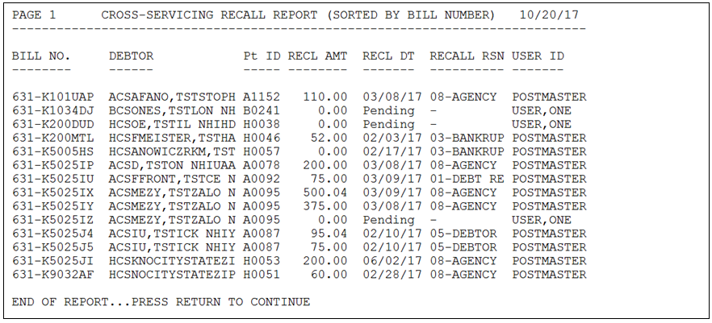

### Cross-Servicing Stop Reactivate Report

The **Cross-Servicing Stop Reactivate Report** **[RCTCSP STOP REACTIVATE REPORT]** lists the bills that have been stopped from Cross-Servicing, or Reactivated, or Both. The user may select a range of Debtors or all Debtors, and a range of dates or all dates.

1. From the Cross-Servicing Menu, enter: **Cross-Servicing Stop Reactivate Report or RCTCSP STOP REACTIVATE REPORT**.
2. Select one of the following:

C Currently Flagged

R Reactivated

B Both

Run the Report for: B// oth

1. Start with Debtor: FIRST//

Go to Debtor: LAST//

1. Select one of the following:

A All Dates

R Date Range

Include All Dates or Select by Date Range: Date Range//

Date Entered From: 010117 (JAN 01, 2017)

Date Entered To: T// 123117 (DEC 31, 2017)

1. A prompt displays asking to **CAPTURE report data to an Excel document? NO//**

The default is (N)o.

If (Y)es is entered, the following message displays:

**To capture as an Excel format, it is recommended that you queue this report to a spool device with margins of 256 and page length of 99999 (e.g., spoolname;256;99999). This should help avoid wrapping problems.**

**Another method would be to set up your terminal to capture the detail report data. On some terminals, this can be done by invoking 'Logging' or clicking on the 'Tools' menu above, then click on 'Capture Incoming Data' to save to Desktop. To avoid undesired wrapping of the data saved to the file, change the DISPLAY screen width size to 132 and you can enter '0;256;99999' at the 'DEVICE:' prompt.**

| **NOTE:** |
| --- |
| To avoid undesired wrapping of the data saved to the file, enter '0;256;999' at the 'DEVICE:' prompt. |

1. To queue the report to a MailMan message, at the DEVICE prompt enter the letter ‘Q’:

DEVICE: QUEUE TO PRINT ON

DEVICE: HFS FILE => MESSAGE

Subject: [Enter message subject]

Select one of the following:

M Me

P Postmaster

From whom: Me//

Send mail to: CSUSER,ONE // CSUSER,ONE (default will display here)

Select basket to send to: IN//

And Send to:

Requested Start Time: NOW// (enter time to run report), NOW is the default.

Otherwise, press [Enter] at the DEVICE prompt.

Figure : Cross-Servicing Stop Reactivate Report

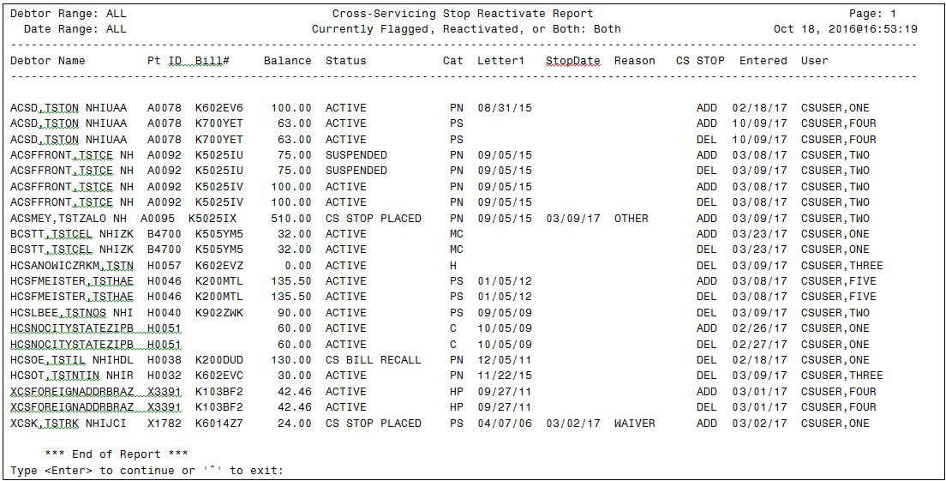

### Debt Referral Reject Report

The **Debt Referral Reject Report** lists the rejected bills by Debtor Name from the Unprocessable Files from AITC, DMC, and Treasury (where applicable). The report includes the bill number (*BILL #*), debtor’s name (*DEBTOR*), SSN, the record type (*TYP*), action code (*ACTNCD*), reject date (*REJECT DATE*), the source of the reject (*SRC*), and the error codes (*ERROR CODES*) (refer to *Section 4.1.4.1 List of IAI Error Codes*). For the detailed report, the reject reasons associated with the error codes will also display.

1. From the Cross-Servicing Menu, enter: **Debt Referral Reject Report** or **RCTCSP REJECT REPORT**.
2. Enter the date range of the report at the following prompt:

**FROM: T-7//**

**TO: T//**

Dates can be in MMDDYYYY (10272014) or MMM DD, YYYY (OCT 27, 2014) format.

Note that the default date range is a one-week timeframe from the day the report is being run.

1. At the **Group Error Codes: Brief or Detail: (B/D):B//** prompt, choose between Brief and Detail. Note that the default is Brief. The descriptions of each are below:

* If (**B**)rief, all error codes for a bill will be concatenated into one string and displayed with a single bill without error descriptions. One line per bill with a sum of all of the error codes.
* If (**D**)etail, each error code will be accompanied by an error description. Thus, there may be multiple lines per bill.

1. Select how to sort the report at the **Sort by:1//**  prompt, choosing one of the following. (The default is by Bill Number.)

**1 Bill Number**

**2 Debtor Name**

**3 CS Reject Date**

1. Once the primary sort is selected, an **Include Only: AITC, DMC, TREASURY or 'ALL': (A/D/T/ALL): ALL//** prompt displays for a secondary sort of the reject source. Choose from the following:

(**A**)ITC: Rejects from AITC

(**D**)MC: Rejects from DMC

(**T**)reasury: Rejects from Treasury

(**ALL**): Rejects from all sources (Default)

1. Next, choose the sort order of the report **(A)scending** or **(D)escending**. Note that the default is (A)scending.
2. If the Detail option is selected, the Excel prompt will not display. If the Brief option is selected, a prompt displays asking to **CAPTURE report data to an Excel document?? NO//**

The default is (N)o.

If (Y)es is entered, the following message displays:

**To capture as an Excel format, it is recommended that you queue this report to a spool device with margins of 256 and page length of 99999 (e.g., spoolname;256;99999). This should help avoid wrapping problems.**

**Another method would be to set up your terminal to capture the detail report data. On some terminals, this can be done by invoking 'Logging' or clicking on the 'Tools' menu above, then click on 'Capture Incoming Data' to save to Desktop. To avoid undesired wrapping of the data saved to the file, change the DISPLAY screen width size to 132 and you can enter '0;256;99999' at the 'DEVICE:' prompt.**

| **NOTE:** |
| --- |
| To avoid undesired wrapping of the data saved to the file, enter '0;256;999' at the 'DEVICE:' prompt. |

1. To queue the report to a MailMan message, at the DEVICE prompt, enter the letter ‘Q’:

DEVICE: QUEUE TO PRINT ON

DEVICE: HFS FILE => MESSAGE

Subject: [Enter message subject]

Select one of the following:

M Me

P Postmaster

From whom: Me//

Send mail to: CSUSER,ONE // CSUSER,ONE (default will display here)

Select basket to send to: IN//

And Send to:

Requested Start Time: NOW// (Enter time to run report. NOW is the default)

Report compilation has started with task# 999999.

1. The report will display based on the selected parameters in the previous steps (refer to the figures below for samples of the **Debt Referral Reject Report**).

Figure : Debt Referral Reject Report (Brief – Treasury - Sorted by Bill Number)

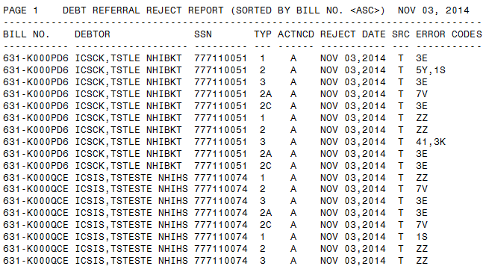

### List of IAI Error Codes

To accompany the **Debt Referral Reject Report**, the **Cross-Servicing Menu** also contains the **List of IAI Error Codes** option. Selecting this option lists the various error codes that will display in the **Debt Referral Reject Report**. In addition to the error codes, the list contains the field name / action, record type, and error message (Figure 19).

To queue the report to a MailMan message, at the DEVICE prompt enter the letter ‘Q’:

DEVICE: QUEUE TO PRINT ON

DEVICE: HFS FILE => MESSAGE

Subject: [Enter message subject]

Select one of the following:

M Me

P Postmaster

From whom: Me//

Send mail to: CSUSER,ONE // CSUSER,ONE (default will display here)

Select basket to send to: IN//

And Send to:

Requested Start Time: NOW// (Enter time to run report. NOW is the default)

Report compilation has started with task# 999999.

Otherwise, press [Enter] at the DEVICE prompt.

Refer to *Appendix B. Cross-Servicing IAI Error* Codes for a complete list of the error codes.

Figure : List of IAI Error Codes (Codes 10 – 17)

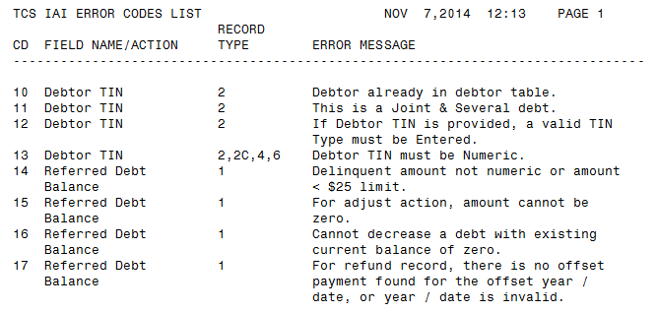

### Print Cross-Servicing Report

The **Print Cross-Servicing Report** provides the current balance of all bills referred to Cross-Servicing. The report output contains the bill number (*BILL NO*.), the debtor’s name (*DEBTOR*), the *SSN*, the original amount of the bill (*ORIG AMT*), the date the bill was referred to Cross-Servicing (*CS REF DT*), and the current amount of the bill (*CURR DEBT*).

1. At the **Select Cross-Servicing Menu Option:** prompt, enter: **Print Cross-Servicing Report** or **RCTCSP REPORT**.
2. Select to sort the report by bill number, debtor name, or the date the bill was referred to Cross-Servicing by entering **1** [Bill Number], **2** [Debtor Name], or **3** [CS Referred Date] at the **Select one of the following:** prompt.
3. To queue the report to a MailMan message, at the DEVICE prompt enter the letter ‘Q’:

DEVICE: QUEUE TO PRINT ON

DEVICE: HFS FILE => MESSAGE

Subject: [Enter message subject]

Select one of the following:

M Me

P Postmaster

From whom: Me//

Send mail to: CSUSER,ONE // CSUSER,ONE (default will display here)

Select basket to send to: IN//

And Send to:

Requested Start Time: NOW// (Enter time to run report. NOW is the default)

Report compilation has started with task# 999999.

1. Otherwise, press [Enter] to view the complete report.
2. A list of all bills referred to Cross-Servicing at the time the report was run will display according to the sort option selected (Figure 17.)

Figure : Print Cross-Servicing Report (Sorted by Bill Number)

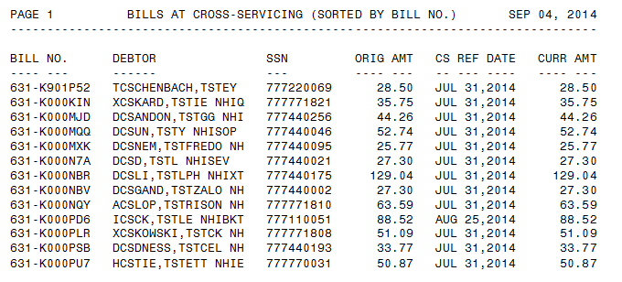

### Reconciliation Report – Cross-Servicing

The **Reconciliation Report - Cross-Servicing [RCTCSP RECONCIL REPORT]** lists all of the debt that has been returned from Cross-Servicing by Treasury for reconciliation. The report columns include the debtor’s name (*DEBTOR*), bill number (*BILL NO.*), and the returned and closed date. The report also includes the return reason description and any required supporting information required (refer to the following sub-sections).

1. From the Cross-Servicing Menu, enter: **Reconciliation Report** or **RCTCSP RECONCILIATION REPORT**.
2. Enter the date range of the report at the following prompt:

**FROM: T-30//**

**TO: T//**

Dates can be in MMDDYYYY (10272014) or MMM DD, YYYY (OCT 27, 2014) format.

Note that the default date range is a one-month timeframe from the day the report is being run.

1. A prompt displays asking to **CAPTURE report data to an Excel document? NO//**

The default is (N)o.

If (Y)es is entered, the following message displays:

**To capture as an Excel format, it is recommended that you queue this report to a spool device with margins of 256 and page length of 99999 (e.g., spoolname;256;99999). This should help avoid wrapping problems.**

**Another method would be to set up your terminal to capture the detail report data. On some terminals, this can be done by invoking 'Logging' or clicking on the 'Tools' menu above, then click on 'Capture Incoming Data' to save to Desktop. To avoid undesired wrapping of the data saved to the file, change the DISPLAY screen width size to 132 and you can enter '0;256;99999' at the 'DEVICE:' prompt.**

| **NOTE:** |
| --- |
| To avoid undesired wrapping of the data saved to the file, enter '0;256;999' at the 'DEVICE:' prompt. |

1. To queue the report to a MailMan message, at the DEVICE prompt enter the letter ‘Q’:

DEVICE: QUEUE TO PRINT ON

DEVICE: HFS FILE => MESSAGE

Subject: [Enter message subject]

Select one of the following:

M Me

P Postmaster

From whom: Me//

Send mail to: CSUSER,ONE // CSUSER,ONE (default will display here)

Select basket to send to: IN//

And Send to:

Requested Start Time: NOW// (Enter time to run report. NOW is the default)

Report compilation has started with task# 999999.

1. Otherwise, press [Enter] to view the complete report.
2. The Reconciliation Report will display (Figure 20).

Figure : Print Reconciliation Report

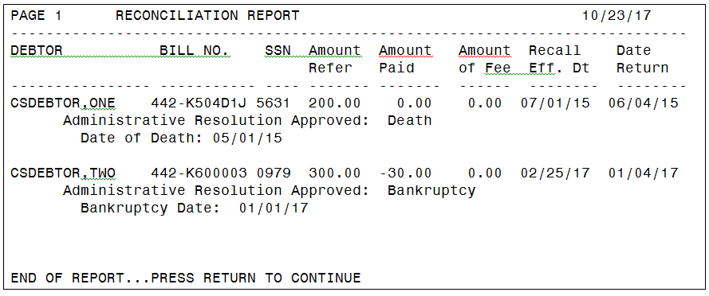

#### Compromise Offer

If the Return Reason Code = ‘P’ and the Compromise Indicator = ‘Y’ is sent in the Reconciliation IAI file, then a Compromise Amount will also be included to identify the amount that is not collected. The Reconciliation Report will display the Return Reason Code as ‘Satisfied PA – Paid in Full or Compromised’, a secondary note stating ‘Compromise, Please write this bill off by the manual process’, and the compromise amount that has not been collected and is to be written off manually.

#### Bankruptcy

If the Return Reason Code = ‘B’ is sent, then the Bankruptcy Date will also be included. The Reconciliation Report will display the Return Reason Code as ‘Administrative Resolution Approved for Bankruptcy’ and the Bankruptcy Date.

#### Death

If the Return Reason Code = ‘D’ is sent, then the Date of Death will be included. The Reconciliation Report will display the Return Reason Code as ‘Administrative Resolution Approved for Death’ and the Date of Death.

#### Other Returned Reasons

The following Return Reason Codes may also be returned in the Reconciliation file from Treasury.

**Z** Uncollectable

**W** Administrative Resolution Approved for Inability to Pay

**E** Administrative Resolution Approved for Entity out of Business

**T** CA Agrees – Complaint – Stop Collection Activity

**Y** CA Agrees – Debt amount is incorrect – Stop Collection Activity

**C** CA Agrees – Congressional Dispute – Stop Collection Activity

**M** CA Agrees – Miscellaneous Dispute – Stop Collection Activity

**G** CA Agrees – Wrong Debtor – Stop Collection Activity

**V** CA Agrees – Previously Paid – Stop Collection Activity

**H** CA Agrees – Previously Resolved – Stop Collection Activity

**X** Dispute Timer Expired

**F** Paid in Full (Outside of a Payment Agreement)

**S** System Compromised (balance below $25)

**R** Recalled (Note: Once a bill is recalled from Cross-Servicing, it cannot be re-referred.)

**A** Manually Returned to Agency

**N** Proof of Debt documentation not provided – Stop Collection Activity

**Q** Proof of Debt Timer Expired

### Treasury Cross-Servicing IAI Report

The **Treasury Cross-Servicing IAI Report [RCTCSP IAI REPORT]**  displays a record of current VHA bills at Treasury. It is a tool that can be used to identify bills erroneously   
listed in a referral status in VistA when reconciled with the Print Cross-Servicing Report.

1. Select Cross-Servicing Menu <TEST ACCOUNT> Option: TREASury Cross-Servicing IAI Report

Select one of the following:

1 06/03/17

2 05/30/17

Print IAI report date?: 1// 06/03/17

1. CAPTURE Report data to an Excel Document? NO//
2. To queue the report to a MailMan message, at the DEVICE prompt, enter the letter ‘Q’:

DEVICE: QUEUE TO PRINT ON

DEVICE: HFS FILE => MESSAGE

Subject: [Enter message subject]

Select one of the following:

M Me

P Postmaster

From whom: Me//

Send mail to: CSUSER,ONE // CSUSER,ONE (default will display here)

Select basket to send to: IN//

And Send to:

Requested Start Time: NOW// (Enter time to run report. NOW is the default)

Report compilation has started with task# 999999.

Otherwise, press [Enter] at the DEVICE prompt.

Figure : Treasury Cross-Servicing IAI Report

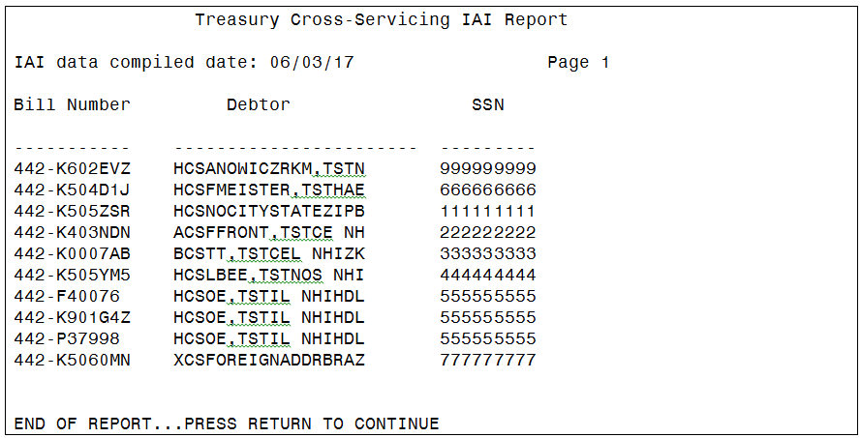

## Recall/Reactivate TCSP Referrals

The **Recall/Reactivate TCSP Referral** options are used to recall a debt or debtor (all debt for the debtor) from Cross-Servicing. Once a bill is recalled from Cross-Servicing, the bill will no longer be eligible for re-referral. This is due to Treasury’s technical inability to handle re-referred debt, following the recall.

| **NOTE:** |
| --- |
| Once a bill is flagged to be recalled from Cross-Servicing and the Recall Batch Job has run, the bill will no longer be eligible for re-referral to Cross-Servicing. A message will display indicating that reactivation (removing the recall flag) is not available. |

The table below provides the scenarios for when the recall debt / debtor functionality should be used for debt referred to Cross-Servicing, the recall reason, and the action in VistA.

The following sub-sections outline the steps for recalling a debt / debtor from Cross-Servicing.

Table : Recall Scenarios for Cross-Serviced Debt

| **Scenario** | **Recall Reason To Use** | **VistA Action** |
| --- | --- | --- |
| Bankruptcy | 03 – Bankruptcy with Automatic Stay | Cancel Copayment (Suspend Copayment) |
| Debtor Deceased | 06 – Debtor is Deceased | Termination of debt when reclamation requirements are met |
| Debtor Disabled / Inability to Pay | 05 – Debtor is Disabled with the Inability to Pay | Termination of debt or write-off when it’s deemed that further collection activity will not be successful or not cost effective |
| Hardship / Waiver determined in favor of debtor | 07 – Agency is Forgiving Debt | Cancel Copayment (Waive Debt) |
| If DMC sets up an offset of VA benefits after a debt has been referred to Cross-Servicing, and the Veteran requests to be removed from the Cross-Servicing process, and VA can collect the full debt within three years through internal offset. | 08 – Agency can collect through internal offset | Enter DMC LESSER AMOUNT |
| Other | 01 – Debt Referred in Error | Add Debtor Comment Explanation |
| Service-Connected Determination or Adjudication | 01 – Debt Referred in Error | Reset Pharmacy or Cancel Copayment |

### Recall TCSP Referral for a Bill

Once a week, VistA automatically recalls bills that are less than $25 and have had no payment activity in 365 days or more or have been Cancelled. When bills are automatically recalled, the Recall Reason of “07 - Agency is Forgiving Debt” is automatically added as the Recall Reason.

In addition to the automatic recalls, the Cross-Servicing functionality allows for the manual recall of bills referred to Cross-Servicing. Manual recalls are performed using the **Bill** **Recall/Reactivate TCSP Referral [RCTCSP RECALLB]** option. This option is a toggle that flags the bill to be recalled the next time the Recall Batch Job runs. Once the Recall Batch Job runs, the Cross-Servicing referred information on the profile screens for that bill is deleted, and the bill is no longer eligible for re-referral to Cross-Servicing. Where required, and before the Recall Batch Job runs, use the option again to delete the “recall flag”.

| **NOTE:** |
| --- |
| Once a bill is manually recalled, VistA automatically calculates and applies all administrative fees and interest to the recalled bill, from the CS Referred Date to the CS Recall Date. This does NOT apply to those bills that have been automatically recalled due to no payment activity in 365 days or more and if a bill is less than $25. |

The steps below outline the prompts for manually recalling a bill from Cross-Servicing:

1. From the **Cross-Servicing Menu**, enter: **BILL RECALL/REACTIVATE TCSP REFERRAL** or **RCTCSP RECALLB**.
2. Enter the bill number at the **ACCOUNTS RECEIVABLE BILL NO.** prompt.
3. The following confirmation message will display: **Are you sure you want to set this bill to be recalled from Cross-Servicing?**
4. Enter: **Y** for “Yes”.
5. The next step is to enter the reason for the recall at the **TCSP Recall Reason** prompt.

The available reasons for recalling a bill include the following:

**01 DEBT REFERRED IN ERROR**

**07 AGENCY IS FORGIVING DEBT**

**08 AGENCY CAN COLLECT THROUGH INTERNAL OFFSET**

1. After you have entered the reason for recall, the following confirmation displays: **Setting this bill for Recall from Cross-Servicing is complete.**
2. Using this functionality flags the bill to be recalled from Cross-Servicing when the next Recall Batch Job runs.
3. When the Recall Batch Job runs, a confirmation message will be transmitted through MailMan with the Subject line: **CS RECALLS SENT ON [MM/DD/YYYY]**
4. Once the batch process is complete, the Cross-Servicing-referred information for this bill will be deleted from the profile screens. Also, the Recall Reason and Recall Date will display on the following screens (refer to *Section 3 Cross-Servicing Fields & Messages* for the location of the Recall Reason and Recall Date on the following screens):
   * Full Account Profile (bill sub-screen for the recalled bill)
   * Brief Account Profile (bill sub-screen for the recalled bill)
   * Profile of Accounts Receivable
   * Bill Profile
   * Account Profile (from **Agent Cashiers Menu**)

| **NOTE:** |
| --- |
| Recalling all of the bills referred to Cross-Servicing (for a given debtor) also recalls the debtor. The informational display, “x Debt Referred to Cross-Servicing” and the “Total CS Debt” on the above screens will remain on the debtor’s account until all of the bills are recalled from Cross-Servicing (refer to *Section 4.2.2 Recall TCSP Referral for a Debtor*). |

### Debtor Recall TCSP Referral

Use the **Debtor** **Recall/Reactivate TCSP Referral [RCTCSP RECALLD]** option to recall a debtor from being referred to Cross-Servicing. By recalling a debtor, all debt on a debtor’s account that has been referred to Cross-Servicing is recalled. Future debts for that same Debtor meeting the Cross-Servicing criteria will be Cross-Serviced.

The steps below outline the prompts for recalling a Cross-Servicing referral for a debtor:

1. From the **Cross-Servicing Menu**, enter: **DEBTOR** **RECALL/REACTIVATE TCSP REFERRAL**or **RCTCSP RECALLD**.
2. Enter the debtor’s name at the **Select AR Debtor** prompt.
3. The following confirmation message will display: **Are you sure you want to recall this debtor and bills from Cross-Servicing?**
4. Enter: **Y** for “Yes”.
5. The next step is to enter the reason for the recall at the **TCSP Recall Reason** prompt. The available reasons include the following:

**03 BANKRUPTCY WITH AUTOMATIC STAY**

**05 DEBTOR IS DISABLED WITH INABILITY TO PAY**

**06 DEBTOR IS DECEASED**

1. After you have entered the reason for recall, the following confirmation displays: **Setting this debtor for Recall from Cross-Servicing is complete.**
2. Using this functionality flags the debtor to be recalled from Cross-Servicing when the next Recall Batch Job runs.
3. When the recall batch process is run, a confirmation message will be transmitted through MailMan with the Subject line: **CS RECALLS SENT ON [MM/DD/YYYY]**
4. Once the batch process is complete, the Cross-Servicing referred information will be deleted on all bills for this debtor. The Recall Reason and Recall Date will display on the following screens (refer to *Section 3.2 Debt / Debtor Recalled from Cross-Servicing*) for the location of the Recall Reason and Recall Date on the various screens):
   1. Full Account Profile (bill sub-screen for the recalled bill)
   2. Brief Account Profile (bill sub-screen for the recalled bill)
   3. Profile of Accounts Receivable
   4. Bill Profile
   5. Account Profile (from **Agent Cashiers Menu**)

### Reactivate Referral After Recall

Once a debt or debtor has been set to be recalled from Cross-Servicing and the Recall Batch Job has run, no debt on a debtor’s account that was previously referred to Cross-Servicing can be re-referred. If the recall flag has been set and the Recall Batch Job has NOT run, the recall flag can be removed by completing the steps in the following sub-sections.

#### Reactivate Bill (Remove Recall Flag)

1. Enter the option name: **Bill Recall/Reactivate TCSP Referral**
2. Press [Enter].
3. Enter the Bill Number at the **Select ACCOUNTS RECEIVABLE BILL NO.:** prompt.
4. The following message will display if the bill has been set for recall:

**This bill has already been set for recall from Cross-Servicing.**

**Do you wish to delete the Cross-Servicing Recall for this bill? NO//**

1. Enter: **YES**
2. The following message will display if the recall flag was removed successfully:

**Recall from Cross-Servicing has been deleted for this bill.**

1. If the Recall Flag has been set on a bill and the Recall Batch Job HAS run, a message displays indicating that Recall Reactivation is not available. Any bills on a debtor’s account that have been previously referred to Cross-Servicing and then recalled will NOT be able to be referred to Cross-Servicing (see message below).

**Not Available for Reactivation. The Recall Request Has Already Been Processed.**

#### Reactivate Debtor (Remove Recall Flag)

1. Enter the option name: **Debtor Recall/Reactivate TCSP Referral**
2. Press [Enter].
3. Enter the Debtor’s Name or SSN.
4. The following message will display if the debtor (and all Cross-Serviced bills) has been set for recall:

**This debtor has already been set for recall from Cross-Servicing.**

**Do you wish to delete the Cross-Servicing Recall for this debtor? NO//**

1. Enter: **YES**
2. The following message will display if the recall flag was removed successfully:

**Recall from Cross-Servicing has been deleted for this debtor.**

1. If the Recall Flag has been set for the debtor and the Recall Batch Job HAS run, a message displays indicating that Recall Reactivation is not available, as indicated in the previous sub-section.

## Stop/Reactivate TCSP Referral for a Bill

The **Stop/Reactivate TCSP Referral** **for a Bill** **[RCTCSP STOP]** option is used to stop a bill from being referred to Cross-Servicing, and also to stop updates from being transmitted on the Cross-Serviced bill (e.g., changes to debtor’s address, phone number, etc.). This ‘Stop’ toggle indicates to VistA to not send Cross-Servicing records to Treasury regarding this bill. Once the stop is set, the option can be run again to delete the ‘Stop’ flag. Removing the stop allows this bill to be processed again as a referral to Cross-Servicing and to allow updates to be sent on the bill / debtor’s account.

### Stop TCSP Referral for a Bill

Below are various reasons for stopping a Cross-Servicing referral and when these reasons should be used:

1. **Bankruptcy:** Debtor has included VA in their bankruptcy petition and has provided proof of bankruptcy.

| **NOTE:** |
| --- |
| Review the date on the debtor’s account for the bankruptcy petition. Only bills that originated after the bankruptcy date can be marked with a stop reason of “Bankruptcy”. |

1. **Waiver:** VA has granted waiver on outstanding bills not yet referred to Cross-Servicing. Or a waiver was received in a timely manner, and a decision has not yet been made.
2. **Other:** Stop the referral in order to research and verify the status of the referrals. (Stop the referral while awaiting bankruptcy paperwork, granting of waiver, etc.)
3. **Rejected by Cross-Servicing:** Reason automatically added to all debt rejected by Cross-Servicing from any source (Treasury, DMC, or AITC).

If Bankruptcy, Waiver, or Other is selected as the Stop Cross-Servicing Referral Reason, the user is required to enter an effective date. Below are the steps for setting the ‘Stop’ flag on a Cross-Servicing referral:

1. From the **Cross-Servicing Menu**, select the option, **Stop/Reactivate TCSP Referral for a Bill**.
2. At the **Select ACCOUNTS RECEIVABLE BILL NO.:** prompt, enter the bill number to be stopped from being referred to Cross-Servicing.
3. The system will display the bill information to help identify the correct bill, including the debtor’s name, the status of the bill, and the debt amount.
4. Additionally, the system will indicate whether or not the stop flag is set: **Stop flag for Cross-Servicing Referral set? : NO**
5. At the **Are You Sure You Want To Stop the Cross-Servicing Referral for this bill?:** prompt, type **Y** or **YES** and press the [Enter] key.
6. At the **Enter Stop Cross-Servicing Reason:** prompt, the following reasons are available. Enter the reason code and press the [Enter] key.

**B BANKRUPTCY**

**W WAIVER**

**O OTHER** (If Other is entered, you will be prompted to enter a comment at the **Stop Reason Comment** prompt.)

**R REJECTED BY CROSS-SERVICING** (automatically applied to debt rejected by Cross-Servicing)

1. At the **Enter Effective Date:** prompt, enter the effective date in MM/DD/YYYY format (if appropriate) or enter “T” (for Today) and press [Enter].
2. A **Stop Cross-Servicing Referral complete** message will display when the stop is completed.

| **NOTE:** |
| --- |
| Timing is critical. A request to stop a Cross-Servicing referral may NOT be honored because the referral has already occurred. |

### Reactivate TCSP Referral for a Bill (Remove ‘Stop’ Flag)

The **Stop/Reactivate TCSP Referral for a Bill** functionality is also used to reactivate a Cross-Servicing referral for a bill that was previously stopped (remove the ‘Stop’ flag) (refer to the steps below):

1. From the **Cross-Servicing Menu**, enter the option: **Stop/Reactivate TCSP Referral for a Bill.**
2. At the **Select ACCOUNTS RECEIVABLE BILL NO.:** prompt, enter the bill number to be re-referred to Cross-Servicing.
3. The system will display the bill information to help identify the correct bill, including the debtor’s name, the status of the bill, and the debt amount.
4. The following sample message will display (if the bill was previously stopped), with the effective date and reason entered at the time of the stop:   
   **Referral to Cross-Servicing has already been stopped for this bill**

**Stop Cross-Servicing referral effective date: DEC 18, 2014**

**Stop Cross-Servicing referral reason: WAIVER**

**Do you wish to re-institute Cross-Servicing Referral for this bill? NO//**

1. Type **Y** or **YES** and press the [Enter] key.
2. If the reactivate was successful, the following message will display: **Bill is now eligible to be Referred to Cross-Servicing**
3. Updates may continue on the bill and/or will be referred to Cross-Servicing in the next weekly transmission.

## TCSP Flag Control

The **TCSP Flag Control [RCDP TCSP FLAG CONTROL]** The options included in this menu are used to correct the bill or debtor data attributes (or flags) as needed because of a variance in the bill or debtor data between the VistA system and the Treasury system.  Note that this option is only seen by and accessible to those users assigned to **RCDP TCSP FLAG.**

Figure : TCSP Flag Control Menu option

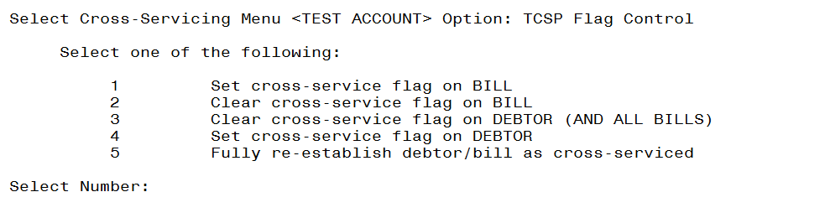

### Set Cross-Service Flag on Bill

The **Set Cross-Service Flag on Bill** functionality is used to set a bill as Cross-Serviced in the

system and on the Bill Profile screens.

Figure : Set Cross-Service Flag on Bill

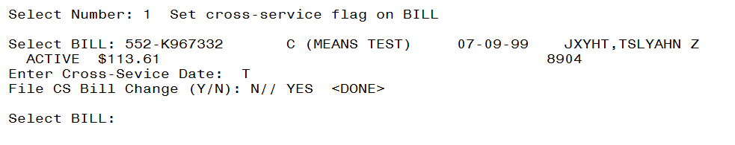

### Clear Cross-Service Flag on Bill

The **Clear Cross-Service Flag on Bill** functionality is used to clear a bill from being Cross- Serviced in the system and on the Bill Profile screens.

Figure : Clear Cross-Service Flag on Bill

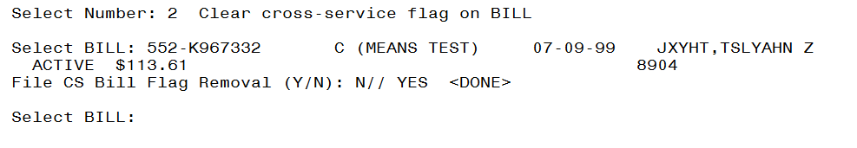

### Clear Cross-Service Flag on Debtor (and all Bills)

The **Clear Cross-Service Flag on Debtor (and all Bills)** functionality is used to clear a Debtor and all of their bills from being Cross-Serviced in the system and on the Bill Profile screens

Figure : Clear Cross-Service Flag on Debtor (and all bills)

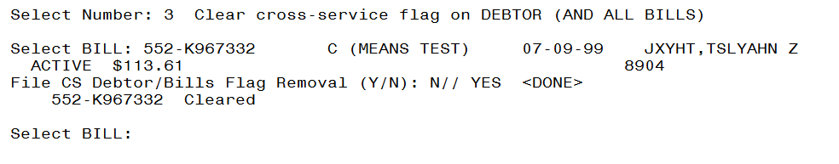

### Set Cross-Service Flag on Debtor

The **Set Cross-Service Flag on Debtor** functionality is used to set a Debtor as Cross-Serviced in the system and on the Bill Profile screens.

Figure : Set Cross-Service Flag on Debtor

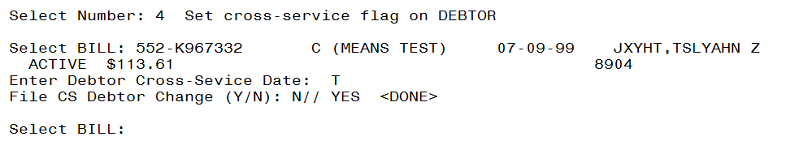

### Fully Re-establish Debtor/Bill as Cross-Serviced

The **Fully Re-Establish Debtor/Bill as Cross-Serviced** functionality is used to re-set a debtor and his/her bill as Cross-Serviced in the system and on the Bill Profile screens.

Figure : Fully re-establish debtor/bill as cross-serviced

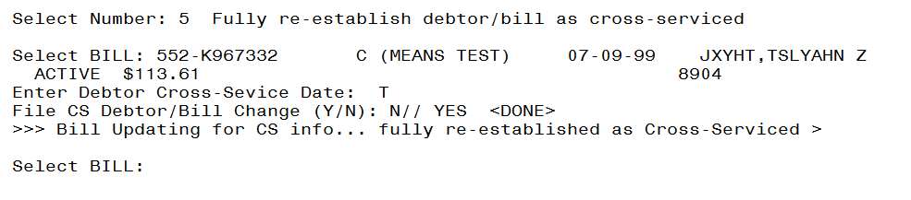

## Reconciliation List Manager Option

The **Reconciliation List Manager [RCTCSP RECONCILIATIONWORKLIST]** functionality is used to manage bills that have been returned by Treasury from Cross-Servicing for reconciliation. From the list manager screens, the user is able to view an expanded version of the selected patient’s cross-serviced bill, insurance data, view and manage the patient’s account, print statement and remove bills from the worklist.

1. At the **Select Type of Report:** prompt, enter **RECONCILIATION LIST MANAGER** or **RCTCSP RECONCILIATION WORKLIST**
2. Choose the type of report:

1 Bankruptcy

2 Deaths

3 Uncollectible

4 Payment in Full

5 Satisfied PA

6 Compromise

7 All Returns

Enter a list or range of numbers (1-7):

This response must be a list or range, e.g., 1,3,5 or 2-4,8.

1. Select one of the following:

A All Divisions

S Selected Divisions

Select(A)ll or (S)elected Division(s) : All//

Enter 'A' to not filter by Division.

Enter 'S' to view entries for selected Division(s).

1. Select one of the following:

1 List Manager

2 Excel Format

List Manager or Excel Format: 1//

The default is **(1).**

If (2) is entered, the following message displays:

**To capture as an Excel format, it is recommended that you queue this report to a spool device with margins of 256 and page length of 99999 (e.g., spoolname;256;99999). This should help avoid wrapping problems.**

**Another method would be to set up your terminal to capture the detail report data. On some terminals, this can be done by invoking 'Logging' or clicking on the 'Tools' menu above, then click on 'Capture Incoming Data' to save to Desktop. To avoid undesired wrapping of the data saved to the file, change the DISPLAY screen width size to 132 and you can enter '0;256;99999' at the 'DEVICE:' prompt.**

| **NOTE:** |
| --- |
| To avoid undesired wrapping of the data saved to the file, enter '0;256;999' at the 'DEVICE:' prompt. |

### Reconciliation List Manager

The Reconciliation List Manager main screen displays the patient’s name, patient ID (last name first initial, last 4 of the SSN), bill number, balance and return reason code (reference section 4.1.5). Note that the “y” indicates each bill has been returned from Treasury.

Figure : TCSP Reconciliation Worklist – Main Screen

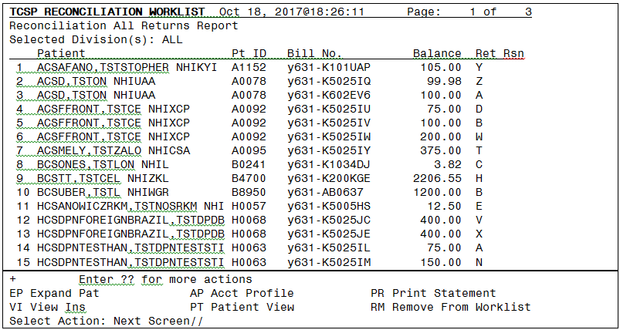

Figure : TCSP Reconciliation Worklist - Expand Patient

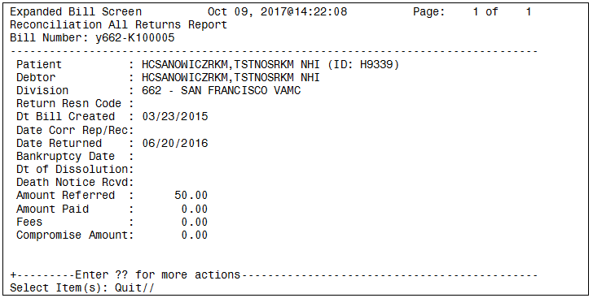

Figure : TCSP Reconciliation Worklist - View Insurance

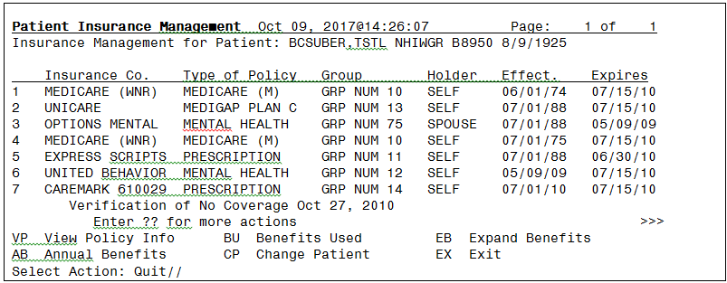

Figure : TCSP Reconciliation Worklist – View Insurance - View Policy Info

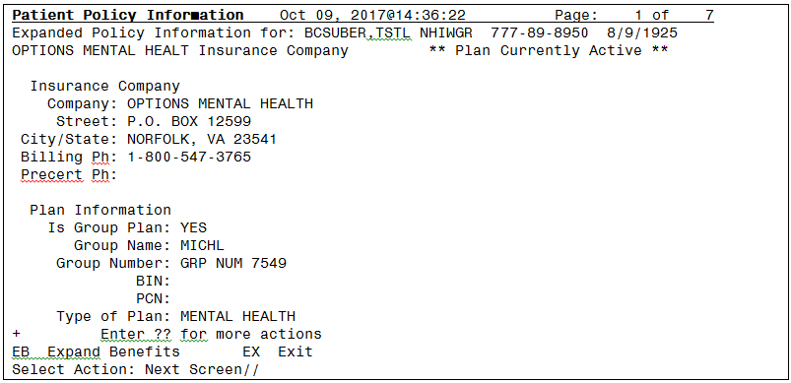

Figure : TCSP Reconciliation Worklist – View Insurance – Annual Benefits

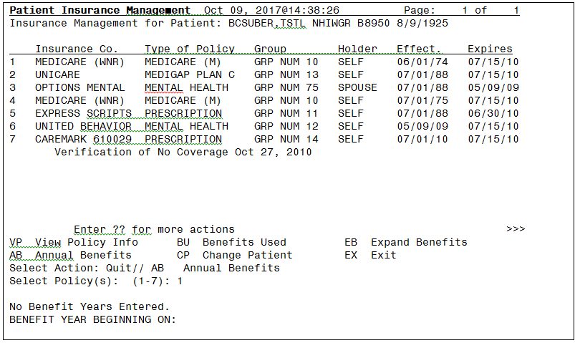

Figure 29: TCSP Reconciliation Worklist – View Insurance – Benefits Used

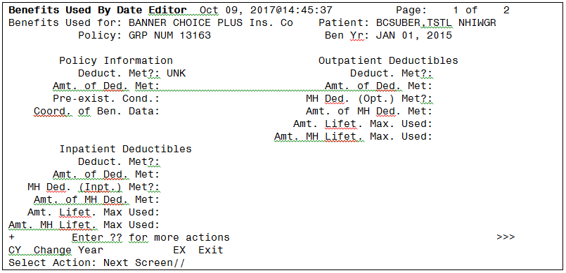

Figure 30: TCSP Reconciliation Worklist – View Insurance – Change Patient

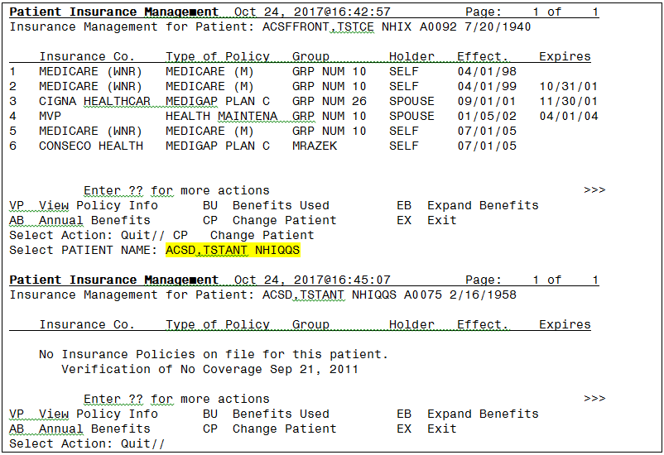

Figure : TCSP Reconciliation Worklist – View Insurance – Expand Benefits

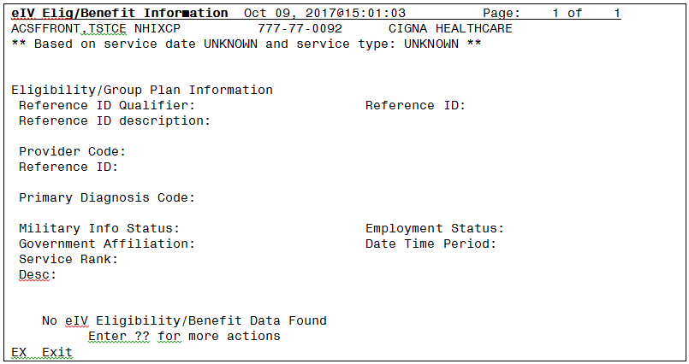

Figure : TCSP Reconciliation Worklist: Patient Inq(uiry)

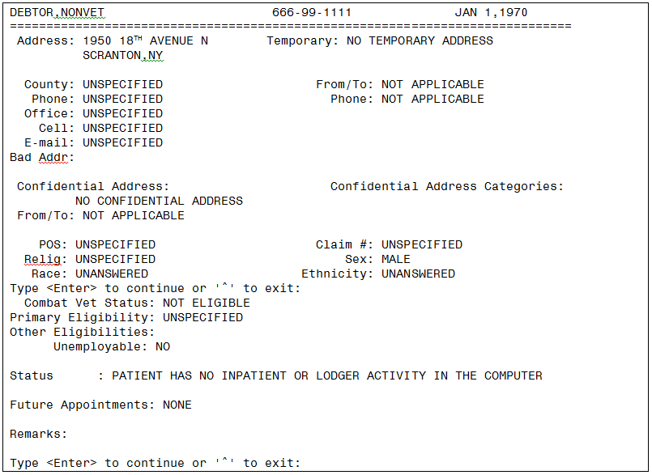

Figure : TCSP Reconciliation Worklist: Print Statement

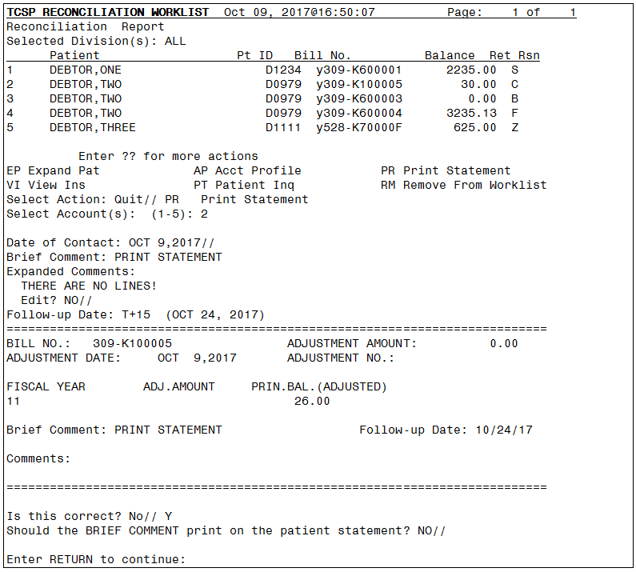

Figure : TCSP Reconciliation Worklist: Remove From Worklist

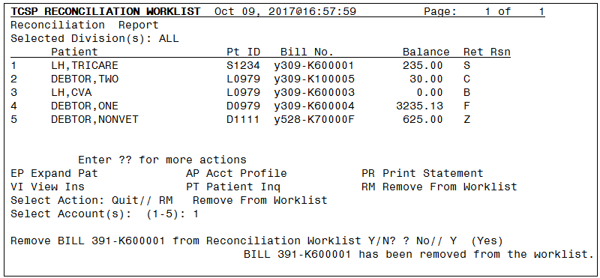

### TCSP Reconciliation Worklist – Account Profile

From the Account Profile screen of the Reconciliation List Manager, the user can perform the following actions on individual or multiple bills for an account: view, stop or delete stop TCSP referral, suspend, re-establish, view transactions, terminate fiscal, select status to view, recall or delete recall flags for a debtor, increase or decrease adjustments or cancel/add/edit bills.

Figure 34: TCSP Reconciliation Worklist – Account Profile

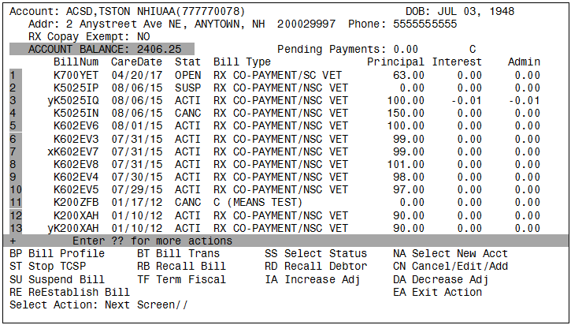

Figure : TCSP Reconciliation Worklist – Account Profile – Bill Profile

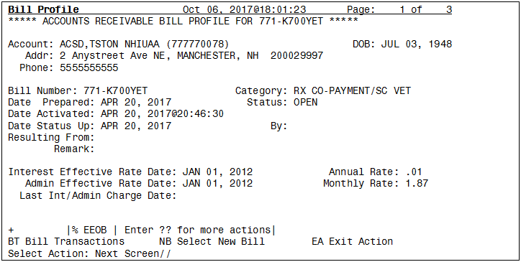

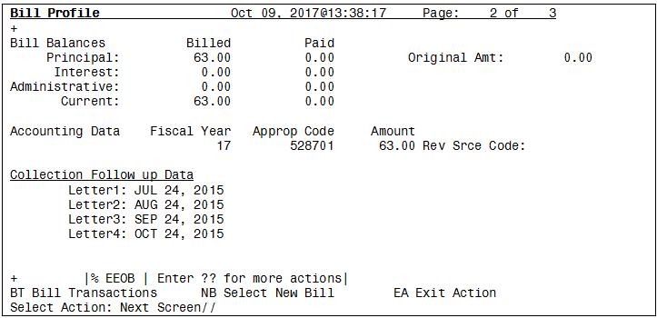

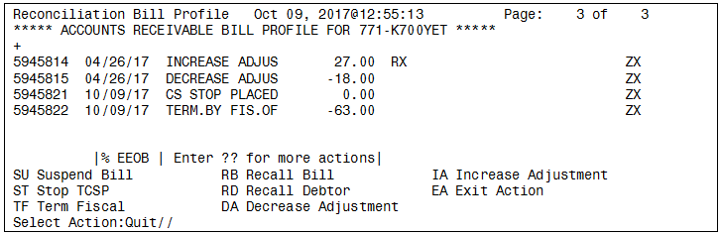

Figure : TCSP Reconciliation Worklist – Account Profile – Stop TCSP

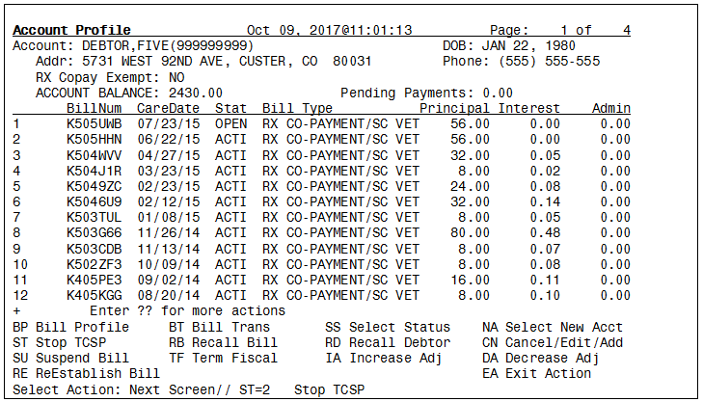

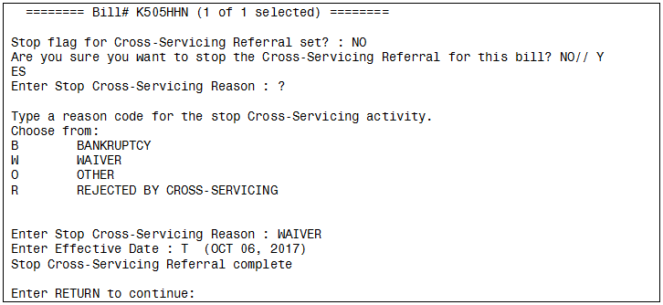

Figure : TCSP Reconciliation Worklist – Account Profile – Delete TCSP Stop

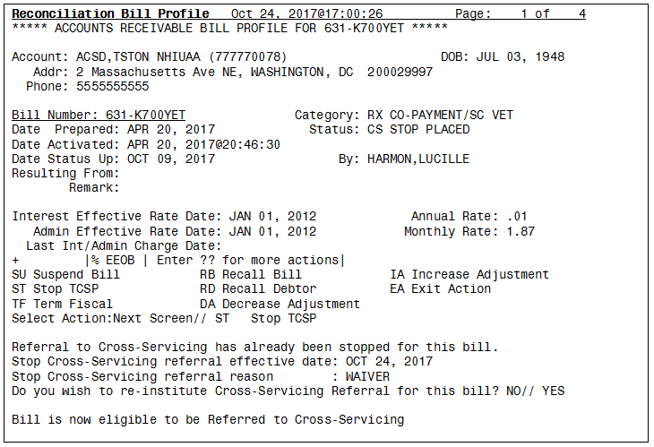

Figure : TCSP Reconciliation Worklist – Account Profile – Suspend Bill

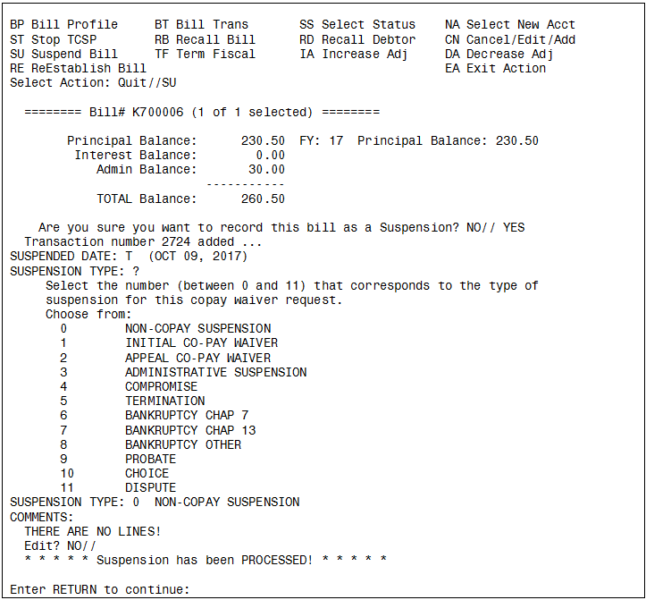

Figure : TCSP Reconciliation Worklist – Account Profile – Re-Establish Bill

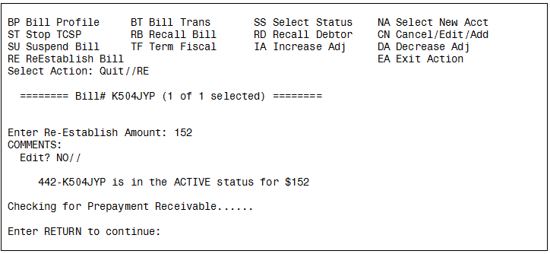

Figure : TCSP Reconciliation Worklist – Account Profile – Recall Bill

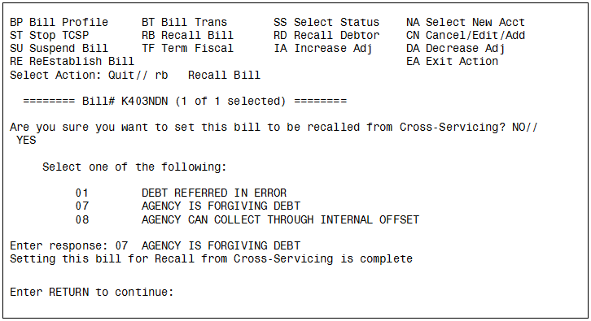

Figure : TCSP Reconciliation Worklist – Account Profile – Delete Bill Recall

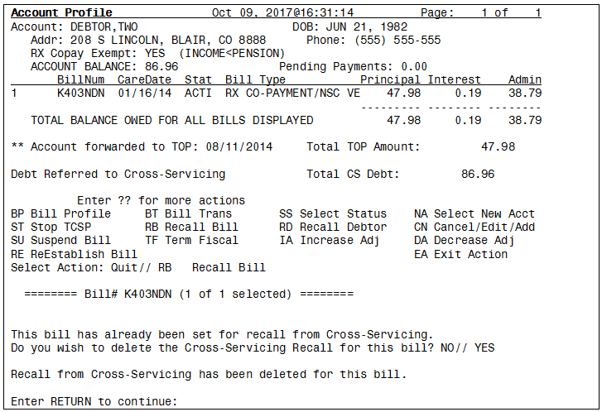

Figure : TCSP Reconciliation Worklist – Account Profile – Term Fiscal

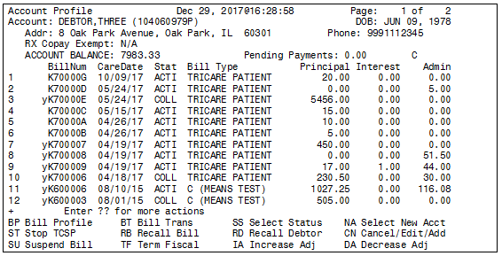

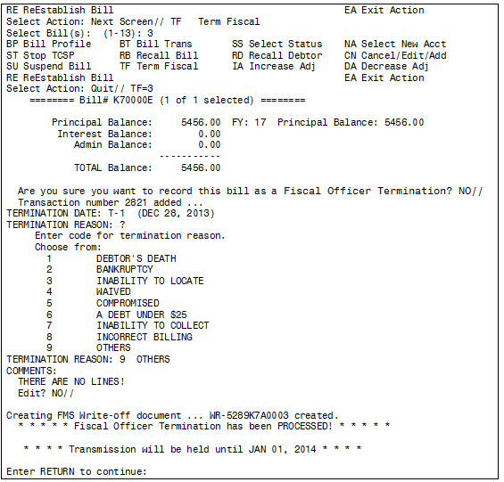

Figure : TCSP Reconciliation Worklist – Account Profile – Select Status

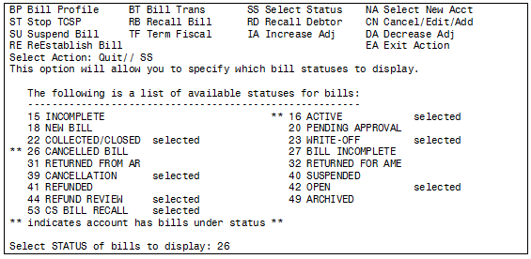

Figure : TCSP Reconciliation Worklist – Account Profile – Recall Debtor

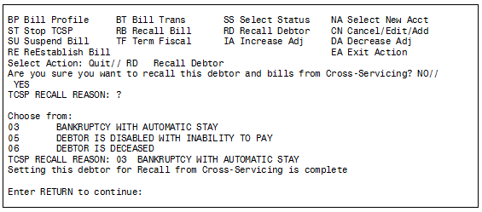

Figure : TCSP Reconciliation Worklist – Account Profile – Increase Adj

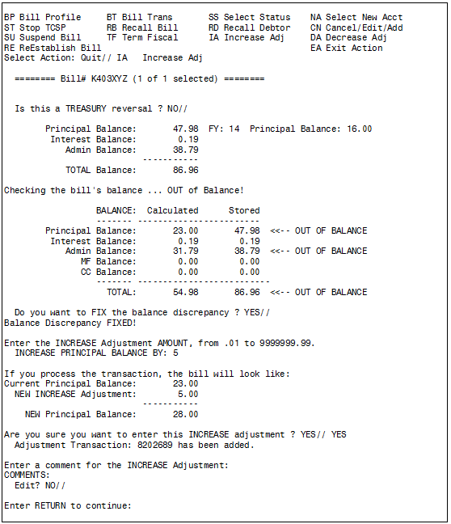

Figure : TCSP Reconciliation Worklist – Account Profile – Select New Acct

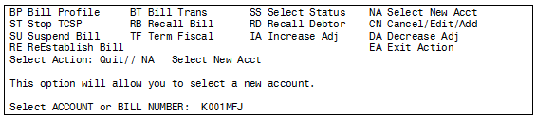

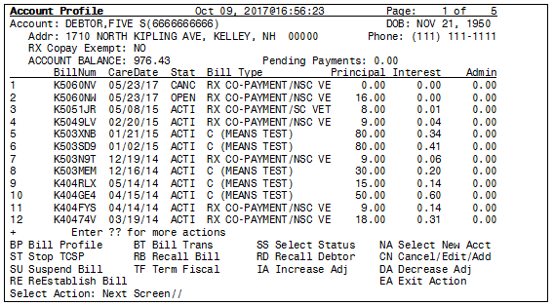

Figure : Account Profile: Cancel/Edit/Add

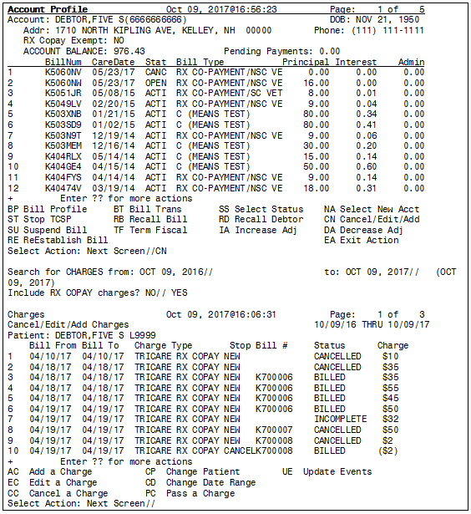

Figure : Account Profile: Cancel/Edit/Add – Add A Charge

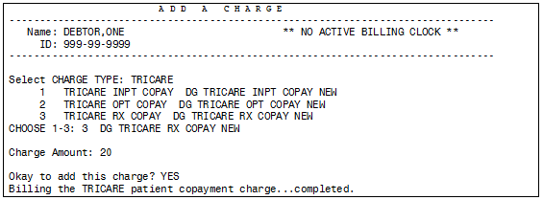

Figure : Account Profile: Cancel/Edit/Add - Cancel A Charge

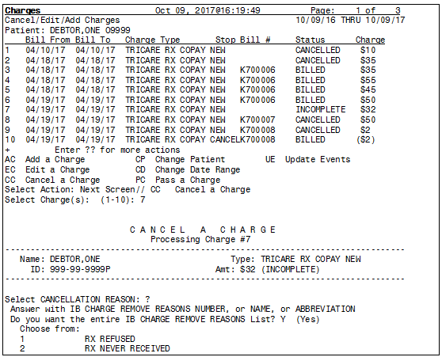

Figure : Account Profile: Cancel/Edit/Add - Cancel A Charge (cont’d.)

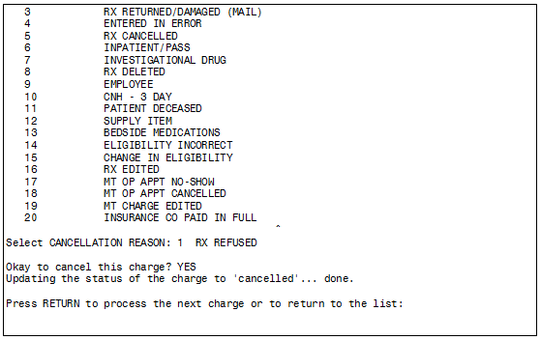

Figure : Account Profile: Cancel/Edit/Add - Change Patient

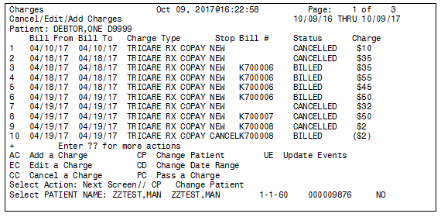

Figure : AccountCCOUNT ProfileROFILE: CancelANCEL/AddDD/EditDIT ChargesHARGES - ChangeHANGE Date DATE Range

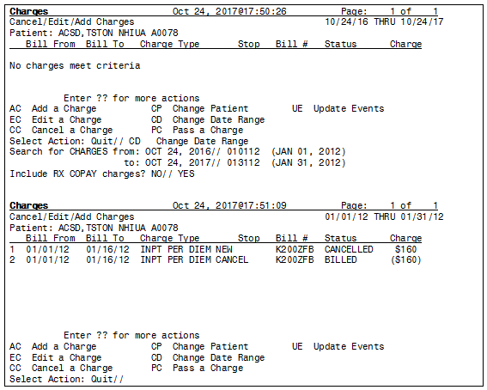

Figure : AccountCCOUNT ProfileROFILE: CancelCANCEL/AddDD/EditDIT ChargesHARGES - PassASS A ChargeCHARGE:

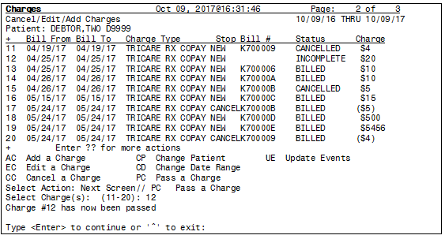

Figure : Account Profile: Cancel/Edit/Add Charges - Update Events

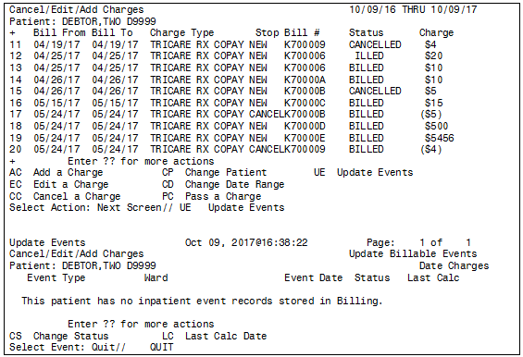

Figure : AccountCCOUNT ProfileROFILE: DecreaseECREASE AdjustmentDJUSTMENT

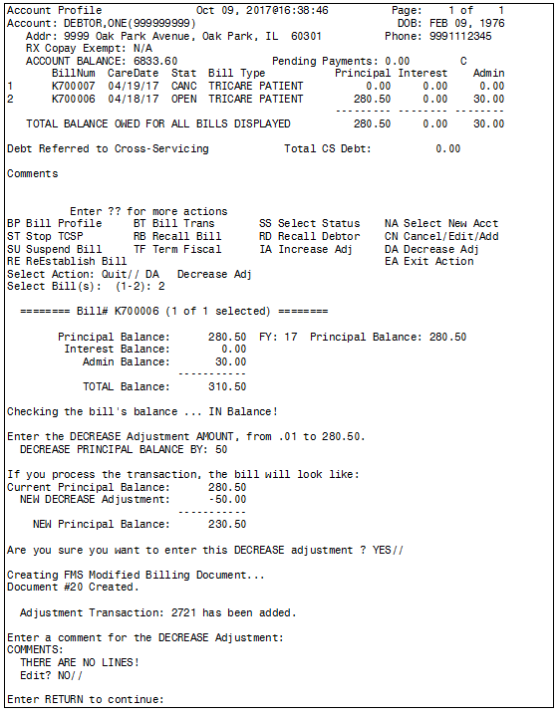

# Cross-Servicing Batch Jobs

The PRCA Nightly Process is a set of AR routines scheduled to run at the same time every night. These routines update all actions completed through the VistA AR software, and initiate all weekly Cross-Servicing messages transmitted to AITC. Cross-Servicing Weekly Messages are transmitted every Tuesday at 1:00 AM ET to AITC and the local VistA mail groups (G.TCSP).

The Cross-Servicing routines that run as part of the PRCA Nightly Process update the following Cross-Servicing actions. These actions are described in more detail in this section.

* **Referral Batch Job**: Transmits new debt to Cross-Servicing that meets all of the required criteria.
* **Update Batch Job**: For those debtors referred to Cross-Servicing, transmits updates to the name (e.g., marriage, etc.), mailing address, phone number, Tax Identification Number (TIN) (Social Security Number [SSN]), and date of birth. Additionally, the Update File contains decrease adjustments.
* **Recall Batch Job**: Recalls all debts and debtors that have been flagged in VistA for recall from Cross-Servicing.

Figure : Referral, Update & Recall Files Transfer Schedule for Cross-Servicing

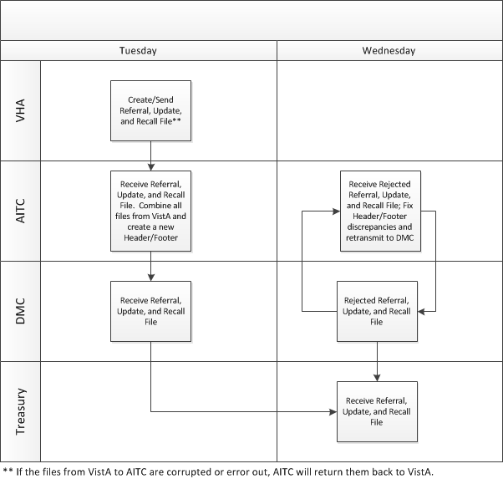

## Referral Batch Job

The Cross-Servicing Referral batch job runs weekly on Tuesday. For a debt to be automatically referred to Cross-Servicing, the following criteria must be true:

* The bill must be delinquent 120 days or more.
* The Debtor Type must be a First Party bill.
* The bill status must be *Active*.
* The Site Deletion Referral Flag for a debtor must be set to ‘blank’ or ‘NO’ in the AR Debtor File (#340).
* The DMC Referral Flag must be removed from the bill. *DATE SENT TO DMC* (File 430,121) must be Null and *DMC Debt Valid* (File 430,125) must be No or Pending.
* An individual bill must be equal to or greater than $25.00.
* The *Letter3* field is populated with a Collection Follow-up Date.

When the Cross-Servicing Referral batch job runs, VistA generates bulletins (MailMan messages), which lists all of the new debt / debtors referred to Cross-Servicing. The bulletins are described in the following sub-sections.

### Add New Debt Referral

For new debt being referred to Cross-Servicing, where a debtor has NOT been previously referred, the “CS Add Referral” bulletin is generated, which includes the Bill Number, SSN (*TIN*) of the debtor, the action code (*TYPE*), “A”, which refers to “Add New Debt” (refer to *Appendix A. Cross-Servicing Record Types & Action Codes*), and the amount of the debt referred to Cross-Servicing (*AMOUNT*) (Figure 22). Cross-Servicing referred text will also display on the various AR profile and bill screens (refer to *Section 3 Cross-Servicing Fields & Messages*). The new debt and debtor are included in the Referral File.

Figure : Bulletin: ‘CS Add Referral’ (New Cross-Servicing Referral Debt)

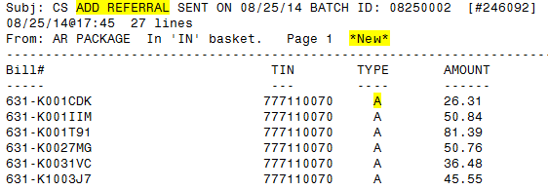

For all newly referred debt, where a debtor has NOT been previously referred, additional transmission messages will also be generated, along with the CS ADD REFERRAL bulletin. Using Bill # 631-K001CDK from the above figure, the following figures represent example transmission messages that are also generated.

Figure : Record Type 1 – Action Code A – Add New Debt

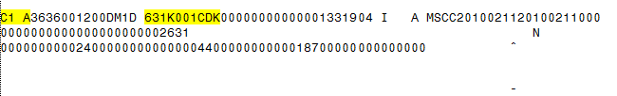

Figure : Record Type 2 – Action Code A – Add New Debtor

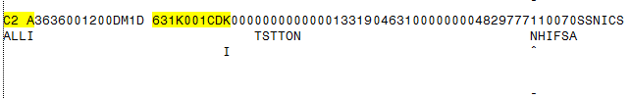

Figure : Record Type 2A – Action Code A – Add New Individual Debtor

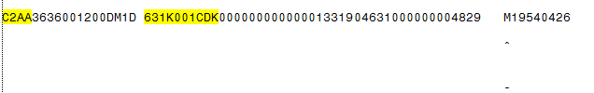

Figure : Record Type 2C – Action Code A – Add New Debtor Contact Information

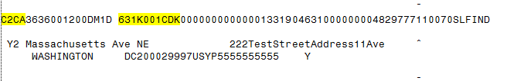

Figure : Record Type 3 – Action Code A – Add Case Information

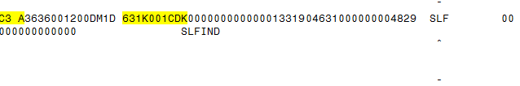

### New Debt for Existing Debtor

For new debt being referred to Cross-Servicing, where a debtor has been previously referred to Cross-Servicing, VistA generates the “CS Add Referral” bulletin, as in Figure 22, and a “CS Existing Debtor” bulletin (Figure 28), which includes the Bill Number, SSN (*TIN*) of the debtor, and the action code (*TYPE*), “B” (for Add New Debt to Existing Debtor) (refer to *Appendix A. Cross-Servicing Record Types & Action Codes*).

Figure : Bulletin: 'CS Existing Debtor' (New Debt for Existing Debtor)

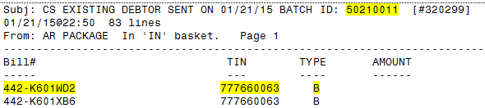

The bill will be marked as referred to Cross-Servicing in the various account profile screens (refer to *Section 3 Cross-Servicing Fields & Messages*). The new debt is included in the Referral File.

Using Bill #442-K601WD2 from Figure 28, Figure 29 illustrates the IAI record types, action codes, and data that are transmitted to Treasury when new debt is added to a previously referred debtor. This transmission message is generated by VistA, along with the ‘CS Add Referral’ and ‘CS Existing Debtor’ bulletins.

Figure : Transmission Message: Add Debt to Existing Debtor

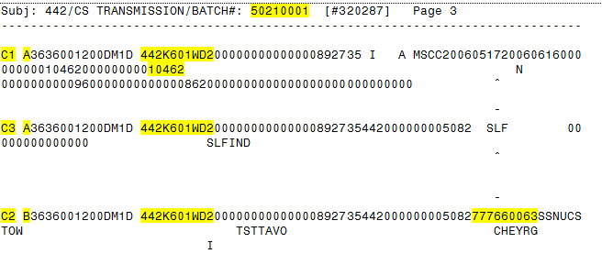

## Update Batch Job

The Update batch job is scheduled to run weekly on Tuesday after the Referral batch job, transmitting updates to the debtor’s patient file and decrease adjustments on the debtor’s account.

### Updates to Debtor’s Patient File

VistA automatically identifies updates to the debtor’s name, SSN (TIN), address, date of birth, and gender since the last weekly run, and includes those updates in the Update File.

Depending on what data is updated, the transmitted record type could be 2, 2A, or 2C, with an Action Code of “U”. The debtor name and SSN is on Record Type 2 (see the figures below). If the change is gender or date of birth, that data is on Record Type 2A, so the update is for 2A. If the change is for address, which is on Record Type 2C, the update is for Record Type 2C, with the additional condition that the Action Code is A. When updates are transmitted, an update bulletin and a transmission message are generated. (*Refer to Appendix A. Cross-Servicing Record Types & Action Codes.*)

Figure : Bulletin: ‘CS Updates’ (Updates to Debtor’s Patient File)

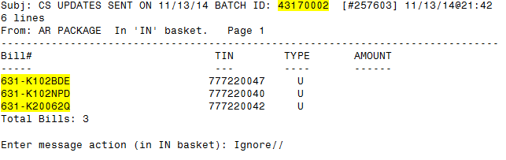

Figure : Transmission Message: ‘CS Updates’ (Updates to Debtor’s Patient File)

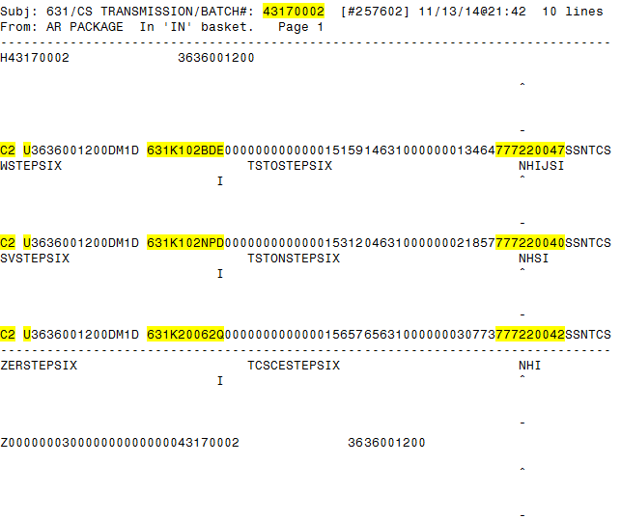

### Adjustments

Additionally, the Update File may include decrease or increase adjustments to the debtor’s account. Once a bill has been referred to Cross-Servicing, VistA will continue to allow the following decrease/increase adjustments:

1. DMC offsets.
2. Adjustments that occur when one or more charges under a bill number are canceled.
3. Manual decreases or increases for third party payments via the claims-matching process.

Both manual and automatic decrease adjustments, increase adjustments, and administrative cost adjustments will produce individual, IAI, 5B records with the “Trans Type” field name (position 66-74) in the 5B record as follows:

1. Trans Type = “AIO” (Agency Internal Offset) for automatic decreases via Lockbox.
2. Trans Type = “ABAL” (Agency Balance Adjustment) for manual decreases (via VistA).

A 5B record type will be generated by VistA when the Offset Type begins with “168” (DMC / C&P Originated), when an Overpayment is applied to other Cross-Serviced bills not in Treasury’s Collection File, or a manual decrease adjustment (via VistA AR’s adjustment feature) is applied to a bill (refer to the following figures). If there are any 5B transactions that take the balance of the bill to zero putting the bill into a collected/closed status, then the bill will no longer be flagged as being Cross-Serviced. The 5B record for increase and administrative cost adjustments will be generated when the user confirms that the adjustment is not a Treasury reversal.

As required by the IAI specifications, the 5B records will include the Signed Principal Amount, Signed Interest Amount, Signed Admin Cost Amount, and Signed Penalty Amount (includes the Marshall Fee and Court Costs amounts in VistA). Note that the Signed Principal Amount is the amount by which the transaction amount changes the principal, not the amount of the principal.

Figure : Transmission Message: Manual Decrease Adjustment - ABAL

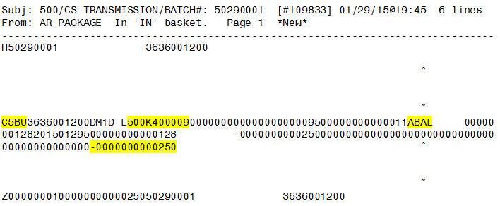

Figure : Bulletin: Manual Decrease Adjustment - ABAL

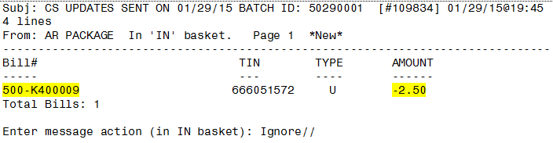

Figure : Transmission Message: Automatic Decrease Adjustment - AIO

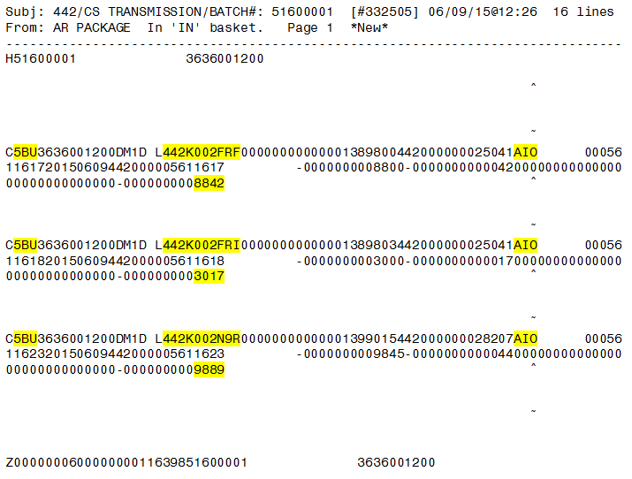

Figure : Bulletin: Automatic Decrease Adjustment – AIO

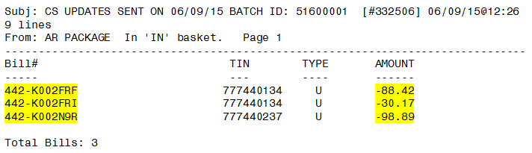

## Recall Batch Job

The Recall batch job is scheduled to run weekly after the Update batch job. This batch job recalls all debt and debtors that have been flagged to be recalled from Cross-Servicing.

### Recall Debt

VistA generates the “CS Recalls’ bulletin containing the bill number, SSN (*TIN*) and the action code (*TYPE*), “L” for recall (refer to *Appendix A. Cross-Servicing Record Types & Action Codes*) (Figure 36). Along with the bulletin, IAI-formatted transmissions for Record Type 1 will be transmitted. The Record Type 1 transmission includes the bill number and the debt recall reason # (“01” in Figure 37). (Refer to *Section 4.2.1 Recall TCSP Referral for a Bill*.)

| **NOTE:** |
| --- |
| Once a bill is flagged to be recalled from Cross-Servicing and the Recall Batch Job has run, the bill will no longer be eligible for re-referral to Cross-Servicing. A message will display indicating that reactivation (removing the recall flag) is not available. *(Refer to Section 4.2.1 Recall TCSP Referral for a Bill.)* |

Figure : Bulletin: ‘CS Recalls Sent’ (Debt Recall)

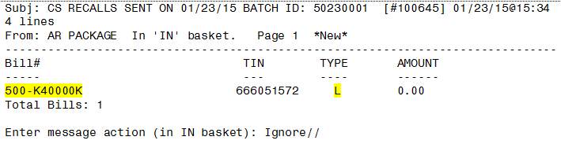

Figure : Transmission Message: Cross-Servicing Recalls (Debt Recall)

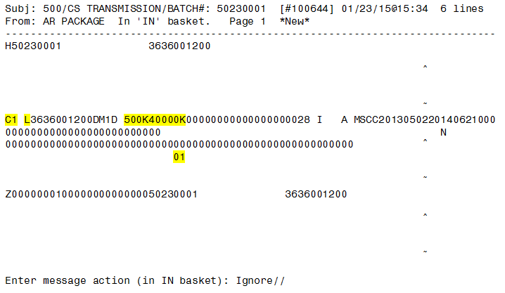

| **NOTE:** |
| --- |
| When all bills on a debtor’s account are recalled, a Type 2 record will also be transmitted with an Action Code of “L” (Figure 39). |

### Recall Debtor

When a debtor is recalled, all debt that is currently referred to Cross-Servicing will be recalled. The bulletin in the below figure illustrates the recall of a debtor, who has just one bill referred to Cross-Servicing. (Refer to *Section 4.2.2 Recall TCSP Referral for a Debtor*.)

Figure : Bulletin: ‘CS Recalls Sent’ (Debtor Recall)

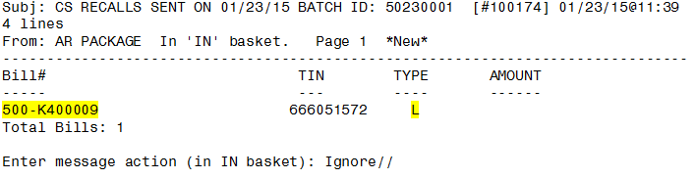

A Record Type 2 with an Action Code of “L” is transmitted for each recalled bill. Using the bill in the above figure (#500-K400009), Figure 39 illustrates the transmission for this particular recalled bill with a Recall Debtor Reason of “3” for “Bankruptcy with Automatic Stay” (refer to *Section 4.2 Recall/Reactivate TCSP Referrals*).

Figure : Transmission Message: Cross-Servicing Recalls (Debtor Recall)

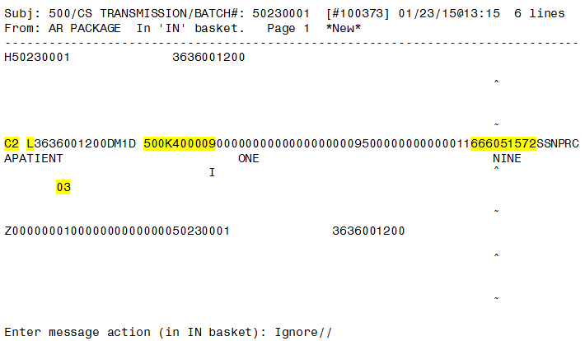

# Debts / Debtors Returned by Treasury for Reconciliation

Following the referral of a debt to Cross-Servicing, there are various reasons why a debt may be returned by Treasury for reconciliation, including, but not limited to, the following: (1) Compromise Offer, (2) Uncollectable, (3) Administrative Resolution Approved for Bankruptcy, and (4) Administrative Resolution Approved for Death. These returned debts are sent from Treasury to VistA in the form of a Reconciliation File on the first day of every month. A bulletin is generated in MailMan listing those debts returned. The bulletin contains the debtor’s name, bill number, returned date, closed date, and return reason (Figure 40). Another Cross-Servicing option that can be used to manage returned debt by Treasury for reconciliation is the **Print Reconciliation Report** (refer to *Section 4.1.5 Print Reconciliation Report*).

When a debt / debtor is returned by Treasury, VistA automatically places a ‘Stop’ on the debt, with a Stop reason of ‘Other’ and a comment of ‘By Reconciliation’. The effective date of the stop referral is also added to the debt. Additionally, the ‘Debt Referred to Cross-Servicing’ flag is removed from the debt (the “x”). Note that the message “Debt Referred to Cross-Servicing” and “Total CS Debt” will remain on the debtor’s account until all debt on the debtor’s account is no longer referred to Cross-Servicing. Refer to the following table for sample reconciliation scenarios and the action to take in VistA. For all other scenarios, please follow the business rules implemented for debts / debtors returned by Treasury for reconciliation.

Table : Reconciliation Scenarios & VistA Actions

| **Reconciliation Scenario** | **VistA Action** |
| --- | --- |
| Compromise Offer | Cancel Copayment (Waive Debt) |
| Uncollectable | Cancel Copayment (Waive Debt) |
| Bankruptcy | Cancel Copayment (Suspend Copayment) |
| Debtor Deceased | Termination of Debt when Reclamation Requirements are Met |

Figure : Bulletin: CS Qualified / Returned Debts

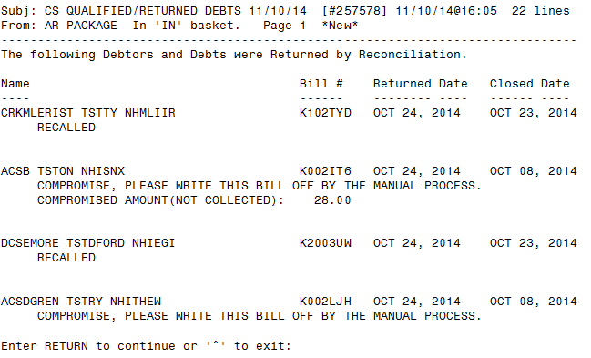

(*This page left intentionally blank for two-sided printing / copying.*)

# Due Process Notification Letter

Upon implementation of Cross-Servicing, a one-time-only process will generate an Initial Due Process Notification (DPN) File that identifies bills that comply with all of the Cross-Servicing rules, but are less than $25. On a weekly basis, the Initial DPN File will be checked by VistA for any bills that had been identified previously as less than $25 and have increased (due to fees and charges) to $25 or more. VistA will send this file (Figure 41) to AITC on Tuesdays. AITC will process through each record and determine if the record is valid. AITC will then generate a printed DPN letter (Figure 44), or determine if it is in error and is to be returned to VistA, identifying the two digit IAI error code(s) (see *Section 7.1 Due Process Notification Rejects*).

VistA receives the DPN Letter Printed & Error IAI File from AITC and logs the date the letter was printed or errors found. When AITC successfully prints the letter, AITC will send an IAI-formatted type file back to VistA with the ‘Date Letter Sent from AITC’. VistA displays this information in a MailMan bulletin (Figure 42).

After a 60-day wait period, the debt / bill associated with the DPN process will be processed by VistA according to the standard, Cross-Servicing, referral criteria.

Figure : Bulletins: Due Process Notification (DPN)

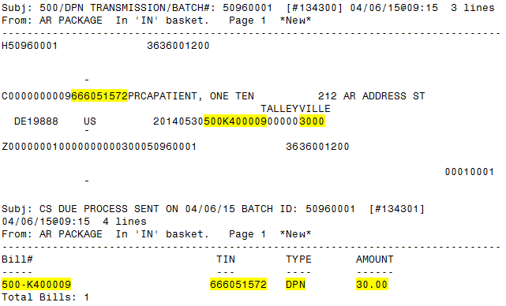

Figure : Bulletin: Due Process Notification Letter Print Date

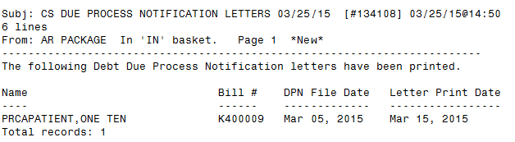

## Due Process Notification Rejects

AITC will process through each DPN record and determine if the record(s) are valid and can generate a printed letter, or determine if the record is in error and is to be returned to VistA. This reject file identifies the errors with the corresponding error codes (refer to *Appendix B. Cross-Servicing IAI Error* Codes).

| **NOTE:** |
| --- |
| Error code, “37”, is transmitted back by AITC for any issues with a debtor’s address related to the DPN transmission, including a blank Address Line 1, Address Line 2, City, State, and Foreign Code. |

The Unprocessable / Reject File for DPN, transmitted from AITC, will generate the DPN Unprocessable Reject Bulletin (Figure 43) in MailMan notifying end users that there is an error, and that a correction needs to take place in order for the DPN processing data to be sent in a future Cross-Servicing batch run.

Figure : Bulletin: Due Process Notification Reject Records

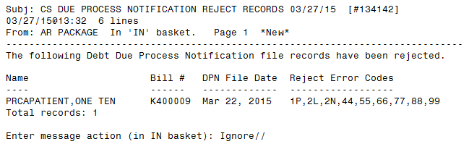

Figure : Sample Due Process Notification Letter

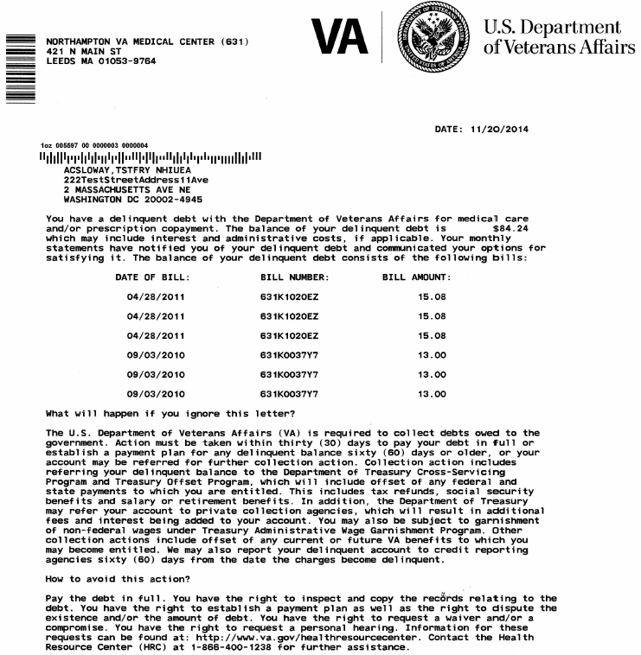

(*This page left intentionally blank for two-sided printing / copying.*)

# Collections: Payment Processing

This section provides a brief overview on the payments and offsets on debt referred to Cross-Servicing. All payments and offsets on Cross-Serviced debt will be transmitted to VistA via AITC’s Lockbox application. No other payments other than those specified below will be allowed for Cross-Serviced bills.

## What is Lockbox?

AITC’s Lockbox application is a centralized, collection point for processing and depositing large volumes of payments and deposits.

For more information on the Lockbox process, refer to *Lockbox Training Guide*.

## No Manual Payments on Cross-Serviced Bills

Once a bill is referred to Cross-Servicing, no manual payments can be applied to the bill. If a debtor’s account has bills referred to Cross-Servicing, VistA will apply any manual payments posted to a debtor’s account to the oldest bill that is not Cross-Serviced. Any overpayments on a debtor’s account (where all Non-Cross-Serviced bills are paid off) will NOT be applied to a Cross-Serviced bill and will be placed in a suspense fund. If a user attempts to post a manual payment by Bill Number to a Cross-Serviced bill, the following message will display:

Figure : Bill Referred to Cross-Servicing - No Manual Payments Allowed

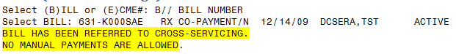

## Lockbox Payment Types

For payments / DMC offsets transmitted to VistA via Lockbox, the first three numbers of the deposit ticket # will indicate the type of offset / payment, as indicated in the table below.

Table : Offset / Payment Types

|  | **DMC (C&P) Offset** | **TOP Payments** | **Treasury (Cross-Servicing) Payments** |
| --- | --- | --- | --- |
| Deposit Ticket Number begins with (1st 3 digits) | 168 | 169 | 170 |

### DMC Offset (168)

DMC Agency Internal Offsets occur around the 25th day of each month, although it varies a few days from month-to-month. When VistA receives an offset from DMC, it applies the payment to the oldest bill in VistA first, no matter if it is a TOP or Cross-Serviced bill. If the oldest bill is a bill that has been referred to Cross-Servicing, then an IAI record type 5B (Financial Adjustment) is created and sent to Treasury (refer to *Section 5.2.2 Decrease Adjustments*).

DMC does not store and will not transmit a Bill Number in the 168 Collections File, as C&P offset is at the account level, not the bill level. The following is the format of the file received by VistA. The file contains the: SSN of debtor, payment amount, deposit number, date of deposit, and a payment type of “2”.

Figure : Lockbox Payment Transmission Content - DMC Collections File (168)

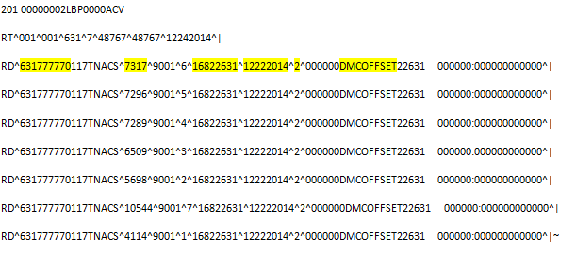

Using the example above, for the deposit number of “16822631”, a search on this deposit using the **Deposit Processing** screen from the **Agent Cashiers Menu**, will display a screen that looks like the below figure. The *Deposit Date* will match the deposit date in the Collections File of “12222014”. The *Payment Type* will be *Administrative Offset*, with total number of records listed under *Count*. For example, the seven records in the above figure, matches the total count on the **Deposit Processing** screen. If you add the dollar amounts in each of the seven records above, this amount is in the *Total Paid* column.

Figure : Deposit Processing (168)

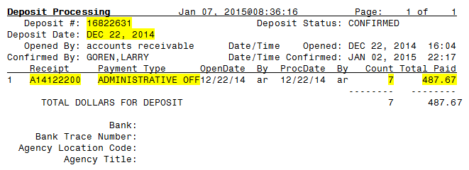

A search on the Receipt # (using “A14122200” in the above figure), displays a **Receipt Profile** screen listing the seven records and the payment amount from each record in the Collections File (Figure 48).

Figure : Receipt Profile (168)

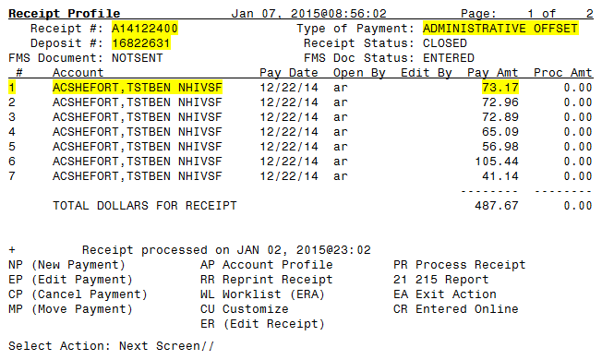

Using Transaction #1 in the above figure, the **Transaction Profile** screen will display the Transaction Date (*TransDate*) and Transaction Amount (*Trans Amt*) from the Collections File, as well as the Receipt Number. If only partial payment is received, the *Type* will read “PAYMENT (IN PART)”. If full payment is received, the *Type* will read “PAYMENT (IN FULL)”.

Figure : Transaction Profile (168)

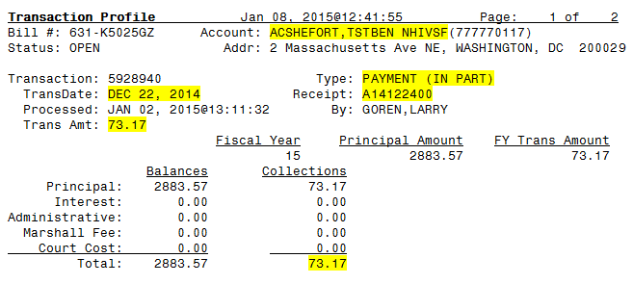

### TOP Payments (169)

For debt referred to TOP, the automatic payment process has not changed with the implementation of Cross-Servicing. DMC will continue to send the payments to AITC via the Lockbox Collections File, which triggers an update in VistA. VistA then sends an Update File to AITC where the files are bundled and transmitted to Treasury.

For payments received via a TOP (169) Collections File, payments will be applied to the oldest bill on those debts previously referred to TOP. The “Payment Type” description will be “TOP Payment”. A TOP payment will NOT be applied to a bill that has been referred to Cross-Servicing.

Figure : Lockbox Payment Transmission Content - TOP Collections File (169)

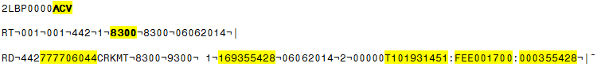

Figure : Deposit Processing Screen (169)

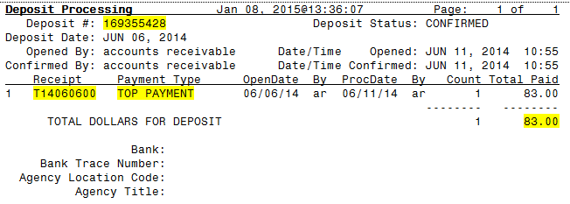

Figure : Receipt Profile Screen (169)

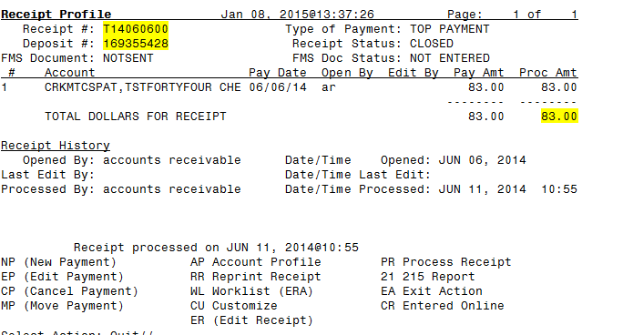

### Treasury Payments (170)

For debt referred to Cross-Servicing, VistA will receive automatic payments from Treasury via Lockbox. Every Monday, Treasury transmits a Collections File to DMC containing payments on all Cross-Serviced debt. Following receipt of the file, DMC converts the file to a Lockbox format before transmitting to AITC. AITC then transmits the file to VistA where payments are applied automatically by Bill Number (Figure 53). Note that VistA will not generate a 5B record when a payment originates from Treasury (170) unless there is money left over from the payment which can be applied to other Cross Serviced bills. Take note that a 170 offset payment that is applied to the Cross-Serviced bill for which it was explicitly meant to be applied, if the bill is paid off taking the balance to zero and applying a collected/closed status to the bill, then the bill will no longer be flagged as being Cross-Serviced. Notifications will be transmitted via MailMan when the Treasury Collections File is received by VistA (Figure 54).

| **NOTE: OVERPAYMENTS** |
| --- |
| VistA will apply any overpayments on a Cross-Serviced bill to other Cross-Serviced bills (where applicable) on a debtor’s account, starting with the oldest, Cross-Serviced bill first. Any remaining balance will first be applied to other bills, starting with the oldest, then, if there are still monies left over, this amount will be placed in suspense, to be reviewed by the Accounting staff to determine whether those funds will be refunded to the debtor or applied to additional Cross-Serviced bills. Funds will be distributed within 60 days of receipt; however, the Veteran may request the refund sooner. |

Figure : Lockbox Payment Transmission Content - Treasury Collections File (170)

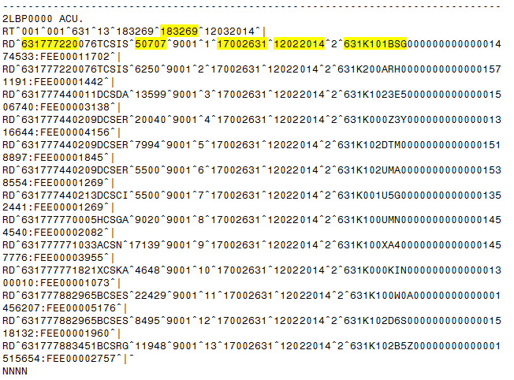

The following figures illustrate the various components of payment processing using the example 170 Collections File in Figure 53. When the 170 Collections File is processed by VistA, a bulletin is generated indicating that the payment processing is complete, with the Deposit # from the original collections file (i.e., 17002631) and a VistA-generated Receipt # (i.e., P14120300). Also, the total amount of all payments received is included (Figure 54).

Figure : Bulletin: Auto Payment Processing Completed (170)

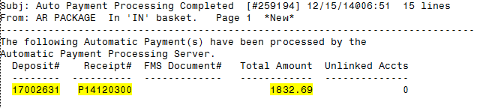

On the **Deposit Processing** screen, the *Payment Type* will be “Private Collection Agency” (Figure 55), showing the number of payments under *Count* and the total dollar amount under *Total Paid*.

Figure : Deposit Processing Screen (170)

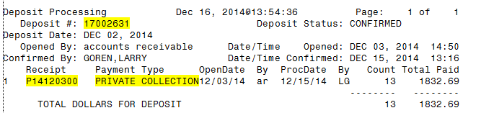

Referring back to Figure 53, the highlighted payment of $507.07 for the debtor with a SSN of 631-77-7220 (TCSISTINE, TSTEY NHIEKP) is reflected on the **Receipt Profile** screen with the same *Receipt #*, *Deposit #*, and *Type of Payment*.

Figure : Receipt Profile Screen (170)

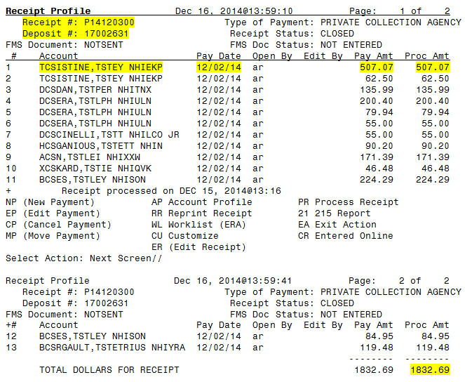

Finally, on the **Transaction Profile** screen, using the same Bill # and payment highlighted in Figure 53 (631-K101BSG for a payment of $507.07), the following figure illustrates that the payment was applied (In Full) to the Cross-Serviced Bill from the 170 Collections File.

Figure : Transaction Profile Screen (170)

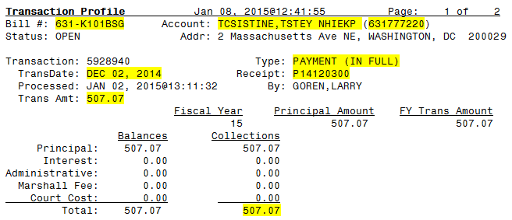

## Other Blocked Options on Cross-Serviced Bills

The options described in this sub-section are now blocked on all bills referred to Cross-Servicing. Note that once a bill is referred to Cross-Servicing, VHA can no longer service the debt.

### Set Up Repayment Plan

For all bills referred to Cross-Servicing, the **Set Up Repayment Plan** [PRCAC SET REPAYMENT] option cannot be performed. A repayment plan must be set up by Treasury and not implemented by VHA in VistA. The following message will display if a user attempts to set up a repayment plan on a Cross-Serviced bill.

Figure : Repayment Plan Option Blocked on Cross-Serviced Bills

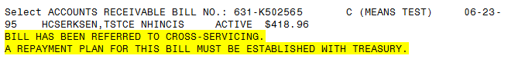

### Administrative Cost Adjustment

The **Administrative Cost Adjustment** [PRCAF ADJ ADMIN] option is blocked on all bills referred to Cross-Servicing. The following message will display if a user performs this option on a Cross-Serviced bill.

Figure : Administrative Cost Adjustment Option Blocked on Cross-Serviced Bills

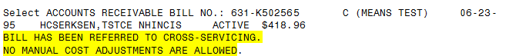

### Fiscal Officer Terminated

Before a user can perform the **Fiscal Offer Terminated** [PRCAC TR TERM-FISCAL] option on a Cross-Serviced bill, the bill must be first recalled from Cross-Servicing. Use the **Recall/Reactivate TCSP Referral for a Bill** option on the **Cross-Servicing Menu** to recall the bill from Treasury (refer to *Section 4.2.1 Recall TCSP Referral for a Bill*).

The following message will display if a user attempts this option on a Cross-Serviced bill:

Figure 102: Fiscal Officer Terminated Option Blocked on Cross-Serviced Bills

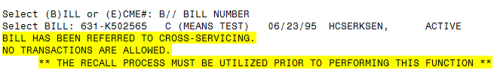

### Compromise Termination

As with the above option, the bill must be recalled from Cross-Servicing before performing the **Compromise Termination** [PRCAC TR TERM-COMPROMISE] option on a Cross-Serviced bill. The same message will display as in Figure .

### Suspend an AR Bill

For all bills referred to Cross-Servicing, the **Suspend an AR Bill** [PRCAC TR SUSPENDED] option cannot be performed until the bill is recalled from Cross-Servicing. A message will display indicating that the recall process must utilized prior to suspending the bill.

### Partial /Full Waiver

The **Partial Waiver** [PRCAC WAIVED PART] and **Full Waiver** [PRCAC WAIVED FULL] options will also be blocked on Cross-Serviced bills until the bill is recalled from Cross-Servicing (refer to Figure ).

# Cross-Servicing Rejects

Once a debt has been rejected by Cross-Servicing, the debt will no longer be considered referred to Cross-Servicing. Reject messages can come from Treasury, DMC or AITC. These messages / files are sent to the VAMC via MailMan on a weekly basis (where applicable).

If a bill that has been referred by Cross-Servicing is rejected by any source, a bulletin (MailMan message) will display in the user’s MailMan inbox. A ‘Stop’ flag is automatically set on the bill with a reason of “Rejected by Cross-Servicing”. Additionally, the Reject Code, Reason, and Date will display on the profile screens (see *Section 3.3 Debt Rejected by Cross-Servicing*). The “**x**” indicator is removed from the bill on the Full Account Profile screen.

VistA prevents the re-referral of any rejected bills until the ‘Stop’ flag is removed. For all bills rejected, the technician is required to research and correct the error(s), and then remove the ‘Stop’ flag from the bill, where applicable (see *Section 4.3.2 Reactivate TCSP Referral for a Bill (Remove ‘Stop’ Flag*)). When correcting an error, follow the business rules implemented for Cross-Servicing. The Cross-Servicing functionality provides the following two options for manually working these rejects, which are found on the main **Cross-Servicing Menu**:

* **Debt Referral Reject Report** (refer to *Section 4.1.4 Debt Referral Reject Report*).
* **List IAI Error Codes** (refer to *Appendix B. Cross-Servicing* *IAI Error* Codes).

Once the error is corrected and the ‘Stop’ flag is removed, the account will follow the appropriate processing sequence. Depending on the status of the account, this may include referral to Cross-Servicing with the next weekly transmission. Note that the reject information will remain on the profile screen even after the error has been corrected.

## Reject Messages

Users must belong to the G.TCSP mail group to receive reject messages. The subject of the CS Reject message will identify the source of the reject. The body of the reject bulletin will include the Debtor’s name (*NAME*), SSN, Bill Number, Record Type (*TYPE*), Action Code (*ACTN*), and all of the Error Codes associated with the referral (Figure 62 & Figure 63).

| **NOTE:** |
| --- |
| For additional information on Error Codes, refer to *Appendix B. Cross-Servicing IAI Error* Codes. For information on Cross-Servicing Record Types and Action Codes, reference *Appendix A. Cross-Servicing Record Types & Action Codes*.  Once the error is corrected, remove the ‘Stop’ flag on the bill by using the **Stop/Reactivate TCSP Referral for a Bill** option (refer to *Section 4.3.2 Reactivate TCSP Referral for a Bill (Remove ‘Stop’ Flag)*). |

## Recall Debtor Rejects

For a reject on debtor recalls using the *Recall TCSP Referral for a Debtor* option, **note that a stop is placed on the first Cross-Serviced bill available for that debtor.** After the error(s) is corrected, the stop will need to be removed from the debt in order for the recall debtor retransmission to occur. Utilize the *Debt Referral Reject Report* to locate the Bill No. on the rejected debtor recall (Type=“2”; Action Code=“L”) where the ‘Stop’ needs to be removed (refer to Figure 61 for a sample report of a reject on a debtor recall).

Figure : Sample Debt Referral Reject Report (Rejects on a Debtor Recall)

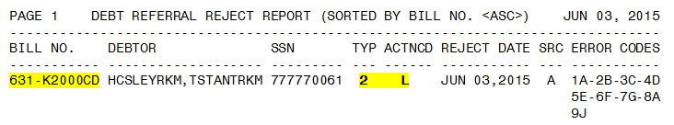

## ZZ Error Code

The ‘ZZ’ Error Code has been introduced as a ‘catch-all’ for errors that do not match up to the list of errors already defined by Treasury. A ‘ZZ’ error code does not indicate what the error is, meaning it will require manual intervention to review the record in VistA in order to locate and correct the error. The definition of Error Code ‘ZZ’ is “Manual Intervention Required”.

Figure : Bulletin: Cross-Servicing Rejects (AITC)

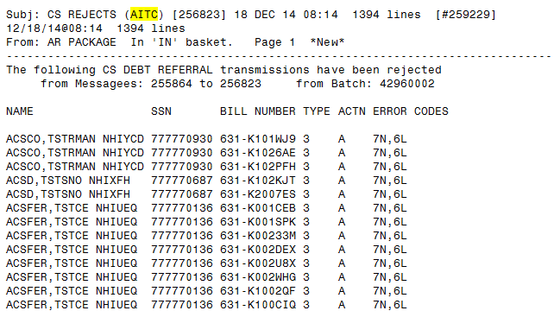

Figure : Bulletin: Cross-Servicing Rejects (Treasury)

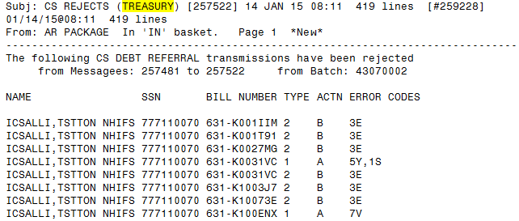

(*This page left intentionally blank for two-sided printing / copying.*)

# Additional VistA Information

This section describes the mail group used for Cross-Servicing, the file transfer schedule for Cross-Servicing, and the Cross-Servicing fields (with file names) stored in VistA.

## Cross-Servicing Mail Group

There is one mail group specifically for receiving Cross-Servicing messages – G.TCSP. This mail group must have members who are active VistA users.

The G.TCSP mail group will also receive notifications when the batch run is completed and when a corrupted debtor record is found during the batch run. This functionality was created with Accounts Receivable patch, PRCA*4.5*327.

Below are illustrations of how the Failed Debtor Action & Batch Completion notifications.

Figure : Failed Debtor Action Notice & Batch Completion Notice

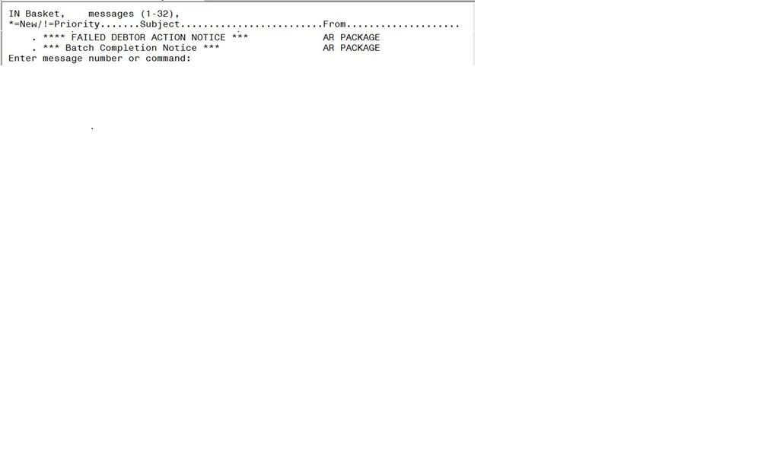

The Failed Debtor Action notice will be sent when a corrupt debtor record has been found during the batch run.

Figure : Failed Debtor Action Notice

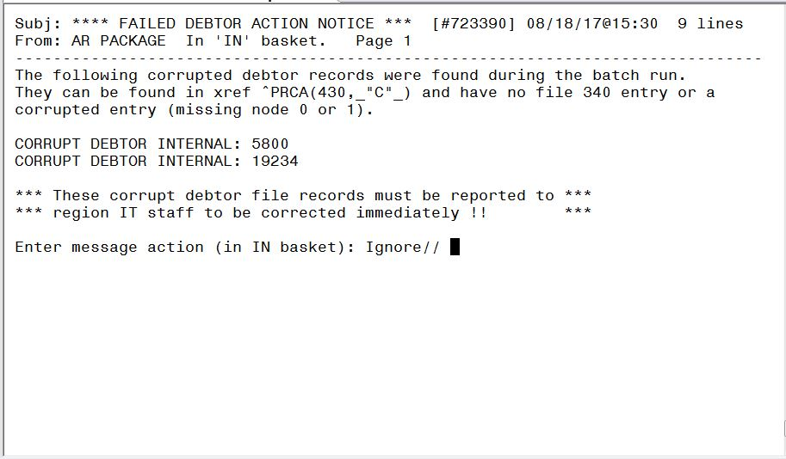

The Batch Completion notice will be sent once the batch run and transmission has been completed.

Figure : Batch Completion Notice

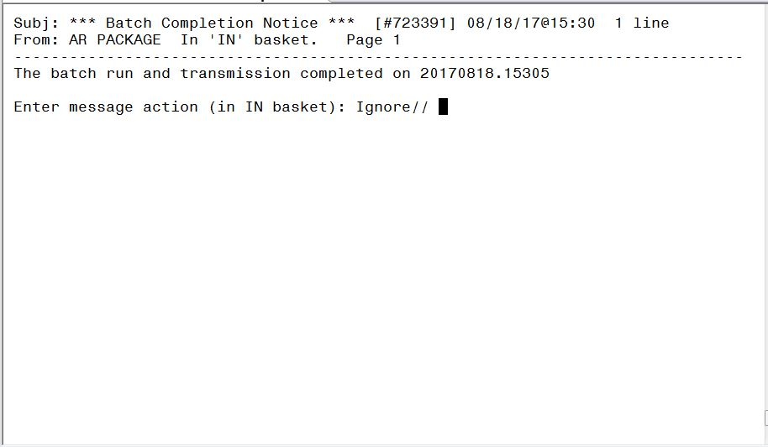

## Cross-Servicing File Transfer Schedule

Figure 65 illustrates the high-level, file transfer schedule between VHA, AITC, DMC, and Treasury for Cross-Servicing. The following files are referenced: Referral, Update, Recall, Collections, Due Process Notification, and Unprocessable.

Figure : Cross-Servicing File Transfer Schedule

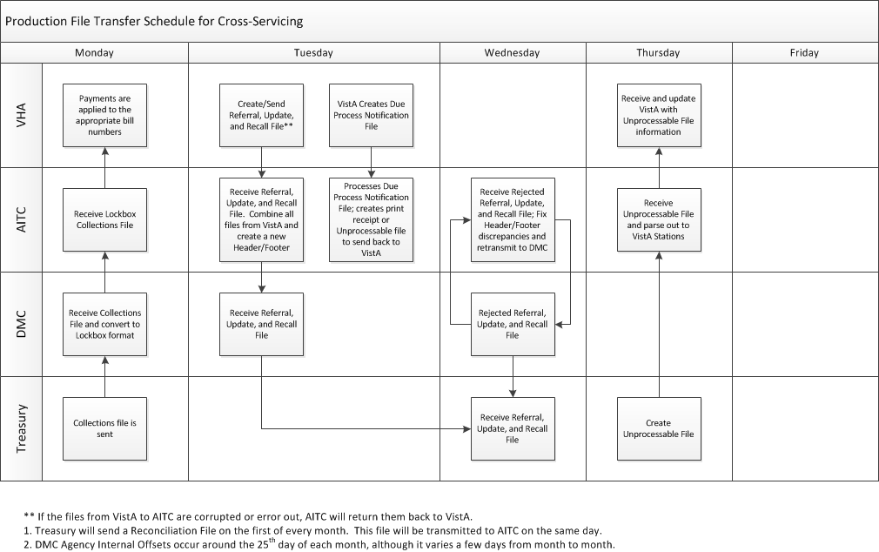

## Cross-Servicing Files & Fields

Cross-Servicing information is stored in the VistA files listed in this section. The following tables list the number, name, and description of each Cross-Servicing field.

Table : Cross-Servicing Fields in AR Debtor File (#340)

| **Field Number** | **Field Name** | **Description** |
| --- | --- | --- |
| 7.02 | TCSP RECALL FLAG | Flag set when debts or debtor recalled from Cross-Servicing. |
| 7.03 | TCSP RECALL DATE | Date the debt is recalled from Cross-Servicing. |
| 7.04 | TCSP RECALL REASON | Reason for recalling the debt. |
| 7.05 | DATE DEBTOR REFERRED TO TCSP | Date the debtor is recalled from Cross-Servicing. |

Table : Cross-Servicing Fields in AR Debtor File (#342)

| **Field Number** | **Field Name** | **Description** |
| --- | --- | --- |
| 100 | CROSS-SERVICING START DATE | Used to automatically calculate when the DPN processing and weekly transmissions of the DPN file to AITC will be halted. |

Table : Cross-Servicing Fields in TCS IAI Error Codes File (#348.5)

| **Field Number** | **Field Name** | **Description** |
| --- | --- | --- |
| 0.01 | ERROR CODE ID | Error code ID in the IAI error code file. |
| 1 | FIELD NAME/ACTION | Field name/action in the IAI error code file. |
| 2 | RECORD TYPE | Record type in the IAI error code file. |
| 3 | ERROR MESSAGE | Error message in the IAI error code file. |

Table : Cross-Servicing Fields in TCS IAI Action Code File (#348.6)

| **Field Number** | **Field Name** | **Description** |
| --- | --- | --- |
| 0.01 | ACTION CODE | Action code in the IAI action code file. |
| 1 | ACTION DESCRIPTION | Description of the action code in the IAI action code file. |
| 2 | RECORD TYPE | Record type in the IAI action code file. |

Table : Cross-Servicing Fields in TCS IAI Record Types File (#348.7)

| **Field Number** | **Field Name** | **Description** |
| --- | --- | --- |
| 0.01 | RECORD TYPE ID | Record Type ID of the IAI Record Type in transmission. |
| 1 | RECORD TYPE DESCRIPTION | Description of the Record Type in the IAI transmission. |
| 2 | DATA TYPE | Type of data in the IAI transmission. |

Table : Cross-Servicing Fields in Accounts Receivable File (#430)

| **Field Number** | **Field Name** | **Description** |
| --- | --- | --- |
| 151 | DATE BILL REFERRED TO TCSP | Date the bill was first referred to Cross-Servicing. |
| 152 | TCSP RECALL FLAG | Set whenever a ‘Recall CS Referral” is entered by the user through the Recall menu options. |
| 153 | TCSP RECALL EFF. DATE | Contains a date, for which bills generated after, are eligible for Cross-Servicing referral. |
| 154 | TCSP RECALL REASON | Contains a code detailing the reason the referral to Cross-Servicing was recalled. |
| 155 | RECALL AMOUNT | The dollar amount of the debt recalled from Cross-Servicing. |
| 156 | ORIGINAL DATE REFERRED TO TCSP | The original date that the debt was referred to Cross-Servicing. This field is set only once. It is not deleted or reset with subsequent actions on the debt. This field should not be used for aging or other computations. |
| 157 | STOP TCSP REFERRAL FLAG | Set whenever a 'Stop CS Referral' is entered by the user through the menu option. |
| 158 | STOP TCSP REFERRAL EFF. DATE | Contains a date, for which bills generated after, are eligible for Cross-Servicing referral. |
| 159 | STOP TCSP REFERRAL REASON | Contains a code detailing the reason the referral to Cross-Servicing was stopped. |
| 159.1 | STOP TCSP REFERRAL COMMENT | Comment field used to support the reason that a stop flag has been set for a debt. A comment is required in the case of 'Other' as a reason code. |
| 159.2 | TCSP CASE RECALL FLAG | Flag that marks this case for recall record creation from Cross-Servicing when the AR nightly background job is run. |
| 159.3 | TCSP CASE RECALL EFF DATE | Date that the recall flag is set for a case. |
| 159.4 | TCSP CASE RECALL REASON | Reason that the case is being recalled from Cross-Servicing. |
| 159.5 | TCSP GENDER | Gender of debtor referred to Cross-Servicing |
| 161 | ORIGINAL TCSP TIN | SSN sent to Cross-Servicing on the original referral document. |
| 162 | ORIGINAL TCSP DEBTOR NAME | Name as sent on the original Cross-Servicing referral document. |
| 163 | TCSP DELINQUENCY DATE | Date that the bill became active. The debt is referred to Cross-Servicing when the debt is 150 days old counted from the delinquency date. |
| 164 | TCSP DEBTOR ADDRESS, LINE 1 | First line of the current debtor address transmitted to Cross-Servicing. |
| 165 | TCSP DEBTOR ADDRESS, LINE 2 | Second line of the current debtor address transmitted to Cross-Servicing. |
| 166 | TCSP DEBTOR ADDRESS, CITY | City included in the debtor address transmitted to Cross-Servicing. |
| 167 | TCSP DEBTOR ADDRESS, STATE | State included in the debtor address transmitted to Cross-Servicing. |
| 168 | TCSP DEBTOR ZIP CODE | Zip code included in the debtor address transmitted to Cross-Servicing. |
| 169 | ORIGINAL TCSP AMOUNT | Original amount referred to Cross-Servicing. |
| 169.1 | CURRENT TCSP AMOUNT | Current debt amount at Cross-Servicing. |
| 169.2 | TCSP DEBTOR PHONE | Residence phone number from the Patient file (#2). |
| 169.3 | TCSP COUNTRY CODE | The country code from the Patient file (#2). |
| 169.4 | TCSP DOB | The patient date of birth. |
| 171 | CS ADJ TRANS NUMBER (multiple 430.0171) | Transaction number in the AR Transaction file (#433) for transactions to be included in a 5B record to be sent to Cross-Servicing. |
| 430.0171, .01 | CS ADJ TRANS NUMBER | Transaction number in the AR Transaction file (#433) for transactions to be included in a 5B record to be sent to Cross-Servicing. |
| 430.0171, 1 | SEND TCSP RECORD 5B | Flag that marks this transaction to be sent to Cross-Servicing in a 5B record when the AR nightly background job is run. |
| 173 | DUE PROCESS NOTIFICATION FLAG | Date that a bill is flagged for Due Process Notification (DPN) |
| 174 | DUE PROCESS REQUEST DATE | Date that the due process request is set |
| 175 | DUE PROCESS LETTER PRINT DATE | Print date of the due process letter. |
| 176 | DUE PROCESS REFERRAL DATE | Date that the bill is referred for due processing. |
| 177 | DUE PROCESS ERROR DATE | Date that the bill is rejected for due process. |
| 178 | DUE PROCESS ERROR CODES | Error codes related to the bill being rejected for due process. |
| 191 | SEND TCSP RECORD 1 | Flag set by the unprocessable file to request that a record 1 be sent for this debt. |
| 192 | SEND TCSP RECORD 2 | Flag set by the unprocessable file to request that a record 2 be sent for this debt. |
| 193 | SEND TCSP RECORD 2A | Flag set by the unprocessable file to request that a record 2A be sent for this debt. |
| 194 | SEND TCSP RECORD 2C | Flag set by the unprocessable file to request that a record 2C be sent for this debt. |
| 196 | SEND TCSP RECORD 5B | Flag set by the unprocessable file to request that a record 5B be sent for this debt. |
| 197 | 5B PRINCIPLE | Principle amount to be set on the 5B record when the request for the 5B record is set. |
| 198 | 5B INTEREST | Interest amount to be set on the 5B record when the request for the 5B record is set. |
| 199 | 5B ADMIN | Admin amount to be set on the 5B record when the request for the 5B record is set. |
| 199.1 | 5B PENALTY | Penalty amount to be set on the 5B record when the request for the 5B record is set. |
| 199.2 | STOP INTEREST ADMIN CALC | Flag to stop interest and admin calculation for debts referred to Cross-Servicing. |
| 301 | RETURNED DATE | Returned date field on the reconciliation file for records returned by Treasury from Cross-Servicing. |
| 302 | RETURN REASON CODE | Returned reason code field on the reconciliation file for records returned by Treasury from Cross-Servicing. |
| 303 | COMPROMISED INDICATOR | Compromise indicator field on the reconciliation file for records returned by Treasury from Cross-Servicing. |
| 304 | COMPROMISE AMOUNT | Compromise amount field on the reconciliation file for records returned by Treasury from Cross-Servicing. |
| 305 | CLOSED DATE | Closed date field on the reconciliation file for records returned by Treasury from Cross-Servicing. |
| 306 | BANKRUPTCY DATE | Bankruptcy date field on the reconciliation file for records returned by Treasury from Cross-Servicing. |
| 307 | DATE OF DEATH | Date of death field on the reconciliation file for records returned by Treasury from Cross-Servicing. |
| 308 | DATE OF DISSOLUTION | Date of dissolution field on the reconciliation file for records returned by Treasury from Cross-Servicing. |
| 309 | REMOVED FROM RECONCILIATION? | This field determines whether or not the bill will display on the Cross-Servicing Reconciliation Worklist. User’s have the ability to manually remove debtors/bills from the worklist and this field is used in that action. |
| 310 | REC ORIGINAL TCSP AMOUNT | This is the original amount referred to Cross-Servicing. It is saved and stored separately from field 169 (see above) for reporting purposes. |
| 311 | REC CURRENT TCSP AMOUNT | This is the current debt amount at Cross-Servicing. It is saved and stored separately from field 169.1 (see above) for reporting purposes. |
| 312 | REC TCSP RECALL EFF. DATE | This is the date that the recall flag is set for the debt. It is saved and stored separately from field 153 (see above) for reporting purposes. |

Table : Cross-Servicing Fields in Subfile CS Decrease Adj Trans Number (sub file of AR #430) (#430.0171)

| **Field Number** | **Field Name** | **Description** |
| --- | --- | --- |
| .01 | CS DECREASE ADJ TRANS NUMBER | Transaction number for the Cross-Servicing decrease adjustment |

Table : Cross-Servicing Fields in Reject Date (sub-file of AR #430) (#430.0172)

| **Field Number** | **Field Name** | **Description** |
| --- | --- | --- |
| .01 | REJECT DATE | Date that a Cross-Servicing referral / update was rejected |
| 1 | REJECT SOURCE | Source of the reject (AITC, DMC, Treasury) |
| 2 | REJECT REASON1 | Reject Reason 1 |
| 3 | REJECT REASON2 | Reject Reason 2 |
| 4 | REJECT REASON3 | Reject Reason 3 |
| 5 | REJECT REASON4 | Reject Reason 4 |
| 6 | REJECT REASON5 | Reject Reason 5 |
| 7 | REJECT REASON6 | Reject Reason 6 |
| 8 | REJECT REASON7 | Reject Reason 7 |
| 9 | REJECT REASON8 | Reject Reason 8 |
| 10 | REJECT REASON9 | Reject Reason 9 |
| 11 | RECORD TYPE | Record type of the reject |
| 12 | RECORD ACTION CODE | Action code of reject |
| 13 | REJECT BATCH ID | Batch ID # of the reject |
| 14 | REJECT MM MSG NO. | MailMan Message # of the reject |

Table : Cross-Servicing Fields in AR Return Reason Code File (#430.5)

| **Field Number** | **Field Name** | **Description** |
| --- | --- | --- |
| .01 | CODE | Code # in the return reason code file. |
| .1 | DESCRIPTION | Description in the return reason code file. |
| 2 | CATEGORY | Category in the return reason code file. |

# Appendix A. Cross-Servicing Record Types & Action Codes

The following table lists the record types and action codes used for Cross-Servicing from Treasury’s IAI File Format specification (refer to *Appendix F. References*).

Table : Cross-Servicing Record Types & Action Codes

|  |  |  |
| --- | --- | --- |
| **Record Type** | **Action Code** | **Description** |
| **H – Header Record** | - | - |
| **1 – Debt Record** | A | Add New Debt |
| U | Update Debt |
| L | Debt Recall |
|  |  |  |
| **2 – Debtor Record** | A | Add new Debtor |
| U | Update Debtor, Update Debtor TIN |
| L | Debtor Recall |
| B | Add New Debt to Existing Debtor |
|  |  |  |
| **2A – Individual Debtor Record** | A | Add New Individual Debtor |
| U | Update Individual Debtor |
|  |  |  |
| **2C – Debtor Contact Information** | A | Add new Debtor Contact Info |
|  |  |  |
| **3 – Case Record** | A | Add Case Info |
|  |  |  |
| **5B - Creditor Agency Financial Transactions (Adjustments)** | U | CA Financial Transaction (Adjustment) |
|  |  |  |
| **Z – Trailer Record** | - | - |

# Appendix B. Cross-Servicing IAI Error Codes

The below table is a list of the IAI error codes for Cross-Servicing. For all errors that cannot be fixed locally, please log a Remedy ticket.

Table : Cross-Servicing IAI Error Codes

| **ID** | **Field Name / Action** | **Record Type(s)** | **Error Message** |
| --- | --- | --- | --- |
| 01 | FAST Code/ ALC/ Station | 1,2,2A,2B,2C,2D,2E,3,4,5A,5B,6 | Cannot be blank or is invalid. |
| 02 | ALC | 1,2,2A,2B,2C,2D,2E,3,4,5A,5B,6 | ALC of input record does not Match file ALC. |
| 03 | DMS Processing Code | 1,2,2A,2B,2C,2D,2E,3,4,5A,5B,6 | DMS Processing Code cannot be blank or is invalid. |
| 04 | Agency Debt ID | 1,2,2A,2B,2C,2D,2E,3,4,5A,5B,6 | Invalid agency debt id or agency debt id not specified. |
| 05 | Debt Type | 1 | Debt Type does not exist in Agency Profile or invalid Debt Type code. |
| 06 | Debt Type | 1 | Cannot reset debt type. |
| 07 | Debtor TIN | 2, 2C,4,6 | Invalid TIN number or TIN not specified. |
| 08 | Debtor TIN | 1,2, 2A, 2B, 2C, 2D, 2E, 3, 4, 5A, 5B, 6 | Cannot reset TIN, change TIN, or TIN does not match existing debt number. |
| 09 | Debtor TIN | 2 | Invalid TIN for a RT 2 Action Code Add record. |
| 10 | Debtor TIN | 2 | Debtor already in debtor table. |
| 11 | Debtor TIN | 2 | This is a Joint & Several debt. |
| 12 | Debtor TIN | 2 | If Debtor TIN is provided, a valid TIN Type must be Entered. |
| 13 | Debtor TIN | 2, 2C, 4, 6 | Debtor TIN must be Numeric. |
| 14 | Referred Debt Balance | 1 | Delinquent amount not numeric or amount < $25 limit. |
| 15 | Referred Debt Balance | 1 | For adjust action, amount cannot be zero. |
| 16 | Referred Debt Balance | 1 | Cannot decrease a debt with existing current balance of zero. |
| 17 | Referred Debt Balance | 1 | For refund record, there is no offset payment found for the offset year / date, or year / date is invalid. |
| 18 | Referred Debt Balance | 1 | Refund record amount in excess of offset. |
| 19 | Referred Debt Balance | 1 | For refund reversal record, there is no offset payment found for the offset year / date, or year / date is invalid. |
| 20 | Referred Debt Balance | 1 | Amount of refund reversal record exceeds amount of previous refund. |
| 21 | Referred Debt Balance | 1 | Referred Debt Balance must be Equal to the Sum of Initial Principal, Initial Interest, Initial Admin Costs, and Initial Penalty. |
| 22 | Referred Debt Balance | 1 | Referred Debt Balance must be Numeric. |
| 23 | Referred Debt Balance | 1 | Referred Debt Balance is Required. |
| 24 | Debt Judgment | 2 | Invalid Judgment Debt value. |
| 25 | Delinquency Date | 1 | Invalid date for Delinquent Date, not numeric or not specified. |
| 26 | Delinquency Date | 1 | Cannot reset Delinquent Date. |
| 27 | Delinquency Date | 1 | Delinquent date cannot be > (later than) processing date. |
| 28 | Delinquency Date | 1 | Date error (incorrect format) when adding or updating debt record. |
| 29 | Delinquency Date | 1 | Date error when updating Debt record. |
| 30 | Delinquency Date | 1 | Date Delinquency Began is more than 10 years prior to current date |
| 31 | Individual or Business | 2 | Invalid Individual/Business Indicator or not specified. |
| 32 | Individual or Business | 2 | Cannot reset Business/individual indicator. |
| 33 | Debtor Name Last or Business | 2 | Debtor Last Name/Business cannot be blank. |
| 35 | Debtor Name Last or Business | 2 | Only present when changing last name. |
| 36 | Debtor Name Last or Business  Debtor Name First  Debtor Name Middle | 2 | The debtor is not in Debtor table. |
| 37 | Contact Address 1 | 2C | Contact address line 1 cannot be blank. |
| 38 | Contact Address 1 | 2C | Cannot reset Contact address line 1. |
| 39 | Contact City | 2C | Contact city cannot be blank. |
| 40 | Contact City | 2C | Cannot reset Contact city. |
| 41 | Contact Country Name, Contact State | 2C | Invalid contact state code or cannot be blank unless country code field is completed and not ‘US’. |
| 42 | Contact Country Name, Contact State | 2C | If Country Code is xx (completed and not ‘US’ on debt record or this update record), State Code must be blank. |
| 43 | Contact State | 2C | Contact state code can only be reset when country code field is completed. |
| 44 | Contact Country Name | 2C | Invalid Contact Country Code or code is not valid since state code is completed on debt record or this update record and country code is not ‘US’. |
| 45 | Contact Country Name | 2C | Invalid Contact Country Code or code is not valid since state code is completed and country code is not ‘US’. |
| 46 | Contact Country Name | 2C | If Contact Country Code is xx (completed and not ‘US’), Alias State Code must be blank. |
| 47 | Contact Zip Code | 2C | The first 5 characters of zip code must be numeric if ‘US’ address or cannot be blank. If country code field is completed and not ‘US’ and state code field is blank, the first five characters must be completed or zeros. |
| 48 | Contact Zip Code | 2C | Cannot reset contact Zip Code unless country code field is completed and not ‘US’. |
| 49 | Debt Origination Date | 1 | Invalid date for Date Debt Originally Opened, not numeric or not specified. |
| 50 | Debt Origination Date | 1 | Date error (incorrect format) when adding or updating date Debt Originally Opened information. |
| 57 | Debtor Alias Last or Business Name | 4 | Alias Last name cannot be blank. |
| 58 | Debtor Alias Last or Business Name | 4 | Cannot reset Alias last name. |
| 59 | Record Type, Action Code | 1,2,2A,2B,2C,2D, 2E,3,4,5A, 5B,6 | Invalid record type/record action. |
| 60 | Record Type |  | Invalid record type for Add Action. |
| 61 | Record Type |  | Invalid record type for Update Action. |
| 62 | Record Type | 2, 2A,2B,2C,2D,2E,3,4 | Invalid record type for Delete Action. |
| 63 | Record Type | 2,2A,2B,2C,2D,2E,3,4,6 | Invalid record type for Adjust Action. |
| 64 | Entire Record Type 1 | 1 | Duplicate Debt record found in database for ‘Add’. |
| 65 | Entire Record Type 1 | 1 | General error occurred when adding or updating debt record. Base debt record not found |
| 66 | Entire Record Type 2 | 2 | Debt record not found for adding debtor information. |
| 67 | Entire Record Type 4 | 4 | Duplicate Debt Alias found in database for ‘Add’. |
| 68 | Entire Record Type 4 | 4 | General error occurred when adding or updating debt record. Base debt record not found. |
| 69 | Entire Record Types 1,2,2A,2B,2C,2D,2E,3,4,5A,5B,6 | 1,2,2A,2B,2C,2D,2E,3,4,5A,5B,6 | Debt record not found in database for update. Missing contact data for debtor |
| 70 | Entire Record Type 4 | 4 | Debt Alias record not found in database for update. |
| 76 | Original Amt of Debt | 1 | Original Amount not numeric or amount < $25 limit or not specified. |
| 85 | Debtor Name Middle | 2 | Middle initial not allowed for business debts. |
| 88 | Bypass Indicators | 6 | Bypass code is invalid or does not exist. |
| 89 | Bypass Indicators | 6 | Bypass code already in place for this debt. |
| 90 | Bypass Indicators | 6 | Bypass code not found for this debt. |
| 91 | Bypass Indicators | 6 | Bypass code indicator is full, cannot add another bypass. |
| 92 | Bypass Indicators | 6 | Default debt load bypass indicator exceed limit of 10. |
| 93 | Bypass Indicators | 6 | Similar or duplicate Bypass Indicator already exists for this debt. |
| 1I | Individual/Joint Several Indicator | 1 | Individual/Joint Several status indicator is invalid. |
| 1J | Individual/Joint Several Indicator | 1 | Cannot reset to a regular debt. |
| 1K | Individual/Joint Several Indicator | 1 | This is the last debtor for this debt. |
| 1L | Individual/Joint Several Indicator | 1 | Cannot add Debtor to non-active Joint & Several Debt. |
| 1M | Individual/Joint Several Indicator | 1 | Individual/Joint Several Ind is Required. |
| 1N | Admin Debt Class | 1 | Admin Debt Class is Required if Debt Type = “A”. |
| 1O | Admin Debt Class | 1 | Admin Debt Class must be Null if Debt Type = “L”. |
| 1P | Admin Debt Class | 1 | Invalid Admin Debt Classification Code. |
| 1Q | Consumer or Commercial | 1 | Invalid Consumer/Commercial Code. |
| 1R | Consumer or Commercial | 1 | Consumer/Commercial is Required. |
| 1S | Initial Principal | 1 | Initial Principal must be Numeric. |
| 1T | Initial Interest | 1 | Initial Interest must be Numeric. |
| 1U | Initial Admin Costs | 1 | Initial Admin Costs must be Numeric. |
| 1V | Initial Penalty | 1 | Initial Penalty must be Numeric. |
| 1W | Initial Principal  Initial Interest  Initial Admin Costs  Initial Penalty | 1 | One of these Referred Balance Components is Required. |
| 1X | Initial Interest Type | 1 | Interest code is not allowed when agency program indicates FedDebt will not accrue interest |
| 1Y | Interest Rate | 1 | Interest Rate is required if Initial Int Type = “A” / “F”. |
| 1Z | Interest Rate | 1 | Interest rate is not allowed when agency program indicates FedDebt will not accrue interest |
| 2A | Interest Rate | 1 | Interest Rate must be Null if Initial Int Type = “C”. |
| 2B | Interest Rate | 1 | Interest Rate must be Between 0.00 And 100.00. |
| 2C | Interest Rate | 1 | Interest Rate must be Numeric. |
| 2D | Penalty Rate | 1 | Penalty Rate is Required if Penalty is Accrued. |
| 2E | Penalty Rate | 1 | Penalty Rate must be Null if Penalty is not Accrued. |
| 2F | Penalty Rate | 1 | Penalty Rate must be Between 0.00 And 100.00 |
| 2G | Penalty Rate | 1 | Penalty Rate must be Numeric. |
| 2H | Last Interest Calc Date | 1 | Date is Required if Interest Rate is Entered or profile indicates required |
| 2I | Last Interest Calc Date | 1 | Last Interest Calc Date must be Null if Interest Rate is Not Entered. |
| 2J | Last Interest Calc Date | 1 | Last Interest Calc Date must be a Valid Date in YYYYMMDD Format. |
| 2K | Last Interest Calc Date | 1 | Last Interest Calc Date must be less than or equal to the System Date. |
| 2L | Last Penalty Calc Date | 1 | Date is Required if Pen Rate is Entered or profile indicates required |
| 2M | Last Penalty Calc Date | 1 | Last Penalty Calc Date must be Null if Penalty Rate is Not Entered. |
| 2N | Last Penalty Calc Date | 1 | Last Penalty Calc Date must be a Valid Date in YYYYMMDD Format. |
| 2O | Last Penalty Calc Date | 1 | Last Penalty Calc Date must be less than or equal to the System Date. |
| 2P | Last PMT Amt Prior to Ref | 1 | Last PMT Amt Prior to Ref must be Numeric. |
| 2Q | Last PMT Date Prior to Ref | 1 | Last PMT Date Prior to Ref must be a Valid Date in YYYYMMDD Format. |
| 2R | Last PMT Date Prior to Ref | 1 | Last PMT Date Prior to Ref must be less than or equal to the System Date. |
| 2T | SOL Expiration Date | 1 | SOL Expiration Date must be a Valid Date in YYYYMMDD Format. |
| 2U | Guarantor Exists | 1 | Invalid ‘Guarantor Exists’ Code. |
| 2V | Foreclosure Indicator | 1 | Invalid Foreclosure Indicator Code. |
| 2X | Written Off | 1 | Invalid Written Off Code. |
| 2Y | Debtor TIN Type | 2 | If Debtor TIN Type is provided, a valid TIN must be Entered. |
| 2Z | Debtor TIN Type | 2 | Invalid Debtor TIN Type Code. |
| 3A | Debtor Generation | 2A | Invalid Debtor Generation Code. |
| 3B | Debtor Gender | 2A | Invalid Debtor Gender Code. |
| 3C | Date of Birth | 2A | Date of Birth must be a Valid Date in YYYYMMDD Format. |
| 3D | Date of Birth | 2A | Date of Birth must be less than the System Date. |
| 3E | Agency Debtor ID | 2,2A, 2B, 2C, 2D,2E,3, 4, 5A,5B, 6 | Agency Debtor ID is Required. |
| 3F | Judgment Date | 1 | Judgment Date must be a Valid Date in YYYYMMDD Format. |
| 3G | Relationship to Primary | 3 | Invalid Relationship to Primary Code. |
| 3H | Relationship to Primary | 3 | Relationship to Primary is Required. |
| 3I | Contact Type to Rcv DL | 3 | Invalid Contact Type to Receive Demand Letter Code. |
| 3J | Contact Type to Rcv DL | 3 | Contact Type to Receive Demand Letter is Required. |
| 3K | Contact Type | 2C | Invalid Contact Type Code. |
| 3L | Contact Type | 2C | Contact Type is missing - see Error Code 3K. |
| 3M | Contact Free Form Name | 2C | Contact Free Form Name cannot be blank. |
| 3N | Contact Title | 2C | Invalid Contact Title |
| 3O | Contact Primary Name | 2C | Contact Primary Name cannot be blank |
| 3P | Contact Phone Type | 2C | Invalid Contact Phone Type Code. |
| 3Q | Contact Phone | 2C | Contact Phone must be Numeric. |
| 3R | Contact Phone Ext | 2C | Contact Phone Ext must be Numeric. |
| 3S | Contact Primary Phone | 2C | Invalid Contact Primary Phone Code. |
| 3T | Contact Primary Address | 2C | Invalid Contact Primary Address code |
| 3U | Contact Email Address | 2C | Invalid Contact Email Address |
| 3V | Contact Primary Email Address | 2C | Invalid Contact Primary Email Code. |
| 3W | Salary | 2E | Salary must be Numeric. |
| 3X | Salary Cycle | 2E | Invalid Salary Cycle Code. |
| 3Y | Salary Gross or Net | 2E | Invalid Salary Gross or Net Code. |
| 3Z | Fed Civilian Employee | 2A | Invalid Fed Civilian Employee Code. |
| 4A | Fed Military Employee | 2A | Invalid Fed Military Employee Code. |
| 4B | Last Debtor Contact Date | 3 | Last Debtor Contact Date must be a Valid Date in YYYYMMDD Format. |
| 4C | Last Debtor Contact Date | 3 | Last Debtor Contact Date must be less than or equal to the System Date. |
| 4G | Business Debtor Type | 2B | Invalid Business Debtor Type Code. |
| 4H | Business Type | 2B | Invalid Business Type Code. |
| 4I | Date of Incorporation | 2B | Date of Incorporation must be a Valid Date in YYYYMMDD Format. |
| 4J | State of Incorporation | 2B | Invalid State of Incorporation Code. |
| 4K | Federal Contractor Indicator | 2B | Invalid Federal Contractor Indicator Code. |
| 4L | Date of Dissolution | 2B | Date of Dissolution must be a Valid Date in YYYYMMDD Format. |
| 4M | Property Type | 2D | Invalid Property Type Code. |
| 4N | Date Reported to CB | 3 | Date Reported to CB must be a Valid Date in YYYYMMDD Format. |
| 4O | Debtor Alias Type | 4 | Invalid Debtor Alias Type Code. |
| 4P | Debtor Alias First Name | 4 | Debtor Alias First Name cannot be blank. |
| 4Q | Debtor Alias Generation | 4 | Invalid Debtor Alias Generation Code. |
| 4R | Financial Transaction Type | 5A,5B | Invalid Financial Transaction Type Code. |
| 4S | Financial Transaction Type | 5A,5B | Financial Transaction Type is Required. |
| 4T | Trans Type | 5A,5B | Invalid Trans Type Code. |
| 4U | Trans Type | 5A,5B | Trans Type is Required. |
| 4V | Identification Date | 5A,5B | Identification Date must be a Valid Date in YYYYMMDD Format. |
| 4W | Identification Date | 5A,5B | Identification Date must be less than or equal to the System Date. |
| 4X | Identification Date | 5A,5B | Identification Date is Required. |
| 4Y | Agency Trans ID | 5A,5B | Agency Trans ID is Required. |
| 5A | Agency Trans ID | 5A,5B | Agency Trans ID must be Unique; Agency Trans ID already exists within FedDebt. |
| 5B | Trans Amount | 5A,5B | Trans Amount must be greater than Zero. |
| 5C | Trans Amount | 5A,5B | Trans Amount must be Numeric. |
| 5D | Trans Amount | 5A,5B | Trans Amount is Required. |
| 5E | SIGNED Principal Amount | 5B | If Financial Type Code = L, the value of the adjustment cannot reduce the Principal Amount below zero. |
| 5F | SIGNED Penalty Amount | 5B | If Financial Type Code = L, the value of the adjustment cannot reduce the Penalty Amount below zero. |
| 5G | SIGNED Principal Amount  SIGNED Interest Amount  SIGNED Admin Cost Amount  SIGNED Penalty Amount | 5B | If Financial Type Code = L, one of these debt balance components is required. |
| 5H | Financial Instrument Type | 5A | Invalid Financial Instrument Type Code. |
| 5I | Financial Instrument Type | 5A | Financial Instrument Type is Required. |
| 5J | Financial Instrument Num | 5A | Financial Instrument Num is Required. |
| 5K | SIGNED Interest Amount | 5B | If Financial Type Code = L, the value of the adjustment cannot reduce the Interest Amount below zero. |
| 5N | Credit Card Authorization Number | 5A | Credit Card Authorization Number is Required if Financial Instrument Type Code = C. |
| 5O | Credit Card Authorization Number | 5A | Credit Card Authorization Number must be Null if Financial Instrument Type Code <> C. |
| 5P | SIGNED Admin Cost Amount | 5B | If Financial Type Code = L, the value of the adjustment cannot reduce the Admin Cost Amount below zero. |
| 5Q | Agency Debt ID and Agency Debtor ID | 5A | Payment or Reversal is Unidentified |
| 5R | Agency Debt ID | 5B | Cannot increase adjustment in PA |
| 5S | Agency Debt ID | 5B | Cannot process an adjustment for a closed case |
| 5T | Recall Request Reason for Debt | 1 | Invalid Recall Request Reason for Debt Code. |
| 5U | Recall Request Reason for Debtor | 2 | Invalid Recall Request Reason for Debtor Code. |
| 5V | Recall Request Reason for Case | 3 | Invalid Recall Request Reason for Case Code. |
| 5W | Trans Sequence Number | 5A,5B | Transaction’s Sequence Number duplicates another transaction’s number in the same file. |
| 5X | Trans Sequence Number | 5A,5B | Transaction’s Sequence Number is Required. |
| 5Y | Judgment/Non Judgment | 1 | Invalid Judgment Debt value. |
| 5Z | Health Insurance Claim | 1 | Invalid Health Insurance Claim Code |
| 6A | Debtor Last Name Update Reason | 2 | Invalid Debtor Last Name Update Reason code |
| 6B | DUNS Num | 2B | Invalid DUNS Num code |
| 6C | Employer Name | 2E | Employer Name cannot be blank |
| 6D | Employer EIN | 2E | Employer EIN cannot be blank |
| 6E | Agency Match Original Trans ID | 5A, 5B | Agency Match Original Trans ID does not match Agency Trans ID of the Original Payment |
| 6F | SIGNED Trans Amt of Original Payment | 5A | Trans Amt of Original Payment does not match corresponding payment |
| 6G | Transaction Amt of Original Adjustment | 5B | Trans Amt of Original Adjustment does not match corresponding adjustment |
| 6H | Transaction Amt of Original Offset | 5B | Trans Amt of Original Adjustment does not match corresponding TOP offset |
| 6I | Debtor Name First | 2 | Debtor First Name cannot be blank for individual debtor. |
| 6J | Property Description | 2D | Property Description cannot be blank if adding a property. |
| 6K | Override Action | 6 | Override Action cannot be blank. |
| 6L | Referring a debt | 1,2,2C,3 | Must include all required record types in order to save debt. |
| 6M | Referred Debt Balance | 1 | Debt Balance must be greater or equal to referral threshold |
| 6N | Processing a debt | 3 | Only one case allowed when individual liability |
| 6O | Processing a debt | 2 | At least one debtor must be assigned to the debt |
| 6P | Processing a debt | 3 | Debt cannot have more than 26 cases assigned |
| 6Q | Processing a debt | 2 | Only one debtor allowed when individual liability |
| 6R | Processing a debt | 1 | At least one case must be assigned to the debt |
| 6S | FAST Code/ ALC/ Station | 1,2,2A,2B,2C,2D,2E,3,4,5A,5B,6 | The agency program profile is inactive |
| 6T | FAST Code/ ALC/ Station | 1,2,2A,2B,2C,2D,2E,3,4,5A,5B,6 | The agency program certification has expired |
| 6U | Agency Debt ID  Agency Debtor ID | 1, 2, 2A, 2B, 2C, 2D, 2E, 3, 4, 5A, 5B, 6 | Debt/Debtor Agency Code Conflict |
| 6V | Agency Debt ID  Agency Debtor ID | 1, 2, 2A, 2B, 2C, 2D, 2E, 3, 4, 5A, 5B, 6 | Debt/Debtor Bureau Code Conflict |
| 6W | Agency Debt ID | 1 | Debt already exists |
| 6X | Agency Debtor ID | 2 | Duplicate debtor for this debt |
| 6Y | Agency Debtor ID | 2 | New debtors may only be added to JOS debts |
| 6Z | Agency Debtor ID | 2 | A debtor already exists with this key |
| 7A | Agency Debtor ID | 2A | Debtor is not an individual debtor |
| 7B | Agency Debtor ID | 2B | Debtor is not a business debtor |
| 7C | Agency Debtor ID | 2 | Debtor not found for agency debtor Id |
| 7D | Individual or Business | 2 | Consumer debt type may not have business debtors |
| 7E | Debtor TIN Type | 2 | Consumer debt may not have debtors with TIN type of EIN |
| 7F | Debtor TIN | 2 | TIN cannot be blank due to debtor in TOP. Mark TIN invalid. |
| 7G | Individual/Joint Several Indicator | 1 | New debtors may only be added to JOS debts |
| 7H | Relationship to Primary | 3 | The Relationship to Primary must not be null |
| 7I | Relationship to Primary | 3 | There can only be one primary debtor for this debt |
| 7J | Relationship to Primary | 3 | There must be a primary debtor for this debt |
| 7K | Admin Debt Class | 1 | Admin Debt Class is not allowed for loan debt type |
| 7L | Penalty Rate | 1 | Penalty rate exceeds system threshold |
| 7M | Penalty Rate | 1 | Not allowed when agency program indicates no accrual |
| 7N | Contact Type to Rcv DL | 3 | Primary and Valid address required for contact to receive Demand Letter. When adding new IAI debt the SLFIND/SLFBUS contact primary name indicator must equal “Y”. |
| 7O | Agency Debtor ID | 2, 3, 4 | Agency Debtor ID does not match agency records |
| 7R | Cannot add debtors to non J&S debt | 2 | Cannot add debtors to non Joint & Several debt. |
| 7T | Override already exists | 6 | Override already exists |
| 7U | Update fields cannot be blank | 1 | Update fields cannot be blank. |
| 7V | The debt/debtor has no case data | 3 | Debt/Debtor has no Case Data – Record Type 3 is Required |
| 7W | Individual Liability Debt May Only Have One Record Type 3 | 3 | Individual Liability Debt May Only Have One Record Type 3 |
| 7X | Invalid Guarantor Exists | 1 | Invalid Guarantor Exists |
| 7Y | Individual Debt Liability Invalid | 3 | Individual Debt Liability is invalid. |
| 7Z | Liability Is Not 100% | 3 | Liability for debt does not equal 100% |
| 8A | Invalid Agency Code – Verify Station Field | 1,2,2A,2B,2C,2D,2E,3,4,6 | Invalid Agency Code – Verify Station Field |
| 8B | Invalid Bureau Code – Verify Station Field | 1,2,2A,2B,2C,2D,2E,3,4,6 | Invalid Bureau Code – Verify Station Field |
| 8C | Invalid Office Code – Verify Station Field | 1,2,2A,2B,2C,2D,2E,3,4,6 | Invalid Office Code – Verify Station Field |
| 8D | Invalid Program Code – Verify Station Field | 1, 2, 2A, 2B, 2C, 2D, 2E, 3, 4, 6 | Invalid Program Code – Verify Station Field |
| 9A | Batch Control ID is Invalid | Header Record | Batch Control ID is invalid |
| 9B | Invalid Beneficiary Name | 1 | Beneficiary Name is Invalid |
| 9C | Invalid Payment Agreement Terms | 1 | Payment Agreement Terms is Invalid |
| 9D | Invalid Job Title | 2E | Job Title is Invalid |
| 9E | Adjustment Information Only | 5A | Full amount of adjustment could not be applied to the debt. Cannot reduce below zero. |
| 9G | Action Code | 5A  5B | Invalid Action Code (Syntax Validation) |
| 9H | Debtor Closed due to Entity Out of Business | 1, 2, 2A, 2B, 2C, 2D, 2E, 3, 4, 6 | Debtor Closed due to Entity Out of Business |
| 9I | Debtor Closed due to Death | 1, 2, 2A, 2B, 2C, 2D, 2E, 3, 4, 6 | Debtor Closed due to Death |
| 9J | Transaction’s Sequence Number should be between 1 and 999,999 | 5A, 5B | Transactions’ Sequence Number should be between 1 and 999,999 |
| 9K | Trans Amt does not match the sum of components | 5B | Trans Amt does not match the sum of components |
| 9L | Trans ID has to be 15 chars long | 5A, 5B | Trans ID has to be 15 chars long |
| 9M | Cannot adjust the current case balance below ZERO | 5B | Cannot adjust the current case balance below ZERO |
| ZZ | Manual intervention required | H,1,2,2A, 2B,2C,2D, 2E,3,4,5A, 5B,6 | A Non-Disclosed error was detected which requires manual intervention to discern the type of error that was encountered. |

# Appendix C. Patient Statement Updates for Cross-Servicing

When debt on a debtor’s account has been referred to Cross-Servicing, the debt will no longer be included on the debtor’s Patient Statement. Also, the debt amount referred to Cross-Servicing will not be included in the total balance due. Additionally, the “Notice of Rights and Responsibilities” section has been updated to include information on the Cross-Servicing Program.

Figure : Notice of Rights and Responsibilities (Page 1)

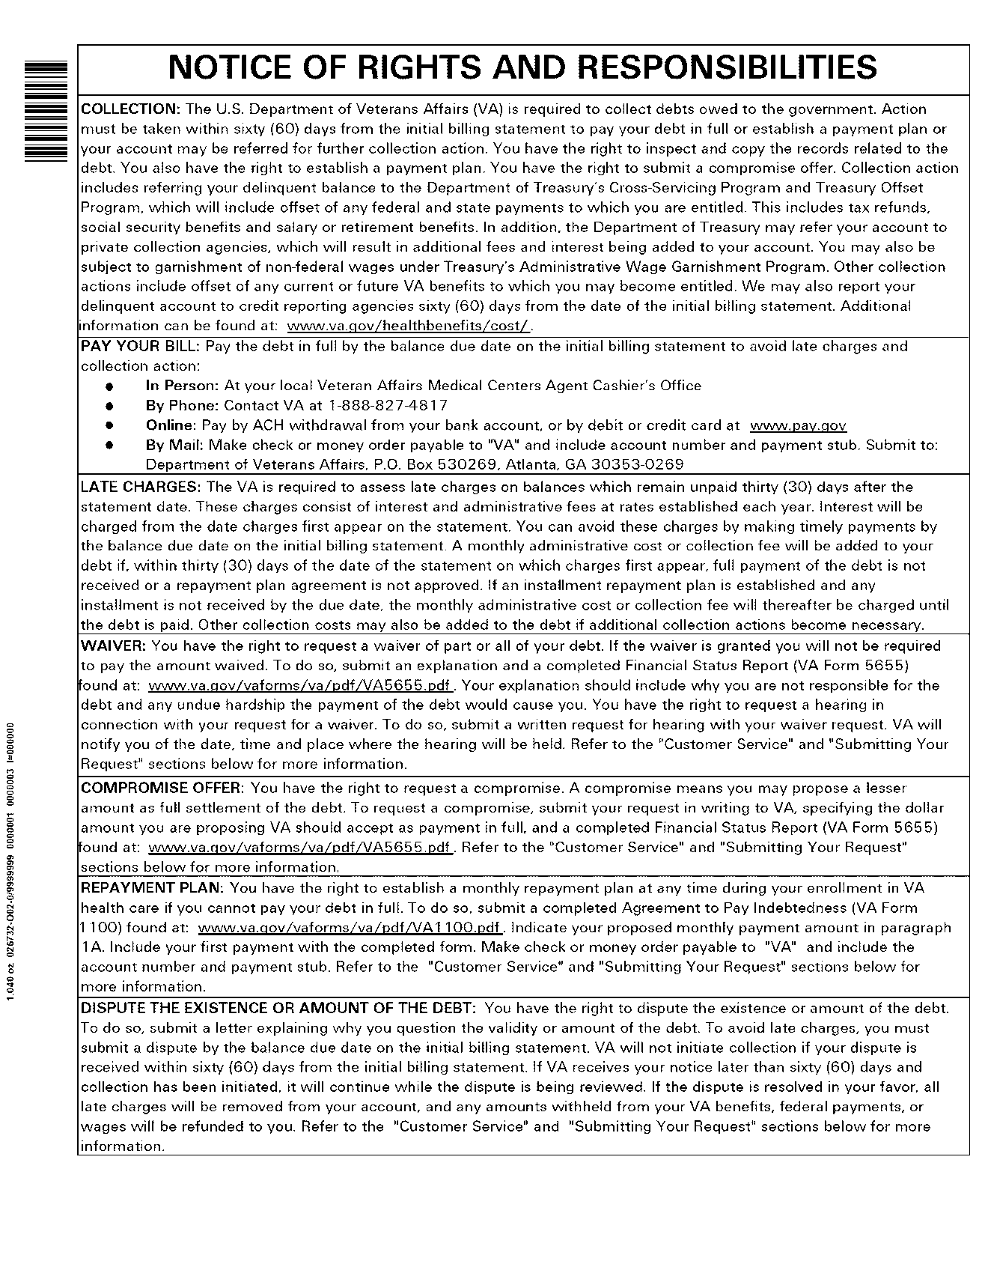

Figure : Notice of Rights and Responsibilities (Page 2)

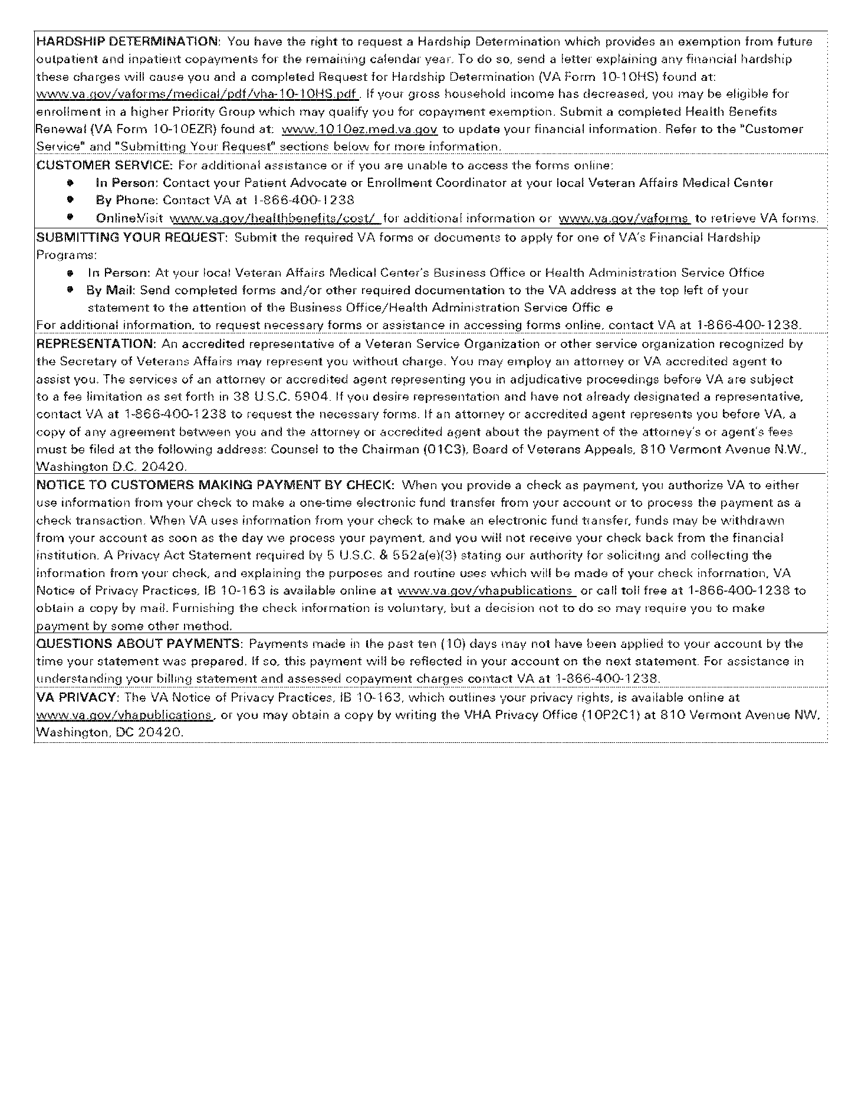

# Appendix D. Acronyms

| **Acronym** | **Definition** |
| --- | --- |
| ABAL | Agency Balance Adjustment |
| AIO | Agency Internal Offset |
| AITC | Austin Information Technology Center |
| AWG | Administrative Wage Garnishment |
| AR | Accounts Receivable |
| C&P | Compensation & Pension |
| CCPC | Consolidated Co-Payment Processing Center |
| CPAC | Consolidated Patient Account Center |
| CS | Cross-Servicing |
| DATA Act | Digital Accountability and Transparency Act of 2014 |
| DCIA | Debt Collection Improvement Act |
| DMC | Debt Management Center |
| DMS | Debt Management Services |
| DOJ | Department of Justice |
| DPN | Due Process Notification |
| IAI | Integrated Agency Interface |
| IPAC | Intra-governmental Payments and Collections |
| PCA | Private Collection Agency |
| SSN | Social Security Number |
| TCSP | Treasury Cross-Servicing Program |
| TIN | Tax Identification Number |
| TOP | Treasury Offset Program |
| VA | Department of Veterans Affairs |
| VAMC | VA Medical Center |
| VistA | Veterans Health Information Systems and Technology Architecture |
| VHA | Veterans Health Administration |

# Appendix E. Glossary

A

**AR** – *See Accounts Receivable.*

**Account** –A record established for a debtor in the AR Debtor file (#340). The account can contain multiple bills for an individual debtor.

**Account Profile** –A screen display or printout showing an activity summary for an entire account. This profile shows if debt on a debtor’s account has been referred to Cross-Servicing with the message, “Debt Referred to Cross-Servicing”.

**Accounts Receivable (AR)** –(1) In the broadest sense, debts owed to VA are referred as Accounts Receivable. (2) Synonymous with the abbreviation ‘AR’. (3) In this document, AR also refers to VA’s automated system designed to process first party debt.

**Accounts Receivable Section** –The staff responsible, as a group, for the establishment and maintenance of debtor account records.

**Active Bill** –Bills that are in an “Active” status are available for collection. Bills must be in an “Active” status in order to be referred to Cross-Servicing.

**Address Unknown** –This field is set in the AR Debtor file (#340) to indicate that the site has not been able to obtain a correct address for the debtor. If this field is set to YES, the debtor’s account will NOT be forwarded to Cross-Servicing.

**Adjustment** –A transaction that makes an administrative change to the principal balance of a bill or an account.

**Admin Charge** –An administrative charge incurred during the debt collection process and added to an account's principal balance. Fees for locator searches, marshal fees, and court costs are administrative charges.

**Administrative Offset** –To withhold money that is either payable by the Government to, or held by the Government for, a person or entity to satisfy a debt the person or entity owes the Government.

**Administrative Wage Garnishment** **(AWG)** – Under Federal law, a Federal agency may, without first obtaining a court order, order an employer to withhold up to 15 percent of a debtor’s wages for payment to the Federal agency to satisfy a delinquent non-tax debt.

**Austin Information Technology Center (AITC)** –VA’s data center site located in Austin, Texas. The AITC receives the transmission files for referred debts and updates to existing referrals from the VistA AR system on a scheduled basis. The AITC compiles this information and forwards it to DMC. The AITC also transmits both confirmation and reject messages to the AR system at each VAMC via MailMan.

**AWG** – *See Administrative Wage Garnishment*.

B

**Bill** –A receivable.

**Bulletin** – Electronic mail messages that are automatically delivered by MailMan under certain conditions. For example, a bulletin can be set up to fire when database changes occur, such as adding a record to the file of users.

**Bureau of the Fiscal Service** – Bureau of the Treasury Department formed from the con­solidation of the Financial Management Service and the Bureau of the Public Debt.

C

**CCPC *–*** *Refer to**Consolidated Copayment Processing Center*.

**Consolidated Copayment Processing Center** **–** Each month, patient-billing information is transmitted to the Consolidated Copayment Processing Center (CCPC) system located at AITC. The CCPC prints and mails billing statements to patients.

**Consolidated Patient Account Centers** –A congressionally mandated program that enhanced billing and collections activities within VHA through the consolidation of traditional revenue program functions into regionalized centers of excellence. There are seven regional consolidated centers around the country: (1) Mid-Atlantic - Asheville, NC; (2) Mid-South - Smyrna, TN; (3) North Central - Middleton, WI; (4) Florida\Caribbean - Orlando, FL; (5) North East - Lebanon, PA; (6) Central Plains - Leavenworth, KS; and (7) West - Las Vegas, NV.

**CPAC** –*Refer to**Consolidated Patient Account Centers.*

**Creditor Agency** –An agency which is owed money, requests Treasury’s services in collecting the debt, and includes its own delinquent debtor records in Treasury’s system for offset. Creditor agencies receive monies that have been offset on their behalf from payments due delinquent debtors.

**CS** – *Refer to Cross-Servicing*.

**Cross-Servicing** –The Cross-Servicing functionality, developed as part of the Cross-Servicing program, was delivered and integrated under the VistA AR 4.5 patch, PRCA*4.5*301. This new functionality will allow VHA to refer a debt that has been delinquent 120 days or more to Treasury for collection.

D

**DATA Act of 2014 –** *Refer to Digital Accountability and Transparency Act of 2014.*

**Debt** –An amount of money that has been determined by an appropriate Federal official to be owed to the United States (U.S.) from any person, organization, or entity other than another Federal agency. Included as debts are amounts due the U.S. from fees, duties, leases, rents, royalties, services, sales of real or personal property, overpayments, fines, penalties, damages, taxes, interest, forfeitures, loans, and other sources.

**Debt Collection** – This is the official name given to the process of sending out bills and collecting payments.

**Debt Management Center (DMC)** – The nationwide debt collection operation for VA located at the St. Paul VA Regional Office and Insurance Center.

**Debt Management Services (DMS)** – As part of the U.S. Department of the Treasury’s Bureau of the Fiscal Service, DMS works with Federal government agencies to provide a comprehensive debt management program. DMS also provides debt collection services to the states.

**Debtor** – A patient, person, vendor, insurance company, or institution that owes VA money.

**Default** –A suggested response provided by the system.

**Delinquent** –The failure of the debtor to pay an obligation or debt when due.

**Digital Accountability and Transparency Act of 2014 (DATA Act)** – Requires VA to notify Treasury of any legally enforceable, non-tax debt owed to VA that is over 120 days delinquent so that Treasury can offset such debt administratively.

**DMC –** *See Debt Management Center.*

**DMS –** *See Debt Management Services.*

**Due Process** –In the context of debt collection, the legal rights of a debtor to be informed of the adverse action and to challenge the propriety of the creditor agency’s decision (e.g., to obtain review within the agency of the indebtedness, etc.).

F

**FedDebt –** A system thatsupports the Federal government’s delinquent, debt collection programs, by providing Debt Management Services (DMS) with a single platform for its business applications, a single entry portal for its business applications, online access for creditor agencies via a web-based customer interface, and a single database for reporting.

**FMS –** *See Treasury Financial Management Service.*

G

**G.TCSP** – Mail group that receives all bulletins and transmission messages related to Cross-Servicing.

I

**IAI –** *See Integrated Agency Interface.*

**Integrated Agency Interface –** The Integrated Agency Interface (IAI) was developed to provide agencies with a single file format to submit multiple record types to FedDebt. IAI can: (1) refer initial debts, (2) recall debts, (3) process collections, reversals, and make adjustments, and (4) modify debt and / or debtor information.

**Interest** –Amount charged to an account being paid on a repayment plan for carrying the account or on delinquent accounts.

M

**Mail Groups** –List of e-mail recipients who can all be addressed at once by reference to a mail group name defined in VistA. Cross-Servicing messages are sent to the G.TCSP mail group.

P

**Patient Statement of Account** –The monthly statement for patient type debtors, reflecting all activity (both charges and payments) recorded for that patient since his last statement was printed. Debt referred to Cross-Servicing will not display on the patient statement, nor will the amount of the Cross-Serviced debt be included in the Total Debt due.

**PCA** **–** *See Private Collection Agency.*

**PRCA Nightly Process** –Set of AR routines scheduled to run at the same time every night. These routines update all actions completed through the AR VistA software. In addition, this set of routines includes those that create, record, and transmit all Cross-Servicing Messages to AITC. Cross-Servicing information is sent to AITC and the local VistA mail groups: Cross-Servicing (G.TCSP).

**Private Collection Agency (PCA)** –Private sector companies with expertise in the area of debt collection, to assist the government in its debt collection efforts. Once Treasury has exhausted efforts to collect the debts internally, the debts are sent to the PCAs for collection activity. The activities of the PCAs are monitored by the personnel of the Receivables Management and Debt Services Division of Debt Management Services (DMS).

**Profile of Accounts Receivable** –Accounts Receivable option displays information on debtor accounts. This profile shows if debt on a debtor’s account has been referred to Cross-Servicing with the message, “Debt Referred to Cross-Servicing”.

R

**RCDP TCSP FLAG** - This security key allows users that are assigned to edit the TCSP flag on Debtor and/or Bill. This Security Key, RCDP TCSP FLAG, should ONLY be allocated by CPAC IT and given ONLY to Veteran Services Supervisors and/or Veteran Services Leads (One, Two or Three). Security key introduced with routine, RCDPCSA, in Accounts Receivable patch, PRCA*4.5*325.

**Reconciliation** – Following the referral of a debt to Cross-Servicing, there are various reasons why a debt may be returned by Treasury for Reconciliation, including, but not limited to, the following: (1) Compromise Offer, (2) Uncollectable, (3) Administrative Resolution Approved for Bankruptcy, and (4) Administrative Resolution Approved for Death. These returned debts are sent from Treasury to VistA in the form of a Reconciliation File on the first day of every month.

S

**Stop/Reactivate TCSP Referral For a Bill Option** –A menu option provided to stop a debt from being referred to Cross-Servicing. This option also is used to remove the ‘Stop’ flag.

T

**Tasked Job** –A job, usually a printout, which has been scheduled to run at a predetermined time. Tasked jobs are set up to run without having a person watching over them.

**Taxpayer Identification Number (TIN)** –A nine-digit unique identifier assigned to all individuals and businesses that file tax returns in the United States. For individuals, the *Social Security Number (SSN)* serves as the TIN; for businesses, organizations, and non-profit entities the *Employer Identification Number (EIN)* assigned by IRS, serves as the TIN.

**TCSP –** Department of Treasury Cross-Servicing Program

**TCSP Flag Control** – This option is used to correct debtor/bill for Treasury Cross Service as seen when viewing the same debtor/bill on the Treasury System or from the monthly TCSP reconciliation report. Note that this option is only seen by and accessible to those users assigned to security key, RCDP TCSP FLAG. This option will allow TCSP flag control to the following options:

1) Set cross-service flag on BILL

2) Clear cross-service flag on BILL

3) Clear cross-service flag on DEBTOR (AND ALL BILLS)

4) Set cross-service flag on DEBTOR

5) Fully re-establish debtor/bill as cross-serviced

**TIN** – *See Taxpayer Identification Number.*

**TOP** – *See Treasury Offset Program.*

**Total CS Debt –** The total amount of debt referred to Cross-Servicing.

**Transaction** –Any action that affects a bill or an account. All transactions are numbered sequentially and can be examined individually.

**Transaction Number** –A number assigned by the computer for an activity against a debt (such as increase adjustment, decrease adjustment, payment, etc.)

**Transaction Profile** –A screen display or printout that shows a summary of a single transaction.

**Treasury Offset Program (TOP)** –Mandatory government wide delinquent debt matching and payment offset system. Debts that cannot be collected by the DMC must be forwarded to this collection program where delinquent debts may be recovered by offset of income tax refunds; Federal salary pay, including military pay; Federal retirement, including military retirement pay; Federal benefit payments; and other Federal payments**. NOTE: The Cross-Servicing Program will be used in replace of TOP for all new, First Party debts.**

U

**Update** –An addition, deletion, or change to a debtor’s record.

**Update File** –Each Tuesday, AR software reviews accounts currently referred to Cross-Servicing and sends updates for Cross-Servicing name, address changes, and decrease adjustments.

V

**VistA** – Veterans Health Information Systems and Technology Architecture. The VA-developed computer system that supports day-to-day operations at local VA health care facilities.

W

**Waiver** –Decision that conditions exist which, under the applicable statutes and regulations, preclude recovery by VA of the outstanding debt, including interest and other late payment charges. An example of a situation when a Veteran may request a waiver is for undue financial hardship.

# Appendix F. References

1. 31 USC § 3716 - Administrative offset:

<http://www.gpo.gov/fdsys/granule/USCODE-2010-title31/USCODE-2010-title31-subtitleIII-chap37-subchapII-sec3716/content-detail.html>

1. Austin Information Technology Center (AITC). *Lockbox to AR Transmission Layout*.
2. Bureau of the Fiscal Services – Debt Management and Cross-Servicing:

<http://fiscal.treasury.gov/fsservices/gov/debtColl/dms/xservg/debt_crosserv.htm>

1. Bureau of the Fiscal Services – Guides, Policies, and Instructions:

<http://fiscal.treasury.gov/fsservices/gov/debtColl/rsrcsTools/debt_manuals.htm>

1. Bureau of the Fiscal Services – Legal Authorities Quick Reference Chart:

<http://fiscal.treasury.gov/fsservices/gov/debtColl/dms/top/legalAuthrtyQkRef/debt_dca_quickref_index.htm>

1. Bureau of the Fiscal Services – Public Laws, Statutes, Regulations & Guidance Managing Federal Receivables:

<http://fiscal.treasury.gov/fsservices/gov/debtColl/rsrcsTools/debt_guidance_mfr.htm>

1. Debt Collection Improvement Act (DCIA) of 1996:

<http://www.fms.treas.gov/debt/dmdcia.txt>

1. Digital Accountability and Transparency Act (DATA Act):

<http://www.gpo.gov/fdsys/pkg/PLAW-113publ101/html/PLAW-113publ101.htm>

1. FedDebt Q & A Site:

<http://fiscal.treasury.gov/fsservices/gov/debtColl/faqs/debt_questions_feddebt.htm>

1. Treasury Financial Manual:

<http://www.fms.treas.gov/tfm/vol1/v1p4c400.pdf>

1. U.S. Department of Treasury. Debt Management Services. Financial Management Service. *Integrated Agency Interface File Format For Cross-Servicing*.

(*This page left intentionally blank for two-sided printing / copying.*)

1. U.S. Department of Treasury. Debt Management Services. Financial Management Service*. Integrated Agency Interface File Format For Cross-Servicing*.